RE Advisor report to Suffolk SACRE: Summer Term, 2026
National Updates
In March 2026, the Government produced the paper: Protecting What Matters: Towards a more confident, cohesive, and resilient United Kingdom. This details the government’s fresh commitment to acting on social cohesion. In the paper it states, “Working closely with faith and belief communities, we will expand Inter Faith Week, boost faith and belief literacy in government and wider society, and strengthen the role of Religious Education, including through improved engagement with SACREs”. The government is committed to driving up standards in RE and recognises that SACREs are already playing a strategic role in collaborative working between faith and belief communities. We await further details of how they will further promote the role of SACREs. The report then further states that two groups (The Ministry of Housing, Communities and Local Government and the Department for Education) will promote the role of SACREs by supporting improved analysis of their annual reports, to better understand the role they play in communities including in relation to cohesion.
KS4
Whilst there is a full scheme of work to support implementation of the Suffolk SACRE’s agreed syllabus for RE in Primary schools, we currently have fewer plans and resources available for Secondary schools. Through our website findings, we are aware that some schools only offer KS4 RE for those taking it as a GCSE, but there remains a legal requirement for all pupils to access RE up to and including KS5 (Core RE). We believe that there is a need to help secondary teachers fulfil the requirements of the Suffolk syllabus and as a result, Suffolk SACRE expressed an interest in recruiting a Secondary RE teacher to help with surveying schools and writing curriculum resources for KS4. Beatrice Trott responded to this request, and I met with her on 20th April to discuss.
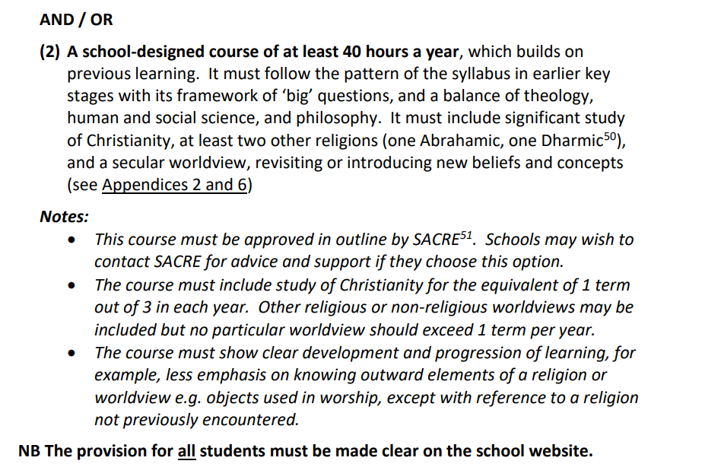
Together, we discussed the current KS4 requirements (see below, p.25 of the syllabus) and created an action plan. SACRE will fund Beatrice’s time to enable her to write these plans. Once written, they will be available for free on our website.

Action | Timeframe
- Survey secondary schools in Suffolk – email/phone calls with Heads of RE to discuss their current provision for RE in KS4. Is it taught as a whole day, or within PSHE curriculum or another way? What planning and resources would support them best to deliver KS4 Core RE? Analyse findings and discuss with Rachel. | End of Summer term (2026)
- Planning and resources for KS4 Core RE. Beatrice will consider a Big Question that would be suitable for a unit of work. Based on findings from the survey, Beatrice may produce two planning – one for schools to use who teach Core RE weekly and another that may be used to teach it as a RE day. This may be adapted. | End of Academic year (26/27)
3. Responding to questions and enquiries from secondary teachers. | Ongoing.

NASACRE Annual Conference
I was delighted to attend the NASACRE Annual Conference in May 2026. The two keynote speakers were Amy Ark from the Faith and Belief Forum, and Dr Vanessa Ogden, who has been chairing the focus groups as progress with the recommendation for RE to become part of the National Curriculum.
Amy spoke about many ways in which community cohesion is enhanced by SACREs and the work of the Faith and Belief Forum, and I intend to signpost schools to the many resources that they offer. In particular, their poetry competition and resources to accompany this, which are suitable for KS1 – KS4. There are some beautiful poems on the topic of ‘Community: Together We Serve” which SACRE members may be interested in taking a look at (available here). I will also promote the School Linking programme, more information here. This programme matches classes from different faith backgrounds to explore issues of identity, community and belief.
Dr Vanessa spoke on “Rejoicing in Difference: SACREs' Role in Building Social Harmony”. Dr Vanessa explained how school play a crucial role in ‘Building a Nation’ and how social fault lines can be strengthened by great visitors (often members of SACRE), benefitting the whole school. She spoke from experience of leading a school in London where they had done this often and had seen the impact of religious cohesion. Dr Vanessa spoke highly of the role that SACREs have, referring to them as ‘an anchor for social harmony ‘. She was passionate about great RE, supported by SACRE, and how it can help people have their own voice, and can use it positively: “One song but many harmonious voices”. Dr Vanessa also spoke about the draft programmes of study that have been written for the National Curriculum.
NATRE and Training
- Click here for NATRE article about RE in Ofsted reports
- NASACRE training: “So you’ve joined your local SACRE!” - 25th June 2026, 6:30-8pm.
A free webinar to help SACRE members understand their role, how SACREs work, their statutory responsibilities and how members make their contribution to a SACRE’s work. To book a place, email: admin@nasacre.org.uk

Rachel Cutts
RE Advisor for Suffolk SACRE
June 2026

