Hold Ctrl + click on the questions below to jump to that section of the document.
I’m new to the role/taking over the submission process for my setting. Where do I start? 1
I can’t see the outcome document on Perspective Lite, what do I need to do? 2
I need to access the outcome data ASAP – can someone email it to me? 2
My file’s been rejected – how do I find out what I need to do? 2
My setting has a new DfE number/our headteacher has changed – how do we update our Perspective Lite record/accounts? 2
I think there is an error in the information provided in the outcome spreadsheet. How do I get this corrected? 3
Some of the rows on my spreadsheet are highlighted red and I can’t seem to fix it. 3
I’m having trouble deleting a row from my submission spreadsheet. 3
I have submitted my spreadsheet and realised there is an error. What do I need to do? 3
I have a query about a specific application. What’s the best way to get in touch with someone for support? 3
If my setting has a specialist unit, how do I include this data in my submission? 3

I’m new to the role/taking over the submission process for my setting. Where do I start?
Now that HNF data is shared via Perspective Lite, this should be a quick & easy process.
Start by ensuring you have a Perspective Lite account and that it has been assigned the “HNF Lead” role by your headteacher (headteachers will need to apply this role to their own accounts). You will need to log out & back in for the applied role to take effect.
Guidance Links: Setting up your Users – Perspective Lite Roles – Perspective Lite
You will then be able to find the previous term’s outcome spreadsheet in the “my confidential files” area. This includes all the latest information about current learners in your setting with bands, including the outcome of the latest applications your setting made.
Guidance Links: Confidential Files – Perspective Lite
Then you can follow the instructions on our Guidance Document to complete your submission process!

I can’t see the outcome document on Perspective Lite, what do I need to do?
There are two main reasons this may be the case:
- Your account has not been assigned the “HNF Lead” role. Make sure you log out & back in once this has been done, for it to take effect. (Guidance: Roles – Perspective Lite)
- The search filter has defaulted to “current academic year”, and the latest spreadsheet was uploaded over the summer. Simply adjust the filter and search again.
If you still can’t see the file, contact us via InclusionFundingHub@suffolk.gov.uk so we can investigate this for you.

I need to access the outcome data ASAP – can someone email it to me?
We have moved to Perspective Lite for data sharing to ensure a secure, reliable transfer of this sensitive data and we will not be able to email this to any settings who are registered with Perspective Lite. Setting up your account and applying the “HNF Lead” role is a quick process and will give you instant access to the data you need.

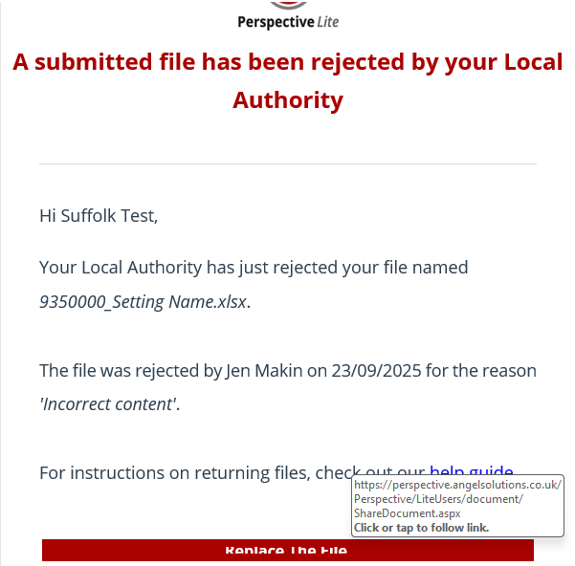
My file’s been rejected – how do I find out what I need to do?
When you receive a “Rejected File” email (see screenshot), it will include the category it was rejected under (e.g. “incorrect content”) but you need to click on the big red “Replace The File” button to find more information about why the file was rejected.
Once you have clicked on this link, you can simply hover over the “rejected” status icon to see more information about why your file was rejected.

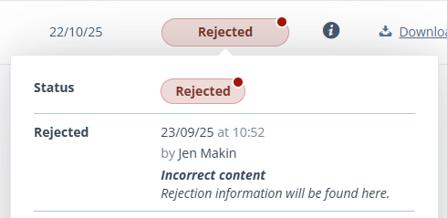
My setting has a new DfE number/our headteacher has changed – how do we update our Perspective Lite record/accounts?
In this situation, please email PerspectiveSupport@AngelSolutions.co.uk and cc InclusionFundingHub@suffolk.gov.uk to let them know and we will ensure your setting and accounts are set up appropriately for you.

I think there is an error in the information provided in the outcome spreadsheet. How do I get this corrected?
Please email us as InclusionFundingHub@suffolk.gov.uk to let us know what information you think is inaccurate, so we can investigate. If needed, we will then reupload an updated outcome spreadsheet for you ready for you to use this for your next submission.

Some of the rows on my spreadsheet are highlighted red and I can’t seem to fix it.
Don’t panic! The red highlight will appear when learners are duplicated on your spreadsheet – however, sometimes it gets stuck and won’t disappear even though you have removed the duplication. As long as you have ensured the learner is NOT duplicated on the spreadsheet, you can still submit it. The file won’t be rejected just because the red highlight is there – it will only be rejected if the learner is found on multiple tabs.

I’m having trouble deleting a row from my submission spreadsheet.
Check the “Guidance Tab” and ensure you are following the instructions shown re how to delete a row. If you are still having trouble, then select the relevant cells and use the “delete” key on your keyboard to remove the data.

I have submitted my spreadsheet and realised there is an error. What do I need to do?
As we are processing submission data for hundreds of settings each term, we do ask that you take care to double (and triple!) check your data before submitting. While early submissions are really helpful, we would rather you submit closer to the deadline than resubmit after we have processed your spreadsheet, if it can be avoided – so feel free to upload if you think you’re ready, but don’t rush to upload if you are anticipating possible changes.
However, we understand that sometimes unexpected situations arise after submitting and that we are also all human so the odd mistake will happen, and we are more than happy to help in this case. If you realise you need to amend your submission, please email us at InclusionFundingHub@suffolk.gov.uk to let us know and we will then confirm that we are able to re-process your submission and will reject the file on Perspective Lite so you can reupload.
It is really important that you let us know what the change is and don’t just reupload a new spreadsheet without saying anything, as this creates significantly more work for our small team as we don’t know what change has been made.

I have a query about a specific application. What’s the best way to get in touch with someone for support?
For these kind of queries, please contact us via InclusionFundingHub@suffolk.gov.uk and we will ensure that your query reaches the best person to support you.

If my setting has a specialist unit, how do I include this data in my submission?
Please submit a separate spreadsheet for any learners in specialist units. This should be uploaded at the same time as your main spreadsheet – if you upload one and then the other, it may overwrite your initial upload, meaning we will only receive the last document you uploaded.
All existing units will receive their own outcome spreadsheet in the “my confidential files” area. For new units, you can download the blank template from the Suffolk Learning website (High Needs Funding – Suffolk Learning) for the first term. After this, you will need to follow the usual process of downloading the most recent outcome spreadsheet and using this as the basis for your submission.

