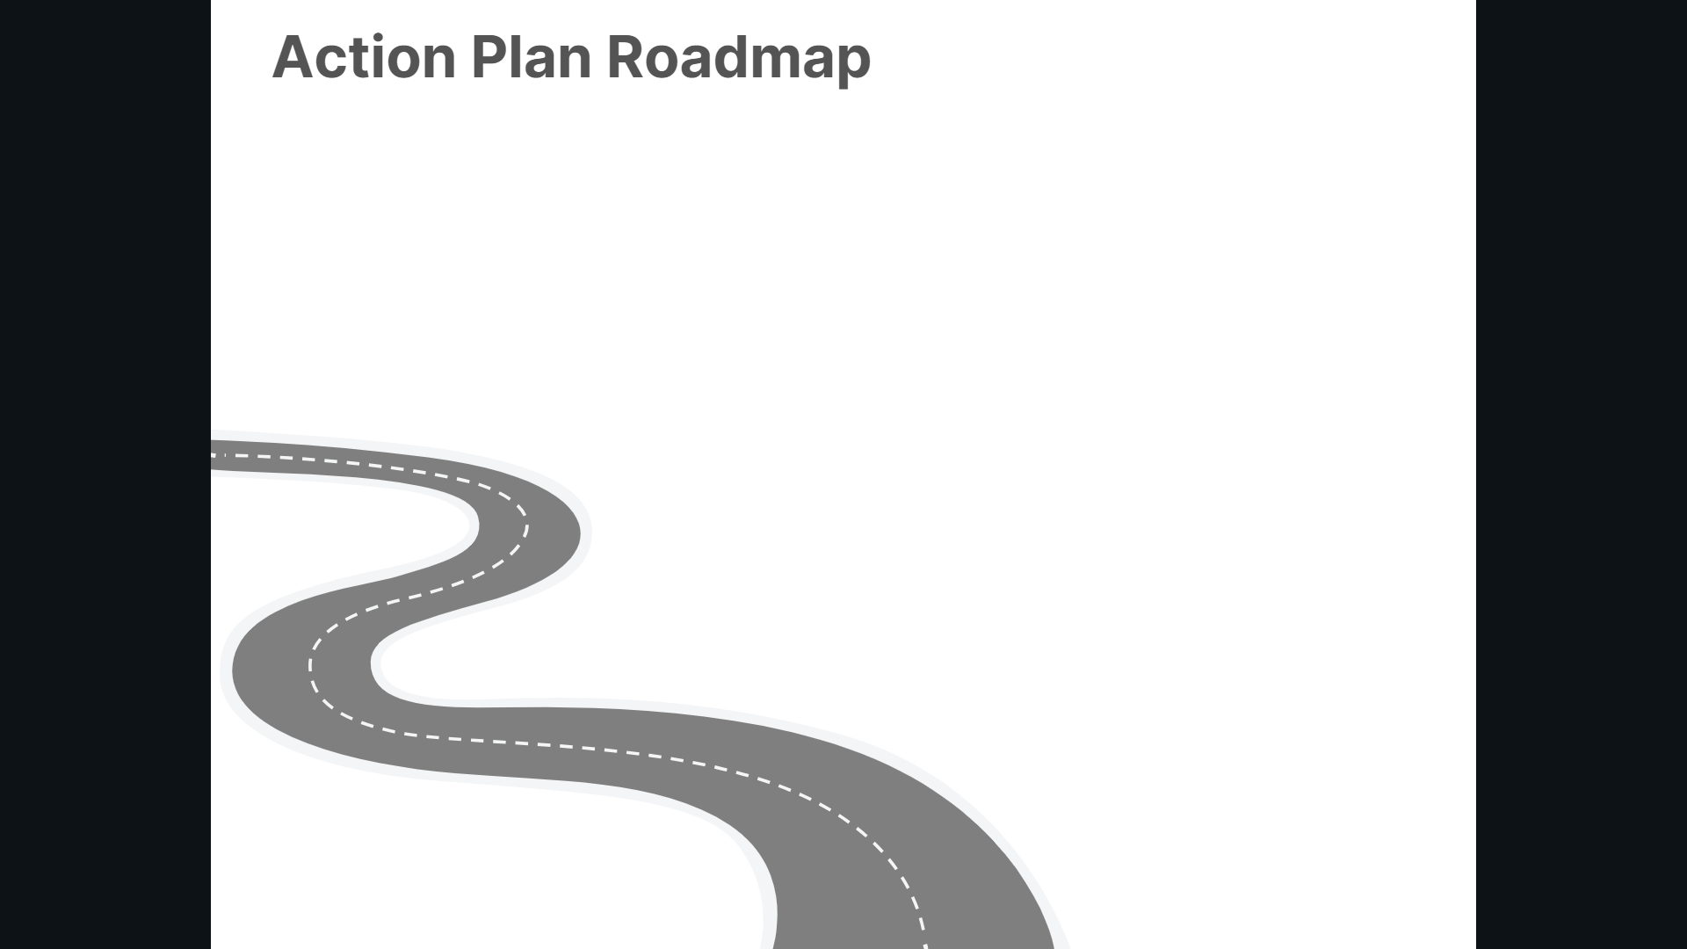
Who’s responsible?
Target date:
Who’s monitoring?
How will you know its complete – what will the impact be?
What next?
Goal:

