Year end March vat files 23-24

This year we have agreed for schools to be able to run their March VAT files early as the schools last day will be the 28th of March. Typically vat files cannot be run until the first of each month as the vat submittal is normally greyed out if you try and process the file before the first of the month. Due not being able to submit your vat submittal this leaves the month open, so it is important that once you have exported your vat file to us that nothing is entered onto your FMS system until you do run your vat submittal.

We will be accepting vat files up until the 4th of April if you will be in the school after the 28th of March.

It is important that schools run their vat submittal for March first thing on their return from Easter break or the first day back in the office after the 1st of April. If that is not run, you will run a risk of entries going into March rather than April causing differences between FMS and Oracle.

Steps for processing your March vat on the 28th

- Reports > General ledger > VAT > Vat Reports

- Once you click on the vat reports the below box will appear and it is important to click on the green plus button in order to add the March vat month or you run a risk of submitting your Febuary vat file twice.
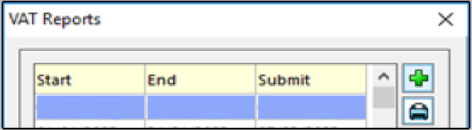

- Once you have the below box opened with the vat period as 12-Mar your next step would be typically to print your Vat Submittal Report but that as you can see is greyed out as that is only available from the 1st of each month, so we skip that step and move straight onto exporting your Vat Long Summary Report.

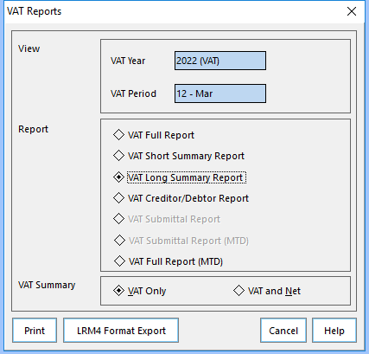

- Select the Vat Long Summary Report and then click on the LRM 4 Format export and save the file as you would normally do for each month. Once saved run Anycomms and the file will be sent to us.

- First day back after the 1st run vat submittal report but please do not export your vat file again as this would duplicate the file within Oracle if we have already received your file on the 28^{th.}

- Reports > General ledger > VAT > Vat Reports

- Click on the green plus button in order to add the March vat month.

- Once you have the below box opened with the vat period as 12-Mar the Vat Submittal Report, which will now be live, should be printed but, as above, the file should NOT be exported again.

While we have offered for the vat files to be sent on the 28th we will accept them up until the 4th of April so if you will be in the school over the Easter break and if that is the case you will just run the vat process as normal as the vat submittal option will be available.

What happens if I do enter something after submitting my vat file and prior to running my March vat submittal? FMS will have an entry that Oracle is not aware of as the vat file has already updated Oracle with your March vat entries causing a difference. If this is the case, we will ask for the school to make an adjustment for those particular entries and re-enter it once the vat submittal has been actioned so that it goes into April.

I have logged back into FMS after the 1st of April to run my March vat submittal report and the March vat period is not there? The only way that the month is saved is when you run the vat submittal so in the situation that was not possible so you will need to revisit the above steps and add the March month again via the green plus button and the only action from that point will be to print your vat submittal with no need to submit or export the file again as we would already have this file.

Many thanks - Schools Accountancy team

