Date: 12 March 2024
Enquiries to: Organisational Support
Email: edorgsupport@suffolk.gov.uk

To: All Headteachers and Chairs of Governors of Maintained Schools and PRUs

LMS Document
No. 2024/02

Dear Colleagues

MAINTAINED SCHOOLS – Changes to Support Staff pay: removal of spinal column point 1 from the grading structure

This letter is to advise you of changes to the support staff pay scales with effect from 01 April 2023.

Background information

The National Joint Council for Local Government Services (Green Book), the 2022 pay deal included the removal of Spinal Column Point (SCP) 1 from the national pay spine with effect from 1st of April 2023.

Unfortunately, the impact of the Job Evaluation project has delayed this work. By way of an update the Job and Person Profile’s (JPP) have been reviewed, and we are drafting communications to share with you over the next few months.

The agreed option for the removal of Spinal Column Point 1 (SCP1) is set out in the table below “New Payscales”.

All support staff in schools will remain on the same grades, apart from support staff in schools who are on SCP1 who will be moved to SCP2 with effect from the 1st of April 2023.

Existing payscale

Spinal Point | 2023 | Grades |  | Hourly Rate
 | Basic
1 | 22,183 | Grade 1 | Grade 2 | 11.50
2 | 22,367 |  |  | 11.59

New payscale
Spinal Point | 2023 | Grades |  | Hourly Rate
 | Basic
Point 1 removed
2 | 22,367 | Grade 1 | Grade 2 | 11.59

If your school does not use Schools’ Choice as its payroll provider, you will need to notify your provider of the changes.

For budgeting purposes, the recently issued support staff spreadsheets can be updated to reflect the change.
Schools will need to update the pay scale information in SIMs.net – guidance on this and updating the support staff spreadsheet will be provided by the Schools’ Choice Finance team very shortly.

As previously noted, employees who are currently on pay point 1 will automatically receive a raise of one spinal point, to Grade 1, point 2, which is the only point within Grade 1, so there is no further scope to receive an incremental pay award within this grade.

This will be implemented in March 2024 and affected staff will receive the increase with their pay at the end of March 2024, backdated to 1 April 2023.

FAQs providing further information are contained in Appendix 1.

Please can you arrange for a copy of this LMS letter to be placed in the personnel file of each member of your support staff on spinal point 1, to provide documentation for an audit trail for the change in spinal point number.

As mentioned above, further work on the pay scales is being undertaken as part of the Job Evaluation project. This work involves resolving the overlap in pay bands 1 and 2 and retaining the mid-point bar within the pay bands.

If you have any queries about the content of this letter, please contact the appropriate team in Schools’ Choice, via the Schools’ Choice contact centre on 0300 123 1420:

Finance – option 1
Payroll and HR Processing – Option 2
HR Consultancy – option 7

Yours sincerely
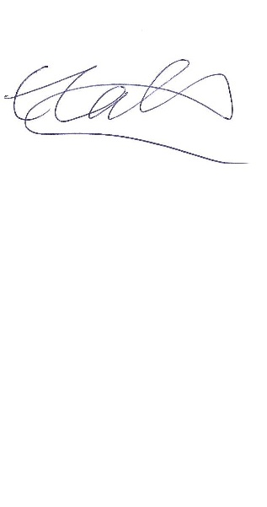
Emma Laflin
Head of Organisational Support
Education, Skills and Learning
Directorate of Children and Young People’s Services

Appendix 1

FAQs on changes to support staff pay: removal of spinal column point 1 from the grading structure

Question | Answer
Will the effected employee receive an individual letter? | LMS letter provided dated March 2024
Will the removal of SCP 1 and the cost to move affected staff to SCP 2 be automatically changed in the schools finance budget? | Schools will need to update the 2024/25 support staff spreadsheet and the 2024/25 budget plan to reflect the increase in the 2024/25 budget forecast.  Backdated charges for the period April 23- March 24 will be included in the March salary costs submitted to schools via the weekly extract file.  Schools will pick up the additional costs of this change to the gradings.
Will the increase to SCP 2 be backdated to 1.4.23? | Yes
Have any other grades changed? | No other grades have changed.
What if the affected member of staff does not want to be moved to SCP 2? | As point 1 has been removed by local government services in 1.4.23, SCC have followed the guidance.
If the affected staff are casuals, will they receive back dated pay? | This will need to be discussed on a case-by-case basis
Will support staff on SCP1 who left employment be able to claim the backdated increase? | This will need to be discussed on a case-by-case basis but they will not be contacted.

