Parent’s name:
Date started:
End date:
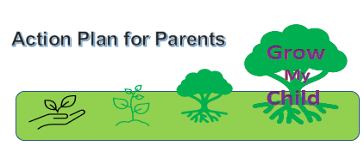

What I want to happen | What I’m going to do | When and where I’m going to do it | How did it go?
1.

2.

- Focus ideas to help your child:
talking | play skills | learning | behaviour
health and happiness | physical development | independence | making friends
- Focus ideas to help you:
Confidence | Knowledge | Enjoyment | Managing anxiety
Behaviour management | Routines | Relationships | Health

