INSTRUCTIONS FOR CLOSING THE PREVIOUS FINANCIAL YEAR ON FMS

Please only use this document in conjunction with your FMS closure authorisation letter.

IMPORTANT:

You should not attempt to close the financial year until authorised to do so via your letter from Schools Accountancy Team – CYP Finance team.

Then please again ensure that: -

Your Year End System Check report is clear:

Reports > Year End > System Checks, select transferable transactions & support items (cheques & transferable items in support of that cheque are ok) Further guidance can be found on Suffolk Learning Website: or by clicking Clearing Year End System Check

A full back up has been completed prior to starting your closure process

You have sole use of FMS

Your log-in has authorisation to close the old year, (you may need to log in as system manager SYSMAN)

1. Checking FMS Allocated Budgets for both Fund 01 and again for Fund 02

If there is any variance to Oracle, then an adjustment will be required, as per authorisation letter

Ensure you are in the old year: Reports > General Ledger > Fund Review

To adjust: Focus > Budget Management > Fund Allocation

Double click on Fund code 01 ‘Table 3 Delegated Budget’ (light blue line), view Tab 1 ’Basic’ and use either the Increase or Decrease button as appropriate

Adjust allocation as per authorisation letter, and in Period 12; with narrative ‘Year end adjustment’ ensuring your amount is included in the CFR Apportioned I01 and Funds delegated by the LA, and then save

You should now repeat this process as appropriate for Fund 02 – Capital Allocation

2. Checking FMS Expenditure Budgets for both Fund 01 and again for Fund 02

If there is any variance to Oracle, then an adjustment will be required, as per authorisation letter

Ensure you are in the old year: Report > General Ledger > Fund Review

To adjust: Focus > Central > Payment

For Fund 01: Click ‘+’ icon at top to add record, select payment, select cost centre and ledger code for adjustment in period 12 (ESS 30390 if difference is not against a single cost centre/code)

For Fund 02: Click ‘+’ icon at top to add record, select payment, select cost centre and ledger code for adjustment in period 12 (Premises C1001 if difference is not against a single cost centre/code)

The values of the central payment adjustment required are detailed in your authorisation letter

NB - If this value has a minus sign, please include minus sign in value field when making central payment adjustment, then save and post

3. Ready to close (**Be careful to ensure you close the old financial year**)

Tools > Define Financial Years > Define/Edit Years.

Ensure that you highlight the appropriate financial year that you wish to close

Click on the box for ‘Preliminary Close’.

A CFR report prompt will appear, click ‘Yes’ to continue.

The system will check all aspects to accept a preliminary close and if all items are green ticked, it will give you the option to ‘Continue’

NB - If any red crosses appear then these need to be investigated by printing ‘Report’ and clearing before continuing

Select ‘Transfer all Central Invoices’, and again click ‘Continue’.

The system now runs some further checks and once all items are green ticked, will give you the option to ‘Perform Close’ which should be selected

A final warning that the preliminary close is not reversible, and the year will be: Closed – Not Finalised, click ‘Yes’

Click on the box for ‘Final Close’

A CFR prompt will appear, click ‘Yes’ to continue

The system will go through a further checking process.

NB - If any red crosses appear then these need to be investigated by printing ‘Report’ and clearing before continuing

IMPORTANT – If a red cross appears on Checking Salary Commitment (if a school has made contract changes in SIMS.net, FMS may backdate the commitments) you will need to clear all old year commitments created, i.e. April to March. To clear these commitments in previous year: Focus > Personnel Links > Salary Projections then click on ‘All Cost Centres’, click on ‘red cross’ top right corner of screen, click on ‘Commitments for Period’ (magnifying glass) Then select each month in turn by double clicking to open. ‘Tag all’ then ’Clear Commitment’. Final close can only now again be attempted/completed

Once all Final checks are green ticked select ‘Continue’

The system will run a final checking process and then gives you the option to ‘Perform Close’

A final warning that the operation is not reversible appears, click ‘Yes’

The appropriate year should now say ‘Finalised’. You should then ‘Save’
4. Removing the Estimated Carryforward for Fund 01 and Fund 02 in current year

The process of closing the old year has automatically entered the F01 Revenue and F02 Capital carryforward into the current year. It is therefore necessary to remove the manually entered carryforward:

In current year: Focus > Budget Management > Fund Allocation

Fund code 01- Table 3 Delegated Budget: Once you have removed the manually entered carryforward this figure should total LA Revenue Delegated Budget plus your schools actual Revenue carryforward from the previous year. See below for instructions

To remove the previously manually entered Revenue carryforward:

- Open Fund 01 Table 3 Delegated Budget by double clicking on blue line
- Tab 1 ‘Basic’ - Select ‘Decrease Allocation’ button
- NB - If you have a deficit carryforward you need to use the ‘increase allocation’
- Reduce allocation by required amount with a narrative ‘Reversal of carryforward (estimated or actual dependent on whether you have previously made manual adjustment for actual carryforward):

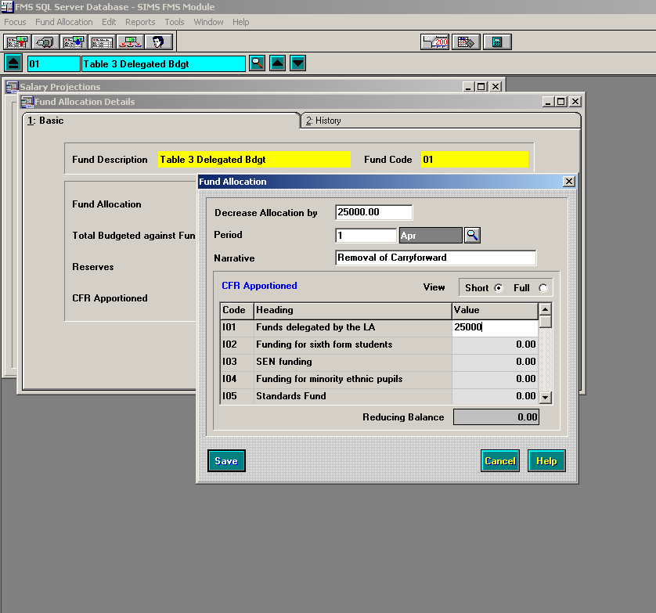
Ensure the amount is included in the CFR Apportioned I01 and Funds delegated by the LA and ‘Save’

You should now repeat this process as appropriate for Fund 02 – Capital Allocation

Focus > Budget Management > Fund Allocation

And select Fund Code 02 Capital

Fund code 02 – Capital: Once you have removed the manually entered Capital carryforward this figure should total your schools actual Capital carryforward from the previous year. See below for instructions

To remove the previously manually entered Capital carryforward:

- Open Fund 02 Capital by double clicking on blue line
- Tab 1 ‘Basic’ - Select ‘Decrease Allocation’ button
- NB If you have a deficit carryforward you need to use the ‘increase allocation’
- Reduce allocation by required amount with a narrative ‘Reversal of Capital carryforward (estimated or actual dependent on whether you have previously made manual adjustment for actual Capital carryforward) ensuring amount is also included in CFR Apportioned I01 (see example above)

5. Check Reserves in current year - The following guidelines apply to Fund 01 & Fund 02

Focus > Budget Management > Fund Allocation

After completion of Step 4 the ‘Reserves’ values should be pence only. The value will appear where any differences between the estimated and actual carryforwards have not been accounted for in the cost centre allocations. See below for instructions:
After completion of Step 4 the ‘Reserves’ values should be pence only. A value other than pence will appear if any difference between the estimated carryforward and actual carryforward has not been accounted for in the cost centre allocations. See below for instructions

Any budget adjustments due to the difference between the estimated and actual carryforward should be recorded on your first Summer Virement report within your budget toolkit, presented to Governors at the next meeting and submitted to the Schools Finance Team for processing

NB - As an interim measure, schools may choose to adjust their ‘Planned Reserves’ figures to account for differences between actual and estimated carryforward prior to presentation of Virement report for Governor approval

To allocate/adjust against cost centre (in whole pounds only – OK to leave if pence):

Focus > Budget Management > Cost Centre Allocation

- Double-click on relevant cost centre (possibly cost centre HC05 if adjusting Revenue Planned Reserves and cost centre YC10 if adjusting Capital Planned Reserves)
- Double-click on appropriate ledger code and enter revised amount remembering to profile.

6. Submission of Audit Trail Report
IMPORTANT:

Once the final closure has been completed and the manual carry forwards removed, your Fund Allocation Audit Trail Report for current year should be run:

Reports > Budget Maintenance > Fund Allocation Audit Trail > Select Summary Report, leave Fund blank, OK

The report should be Exported to Excel with Export Options set to Main Body, and the Format set as Excel 4.0 with a suggested fill name of: XXX(3 digit school number) Audit Trail 2023

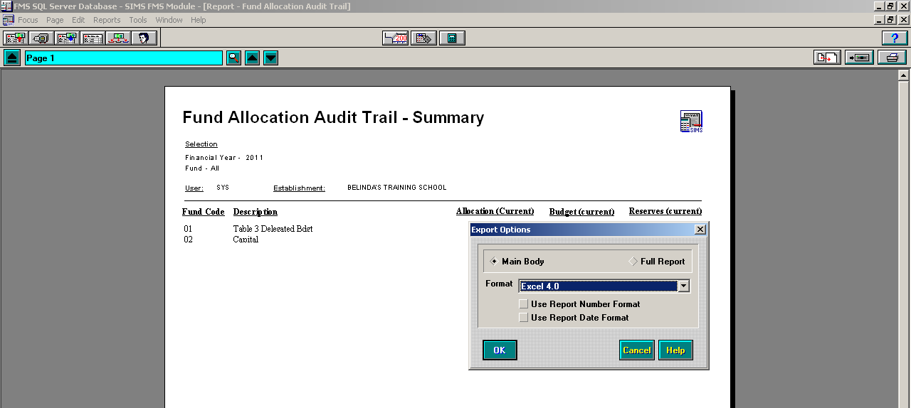

This file should be saved with your other year end documents for Audit purposes and then e-mailed to the Schools Accountancy Team at: sat@suffolk.gov.uk

Your FMS system closure of the previous financial year should now be complete

