**Record of school improvement engagement model work**

|  |  |  |  |
| --- | --- | --- | --- |
| **School** |  | **Phase** |  |
| **Headteacher and email** |  | **Deputy Headteacher and email** |  |
| **Chair of Governors and email** |  | **SENDCo and email** |  |
| **Standards and Excellence Partner (SEP)** |  | **Regional Lead for Education (RLE)** |  |
| **Name of external adviser used for Headteacher Performance Management** |  | **Engaged in the Suffolk Learning and Improvement Network (SLIN) peer review** |  |
| **Type of school** |  | **Current Ofsted judgement and date** |  |

|  |  |  |  |  |
| --- | --- | --- | --- | --- |
| **School’s vision** | | | | |
| 1. **Continuous conversation - summary of the school’s position and trajectory** | | | | |
| **Trajectory to the next Ofsted inspection** | | | | |
| **School’s view** | | **LA view** | | |
| **Autumn** Choose an item.  **Spring** Choose an item.  **Summer** Choose an item. | | **Autumn** Choose an item.  **Spring** Choose an item.  **Summer** Choose an item. | | |
| **Trajectory for assessments at the end of the year** | | | | |
| **Autumn** Choose an item.  **Spring** Choose an item.  **Summer** Choose an item. | | | | |
|  | **Autumn** | | **Spring** | **Summer** |
| **EYFS** |  | |  |  |
| **PHONICS** |  | |  |  |
| **KS1 READING** |  | |  |  |
| **KS1 WRITING** |  | |  |  |
| **KS1 MATHEMATICS** |  | |  |  |
| **KS2 READING** |  | |  |  |
| **KS2 WRITING** |  | |  |  |
| **KS2 MATHEMATICS** |  | |  |  |
| **KS2 RWM Combined** |  | |  |  |
| **PROGRESS** |  | |  |  |
| **KS4 En/Ma (5-9)** |  | |  |  |
| **EBACC ENTRY** |  | |  |  |
| **ATTAINMENT 8** |  | |  |  |
| **PROGRESS 8** |  | |  |  |
| **KS5** |  | |  |  |
| **School Improvement Engagement Model** | | | | |
| **Autumn** Choose an item.  **Spring** Choose an item.  **Summer** Choose an item. | | | | |

|  |
| --- |
| **School Improvement Priorities** |
|  |

|  |  |
| --- | --- |
| **2. Plan for Collaborative Improvement Support** | |
| **How will the Standards and Excellence support entitlement be used?**  **Support from other teams**  **School to school support** | **Autumn**  **Spring**  **Summer** |
| **Support the school could offer other schools** | **Autumn**  **Spring**  **Summer** |

|  |  |  |
| --- | --- | --- |
| **3. Record of joint work** | | |
| **Date:** | | |
| **Present:** | | **Visit Type:**  Choose an item. |
| **Follow up actions from last visit:** | | |
| **Focus of this visit:** | | |
| **Summary evaluation/key points, including evidence, that supports this evaluation:** | | |
| **Next steps:** | **By Date:** | **Who?** |
|  |  |  |
|  |  |  |
| **Next visit date and time:**  **Agenda items:** | | |
| **Documents linked to the visit that school leaders have chosen to share:** | | |
|  | | |

**School Improvement Engagement Model – Additional Engagement Plan**

|  |  |
| --- | --- |
| **School:** |  |
| **Present at meeting:** |  |
| **Start date for additional engagement:** |  |
| **Reasons for additional engagement:** | |
| **Entitlement of up to 12 hours**  Choose an item.  Choose an item.  Choose an item. | **Entitlement of up to 24 hours**  Choose an item.  Choose an item.  Choose an item.  Choose an item. |
| **Timescales for additional engagement (end date)** | |
| **Priorities** | |

|  |  |  |  |
| --- | --- | --- | --- |
| **Team around the school** | | | |
| **Name** | **Job Title** | **Email** | **Phone Number** |
|  |  |  |  |
|  |  |  |  |
|  |  |  |  |
|  |  |  |  |
|  |  |  |  |
|  |  |  |  |
|  |  |  |  |

|  |  |  |  |  |  |  |  |  |
| --- | --- | --- | --- | --- | --- | --- | --- | --- |
| **Progress reviews** | | | | | | | | |
| Are we on track? | | | | | | | | |
| Date |  |  |  |  |  |  |  |  |
| Yes/No |  |  |  |  |  |  |  |  |
| If not on track, summarise reasons: | | | | | | | | |

|  |  |  |  |
| --- | --- | --- | --- |
| **Priority 1**    **The changes we will see (i.e. The difference that actions will make and the impact):** | | | |
| **Summary progress review** | | | |
| **Actions** | **Who** | **When** | **Progress review RAG** |
|  |  |  |  |
| **Priority 2**  **The changes we will see (i.e. The difference that actions will make and the impact):** | | | |
| **Summary progress review** | | | |
| **Actions** | **Who** | **When** | **Progress review RAG** |
|  |  |  |  |
| **Priority 3**  **The changes we will see (i.e. The difference that actions will make and the impact):** | | | |
| **Summary progress review** | | | |
| **Actions** | **Who** | **When** | **Progress review RAG** |
|  |  |  |  |

|  |
| --- |
| **Summary evaluation of progress at the end of the timescale** |
| Date |
| Present |
| *Completed with the school leaders and any officers involved in the last progress review meeting.* |

**Glossary**

New rows can be inserted, and new terms added.

|  |  |
| --- | --- |
| **ADHD** | Attention Deficit Hyperactivity Disorder |
| **ADSL** | Alternate Designated Safeguarding Lead |
| **AHT/AP** | Assistant Headteacher/Assistant Principal |
| **AMO** | Assessment and Moderation Officer |
| **ASD** | Autistic Spectrum Disorder |
| **ASP** | Analysing School performance (government online platform) |
| **BTEC** | Business and Technology Education Council |
| **CEO** | Chief Executive Officer |
| **CLA/CiC/LAC** | Child (Looked After)/Child in Care/Looked After Child (These terms are currently interchangeable) |
| **CoG** | Chair of Governors |
| **CPD** | Continuing Professional Development |
| **DfE** | Department for Education |
| **DHT/VP** | Deputy Headteacher/Vice Principal |
| **DSL** | Designated Safeguarding Lead |
| **DT** | Design Technology |
| **EAL** | English as an Additional Language |
| **EBI** | Even Better If |
| **ECT** | Early Career Teacher |
| **EEF** | Education Endowment Foundation |
| **EHCP** | Education, Health and Care Plan |
| **EHT** | Executive Headteacher |
| **EIF** | Education Inspection Framework |
| **ELSA** | Emotional Literacy Support Assistant |
| **EWO** | Education Welfare Officer |
| **EXS** | Expected Standard |
| **EYFS** | Early Years Foundation Stage |
| **FFT** | Fischer Family Trust |
| **FGB** | Full Governing Body |
| **FTE** | Full-time equivalent |
| **GCSE** | General Certificate of Secondary Education |
| **GDS** | Greater Depth Standard |
| **GLD** | Good Level of Development |
| **GPS** | Grammar, punctuation and spelling |
| **HLTA** | Higher Level Teaching Assistant |
| **HoD** | Head of Department |
| **HoY** | Head of Year |
| **HoS** | Head of School |
| **HPA** | High Prior Attainment |
| **HT** | Headteacher |
| **HTN** | High Tariff Needs |
| **IDSR** | Inspection Data Summary Report |
| **KS1** | Key stage one |
| **KS2** | Key stage two |
| **KS3** | Key stage three |
| **KS4** | Key stage four |
| **KS5** | Key stage five |
| **LA** | Local Authority |
| **LPA** | Low Prior Attainment |
| **MAT** | Multi-Academy Trust |
| **MFL** | Modern Foreign Languages |
| **MPA** | Middle Prior Attainment |
| **MPS** | Main Pay Scale |
| **NFER** | National Foundation for Educational Research |
| **NGA** | National Governance Association |
| **NLE** | National Leader in Education |
| **NQT** | Newly Qualified Teacher |
| **NPQ** | National Professional Qualification |
| **NTP** | National Tutoring Programme |
| **PAN** | Pupil Admission Number |
| **PE** | Physical Education |
| **PEx** | Permanent Exclusion |
| **PUMA** | Progress in Reading Assessment |
| **PSA** | Primary School Accountability |
| **PUMA** | Progress in Understanding Mathematics Assessment |
| **PP** | Pupil Premium |
| **PSHEe** | Personal, Social, Health and Economic education |
| **QA** | Quality Assurance |
| **QLA** | Question-Level Analysis |
| **QTS** | Qualified Teacher Status |
| **RAG** | Red, Amber, Green |
| **RE** | Religious Education |
| **RLE** | Regional Lead for Education |
| **RSE** | Relationships and Sex Education |
| **RWM** | Reading, Writing and Mathematics |
| **SDP** | School Development Plan |
| **SASH** | Suffolk Association of Secondary Headteachers |
| **SATs** | Statutory Assessment Tests |
| **NESTT** | Norfolk, Essex and Suffolk Teacher Training |
| **SCR** | Single Central Register |
| **SEF** | Self-Evaluation Form |
| **SEND** | Special Educational Needs and Disabilities |
| **SENDCo** | Special Educational Needs and Disabilities Coordinator |
| **SEP** | Standards and Excellence Partner |
| **SES** | Specialist Education Services |
| **SIAMS** | Statutory Inspection of Anglican and Methodist Schools |
| **SIMS** | School Information Management System |
| **SLE** | Senior Leader in Education |
| **SLIN** | Suffolk Learning and Improvement Network |
| **SLT** | Senior Leadership Team |
| **SPHA** | Suffolk Primary Headteachers Association |
| **STEM** | Science, Technology, Engineering and Mathematics |
| **TA/LSA** | Teaching Assistant/Learning Support Assistant |
| **TLR** | Teaching and Learning Responsibility |
| **TT** | Target Tracker |
| **UPS** | Upper Pay Scale |
| **VA** | Voluntary Aided |
| **VC** | Voluntary Controlled |
| **VCoG** | Vice Chair of Governors |
| **WTS** | Working Towards the Standard |
| **WWW** | What’s Working Well |

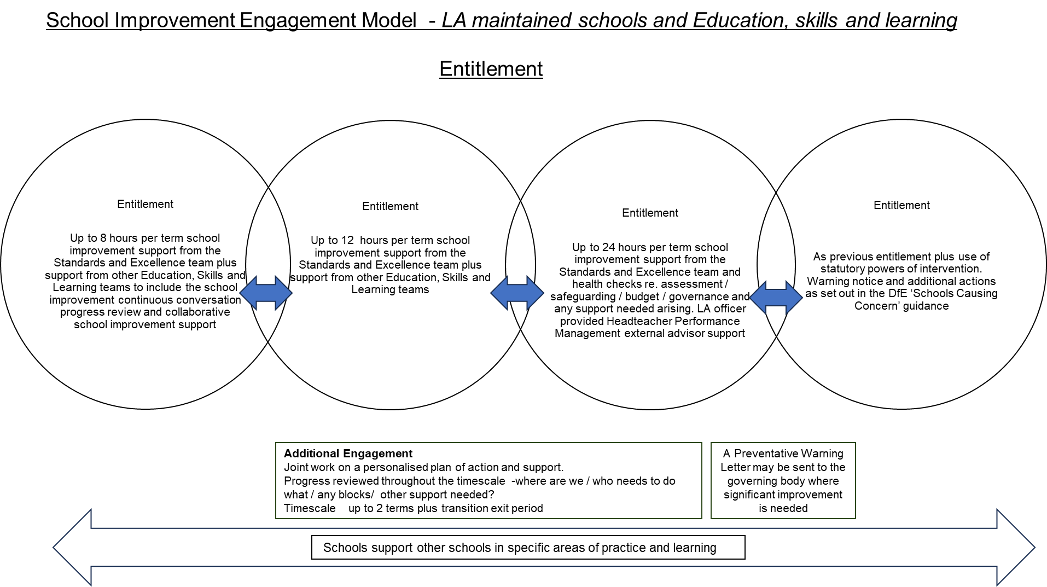

|  |
| --- |
| **The School Improvement Continuous Conversation** |