Apps for tablets

This is a collection of Apps that are visually accessible. Apps are listed in the categories below:
- Animals
- Bubbles
- Communication
- Drawing
- Early Years
- Inclusive Technologies
- Maths
- Sound and Music
- Phonics
- Visual Stimulation
- CVI
- Practical Apps
- Games – VI specific

Or see:
https://www.applevis.com/apps/ios-apps-for-blind-and-vision-impaired
http://www.wonderbaby.org/articles/cvi-educational-tools

Animals

 | Zoo Sounds (Lite) – by Tantrum Apps | Animal sounds with clear images and non-busy backgrounds. Choose two or six images to a page.  Lite version - free
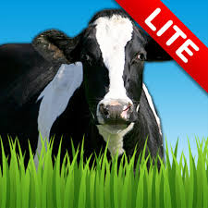 | Farm Sounds (Lite) - by Tantrum Apps | Animal sounds with clear images and non-busy backgrounds. Choose two or six images to a page.  Lite version - free

Bubbles

 | Bubbles – by Hog Bay Software | Create blue bubbles floating on a black background. Make a popping sound when touched.

Communication

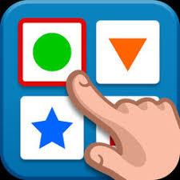 | ChooseIt! Maker 3 – by Inclusive Technology Ltd | Use templates or create your own cause and effect activities, literacy activities, sound loto and matching activities, multiple choice activities, games and quizzes.  Free for the App – need to buy a licence to create your own activities.
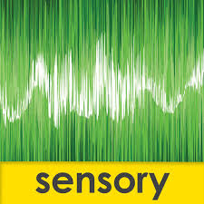 | Sensory Speak Up – Vocalize - By Sensory App House Ltd | A visually stimulating app that responds to sounds. Speak Up can be used to encourage children to vocalize and make sounds. Colours can also be customised.  Free

Drawing

 | glow draw – by Indigo Penguin Limited | Basic drawing app with a black background and lines that glow when drawn.  Free
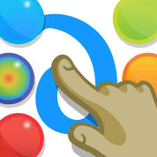 | Finger Paint With Sounds – by Inclusive Technologies Ltd | Finger painting with the option to have sounds effects or music.  Free

Early Years

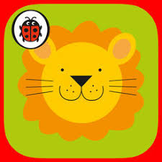 | Happy Babies: Ladybird Baby Touch by Penguin Books | A bright and interactive peekaboo game for babies of six months.
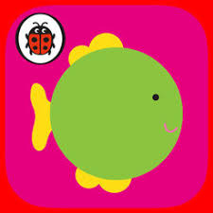 | Peekaboo: Ladybird Baby Touch by Penguin Books | A bright and interactive peekaboo game for babies of six months.
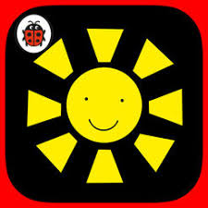 | Ladybird First Focus by Penguin | A high contrast app with yellow, black and white images to engage very young babies.
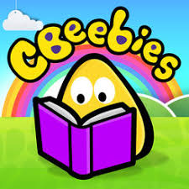 | Storytime from CBeebies by BBC Media Application Technologies Limited | Lots of free storybooks and bedtime stories for young children.  Free
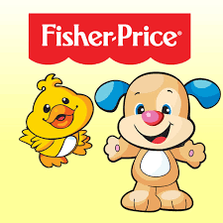 | Fisher-Price | Various free and paid for apps including interactive storybooks.

Inclusive Technologies

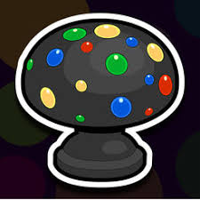 | Inclusive Technologies | Various free and paid for apps which can be used with switches.  Free stories where you need to press to continue the story include: Sensory Room, Carwash, Cash Machine, Pedestrian Crossing, Elevator Up, Television Time, Mobile Cell Phone, Self Service Checkout, Switch Fan, Underground and Vending Machine.

Maths

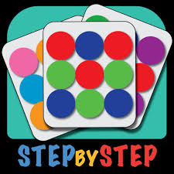 | Mosaics – Arrange colourful pieces to form a mosaic by STEP BY STEP | Arrange colourful pieces to form a mosaic. Mosaics to copy increasing in difficulty.  Free

Sound and Music

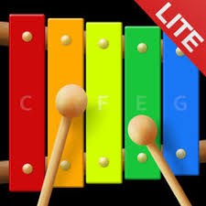 | Awesome Xylophone Lite by THARTS | Virtual Xylophone. Cause and effect, tap to create different notes on the xylophone.  Lite version is free
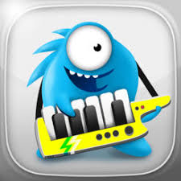 | Jelly Band by Infinite Dreams Inc | Encourages touch and drag skills to create a colourful orchestra of jelly characters. You can choose which characters to add to create your own band.
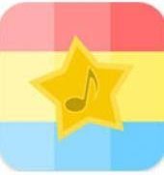 | Baby’s Musical Hands by Streaming Colour Studios | Cause and effect features 15 brightly coloured squares to touch. Red squares make drum sounds, yellow squares piano notes and blue squares guitar notes.
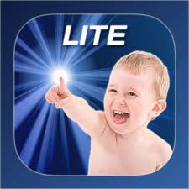 | Sound Touch Lite – Baby Game by Sound Touch Interactive LTD | 6 pages featuring domestic animals, wild animals, birds, vehicles, instruments and household, when image is touched a photo with the correct sound is shown – each item has 6 different sounds and photos  Lite is free
 | ThumbJam by Sonosaurus LLC | 30 high quality musical instruments, includes variety of scales, you can make your own loops.

Phonics

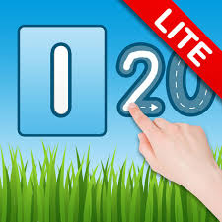 | Number Quiz Lite by Tantrum Apps | Four different games to help with learning numbers. The lite version only goes to number 8.
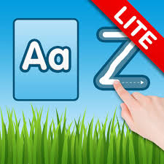 | Letter Quiz Lite by Tantrum Apps | Four different games to help with learning the alphabet. The lite version only goes to letter H.

Visual Stimulation

 | Broom-Broom for iPad by Atech Inc | Draw a line which turns into a road with cars travelling along it. There is also a train version called ‘Let’s play with trains!!’ by Atech Inc  Free
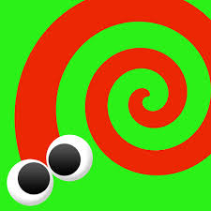 | Touch and Born! Moving paint for iPad – by Atech inc. | Draw a line or dot and it will transform into a moving bug or worm.  Free
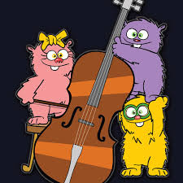 | Peeping Musicians by Inclusive Technology Ltd | Encouraging scanning and using peripheral vision to look for the peeping musicians hidden at the side of the screen. Tap once found and they will play music.
 | Draw with Stars! By L’Escapadou | Let’s you draw with stars.  Free
 | Shhhh! By Inclusive Technology Ltd | Old Wilfred is trying to get some sleep. Touch the door to let in a noisy musician to wake him up! Encourages early touch and targeting skills.
 | Hidden Grid by Inclusive Technology Ltd | Encourages basic touch and drag skills. Drag your finger around the screen to reveal coloured shapes and patterns, with different sound effects.
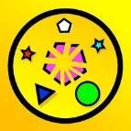 | Pop Shapes by Robert Tempchin | Touch the shapes to pop them and get and animation and sound. Three the same colour in a row changes the background colour.  Free
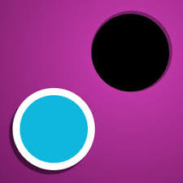 | Dot Collector: Finger Practice by Ellie’s Games, LLC | Collect the dots into a hole. Encourages touch and drag. Lots of customisation possible.
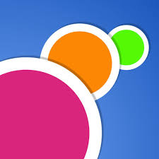 | Colour Dots – Infant Training by Ellie’s Games, LLC | Tap on the colourful dots as they move around the screen. Great for tracking and eye hand co-ordination.  Lots of customisation possible.
 | Sensory Light Box, by Cognable | Uses abstract animation and sound to introduce basic touch skills and awareness.
 | Cause and Effect Sensory Sound Box by Cognable | Sounds change it pitch or intensity as your finger moves around the screen.
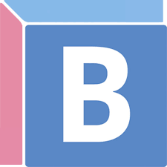 | Baby Shapes by Craig Grummitt | Shapes to track and tap moving around the screen. Different levels to choose from.  Free
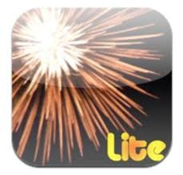 | iLoveFireworks by Fireworks Games | Touch the screen to create firework display.  Lite version is free

Cerebral Visual Impairment (CVI)

 | Big Bang Patterns by Inclusive Technology Ltd | Activities that have been designed for use with children with low vision, including those with CVI and complex needs.
 | EDA PLAY by Rana pece EDA | For the training of vision and fine motor skills. Different images and task levels available.

Practical Apps

 | Be My Eyes – Helping the blind by Be My Eyes | Connects blind and low vision users with sighted volunteers or company representatives who can assist with a range of tasks.  Free
 | BeSpecular – Help The Blind by BeSpecular LTD | The app allows visually impaired users to take a photograph of something which they need more detail about, attach a voice message asking a question, and then send it to a sighted volunteer who is then able to respond to their question via voice message or text message.  Free
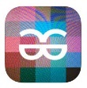 | TapTapSee by Cloudsight, Inc. | Tap anywhere on the screen to take a picture. TapTapSee can photograph two or three dimensional objects and speak the identification back to the user.  Free
 | Seeing AI by Microsoft Corporation | Free app that narrates the world around you. Works with VoiceOver. Enables you to read short text, documents, products by barcode, people, scenes, currency, colours, handwriting and more.  Free
 | Envision AI by Envision Technologies B.V. | App to describe the world around you. The app uses AI to read text, documents and handwriting, describe scenes, scan and find objects it has been taught, detect colour and scan barcodes.  14-day free trial then subscription based.
 | Microsoft Soundscape | Used 3D technology to enhance your awareness of what is around you.  Free
 | Wayfinder app by Transfinder | Navigation app.  Free
 | Dolphin EasyReader by Dolphin Computer Access Ltd | Accessible reading app. Books can be read aloud, text size and colour altered. Works with RNIB BookShare.  Free
 | Voice Dream Reader by Voice Dream LLC | Text to speech app
 | Prizmo Go - Instant Text OCR by Creaceed SPRL | Take a photo of text and it can be read aloud. Built to work with VoiceOver and gives spoken guidance prior to shooting.  Free, but to be able to export text copied the full version is needed.
 | Specific VI reading apps | MD evReader by Macular Society  Spotlight Text by Focus Reading Technology, Inc
 | Make It Big by An Trinh | Displays whatever you type BIG to fill the whole screen. Could be used instead of mini whiteboard. Can change font and background colour.  Free
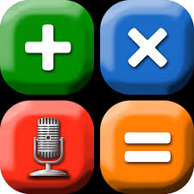 | Talking Scientific Calculator by Adam Croser | Talking calculator that works with VoiceOver. A statistics version is also available.  Currently £4.99

Games – VI Specific
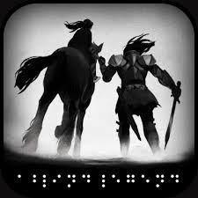 | A Blind Legend by DOWINO | Audio game fully accessible to blind and visually impaired people. 12+  Free
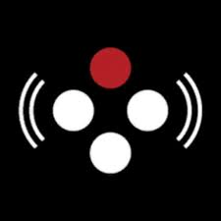 | Audio Game Hub by Sonnar | A set of experimental arcade audio games that use audio as their primary interface. Accessible for both sighted and non-sighted users.  Free

