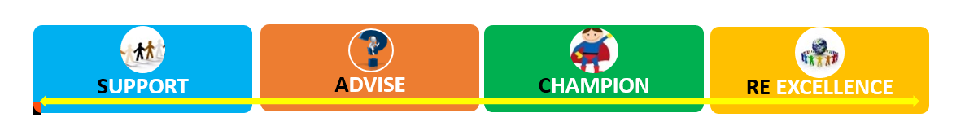
This is a free award offered by Suffolk SACRE* for schools committed to ensuring their RE provision is broad and inclusive.

To achieve the award you must complete the 4 activities within an academic year:
- Attend an RE conference / RE course / RE Network
- Take pupils to a Christian church or community and meet members of the Christian community who worship there.
- Take pupils (or staff) to visit a place of worship of another faith and meet at least one community member.
Or organise a faith visitor to school.
- Arrange an RE event in school, or locally, or a community event, which celebrates aspects of more than one faith, or focuses on a worldview not held by most of the school.
Or enter an RE competition (e.g. ‘Spirited Arts’ or ‘Spirited Poetry’)

You can apply as a school or an individual class. Explanation of the criteria follow along with the application form. Remember we are looking for evidence not essays.
Explanation of criteria for the WIRE Award
- Attend an RE conference / RE course / RE Network  Evidence required is detailed here in red.  NB: ‘evidence not essays’. | This could be a locally run RE course run, or a national one run by Culham St Gabriel or by NATRE. It should not be your own staff meeting but an RE network meeting where several schools meet to share RE ideas and news or work on a project, would be ideal.  Virtual training, where some interactive participation is part of the event is acceptable e.g. RE network meeting, training on the Agreed Syllabus, or a big online conference e.g. RE Today’s ‘Strictly RE’ conferences.  Write 2 or 3 sentences explaining what you did and its benefits.
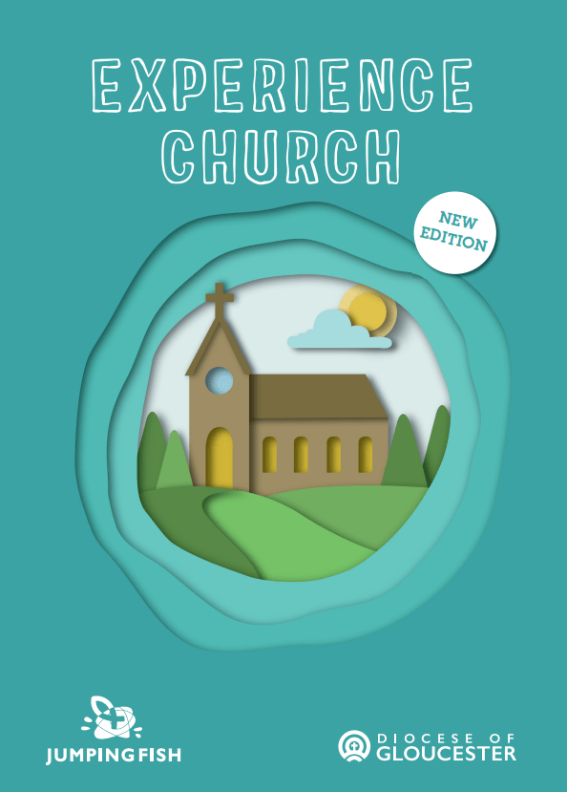  - Take pupils to visit a Christian place of worship and meet members of the Christian community who worship there | This visit could be to a local parish church or chapel but a visit to name parts of the church, or hunt for historical items, is not sufficient, neither is a visit simply for a service e.g. Harvest or Christmas Carols.  The visit must relate to pupils’ current work in RE i.e. involve engagement with the key beliefs and practices of Christians. It must include discussion / Q and A with a member of the community.  A virtual visit to a Christian community at some distance from the school is acceptable but must also include discussion as above.  ‘Experience Church’ (or others in this series) will count where presented by local Christians as it involves discussion of beliefs. https://jumpingfishpublications.co.uk/product/experiencechurch/  Write 2 or 3 sentences which give the context of the visit and how it connected to the pupils’ work in RE. Provide some photographic evidence or a child’s work / thank you letter.
- Take pupils (or staff) to visit a place of worship of another faith and meet at least one community member  OR Arrange for pupils (or staff) to welcome someone of a non-Christian faith to school to enrich a series of lessons on that faith | This visit could involve a small group of pupils who can report back, a whole class, or a staff party. A virtual visit is acceptable.  Both must include conversation between community members and pupils / staff / or the answering of pre-sent questions by a member of the community.  Or  Arrange a non-Christian faith visitor to class (or set up a video call) to enrich learning in an RE unit of work. Pupils should share their learning so far with the visitor and ask questions which take their learning further. A ’flying’ visit with no preparation or follow-up will not count, nor will a general presentation on a religion / worldview with no specific relevance to the pupils’ current RE enquiry.  It would be acceptable for a visitor to come and talk to staff about questions they need to answer in their enquiries with pupils.  Write 2 or 3 sentences to confirm what was planned and how it went, including a specific connection the visit / visitor made with what was being taught in RE. If the visit / visitor is recorded on the school website, a link would be welcome.
- Arrange an RE event in school, or locally, which includes aspects of more than one faith, or focuses on a religion or worldview not held by most of the school  OR Enter an RE competition e.g. ‘Spirited Arts’ or ‘Spirited Poetry’. | This may be a World Religion Day, an Arts and RE Week, a significant display of RE work, or presentation by children of their RE work to parents or community members.  Provide a short report of the event, preferably written by pupils or recorded in pictures, a scrapbook or as a video. A link to a report on the school website would be acceptable.  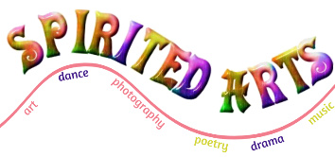  The National Association of Teachers of RE runs an annual ‘Spirited Arts’ competition which results in beautiful galleries on their website. There is also a poetry competition. Schools could choose one of the themes, work it into their RE scheme, produce art for an in-school competition and enter winners for the national one. The competition closes at the end of each July!  Go to: www.natre.org.uk  Alternatively, schools can hold their own RE competition. This should draw on more than one religion / worldview.  Record event / results on school website, social media or in the local press. Write a sentence or two to explain what you did, including the link to your RE programme. If possible, link us to the winners’ work and to children’s comments on their entries.
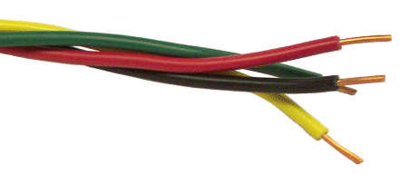
WIRE Award – Application Form

This application is for the academic year: 20____ to 20 _____
Is the application for a class or a school? _________________
Name and full postal address of school
Name / role of staff member applying
School e-mail

Element | Evidence required
- Attend an RE conference / RE course / RE Network | Title / date of the training attended:  Write 2 or 3 sentences explaining what you did and its benefits.
- Take pupils to visit a Christian place of worship and meet members of the Christian community who worship there | Name of place of worship:  Date of visit:  Year group:  Write 2 or 3 sentences which give the context of the visit and how it connected to the pupils’ work in RE. Provide some photographic evidence or a child’s work / thank you letter.
- Take pupils (or staff) to visit a place of worship of another faith and meet at least one community member  OR Arrange for pupils (or staff) to welcome someone of a non-Christian faith to school to enrich a series of lessons on that faith | Name of place of worship / visitor:  Date of visit:  Year group (of children or teacher)  Write 2 or 3 sentences to confirm what was planned and how it went, including a specific connection the visit / visitor made with what was being taught in RE. If the visit / visitor is recorded on the school website, a link would be welcome.
- Arrange an RE event in school, or locally, which includes aspects of more than one faith, or focuses on a religion or worldview not held by most of the school  OR Enter an RE competition e.g. ‘Spirited Arts’ or ‘Spirited Poetry’.  For an RE event, please feel free to invite a SACRE member or school governor and invite them to write a report for you to submit as alternative evidence. | Title / nature of the RE event:  Involving which year group:  Provide a short report of the event, preferably written by pupils or recorded in pictures, a scrapbook or as a video. A link to a report on the school website would be acceptable.  OR  Title / nature of RE competition  Involving which year group:  Record event / results on school website, social media or in the local press. Write a sentence or two to explain what you did, including the link to your RE programme. If possible, link us to the winners’ work and to children’s comments on their entries.
Please send your completed application to the SACRE Clerk: Linden.Pitcher@suffolk.gov.uk
Submissions will be seen at the next termly SACRE meeting. Your certificate will be e-mailed to you, or, if preferred, a SACRE member may present it in school.
I agree that this application for a WIRE award is accurate and representative of our commitment to widening inclusivity in RE.
Headteacher’s signature
Date

