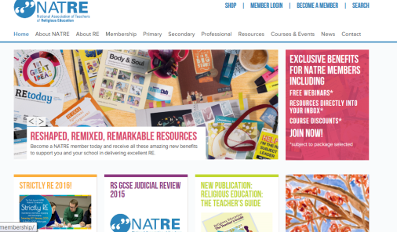
Resources for RE Teachers
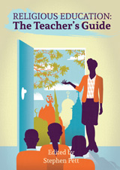
- NATRE – for all teachers of RE / Lots of links, video examples of good teaching, support materials, links to twitter feed and online chats re RE issues http://www.natre.org.uk/
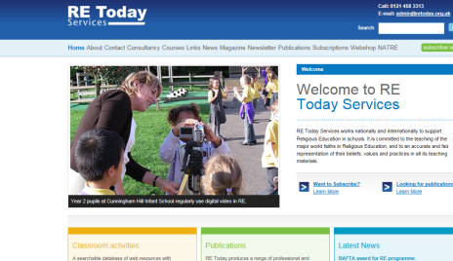
- RE Today Services – largest UK provider of RE teaching resources / Teaching booklets on RE themes and different faiths and a good basic guide to RE for teachers. Termly magazine, annual Spirited Arts competition with galleries of pupils’ previous work, access to ‘mail-a-believer’, conferences etc. http://www.retoday.org.uk/
- RE teaching Resources – an offshoot site of RE Today services and NATRE with easier access to the resources. Membership offered. https://reteachingresources.co.uk/
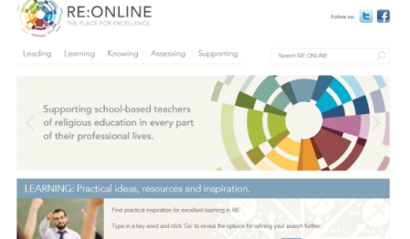
- RE online – working for excellence in RE / Huge amounts of background material on different religions, different pedagogies, resources for children. Access to further training on-line. http://www.reonline.org.uk/

- REquest - supporting excellence in Christianity in RE / Specifically Christian resources for all key stages – video, interview and other background material. Very useful. http://request.org.uk/
- Hope Education - large range of school RE resources - everything from engaging activity packs and games to illustrated books and colourful displays plus posters and artefact packs. https://www.hope-education.co.uk/
- TTS Religion in Evidence – a major supplier of artefacts / Large range of artefacts with emphasis on some storytelling materials and collections of artefacts belonging to a child of the faith. https://www.tts-group.co.uk/primary/re/religious-artefact-collections
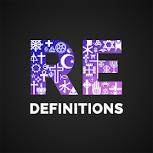
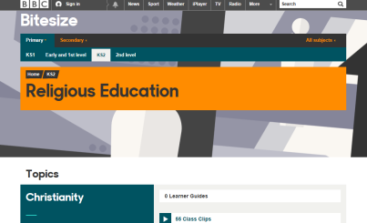
- BBC bitesize clips for RE – always useful for lessons / Some very short clips – many only a minute or so to illustrate religious customs, practices and offer interviews with children of a faith. http://www.bbc.co.uk/education/subjects/
- RE-Definitions – free app giving access to accurate, clear, resource-linked pronunciation and definition of 200+ key terms in seven religions and worldviews, and in the study of ethics and philosophy. Audio and Text. http://re-definitions.org.uk

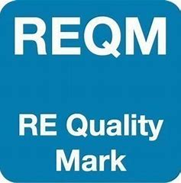

Recognising outstanding learning in religious education / REQM is a great resource for training staff and encouraging great RE in schools of all kinds. You can freely download useful self-assessment tools and pupil perception materials. If you wish to enter for the gold, silver or bronze awards, you pay for an assessor. This is a national recognised award for RE. http://www.reqm.org

