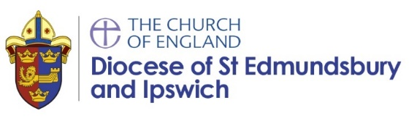
SACRE Report from Diocesan Schools Adviser June 2023
Update
- 57 community primary schools attended syllabus training.
- 5 of these schools have purchased the Emmanuel Project as a result.
- This includes 2 LA schools. One had recently moved from Discovery RE to Cornerstones and is now making another adjustment.
- Part of the syllabus training includes an interactive quiz on the law. The results of this showed little difference in knowledge between CE subject leads and community school leads.
- I have continued to deal with a large number of enquiries from small schools about how to ensure their curriculum is compliant with the changes.
- The two new Emmanuel Project units are complete. I have also written some guidance on two additional units to avoid repetition as units have moved from Year 1 to Year 2.
- The live syllabus staff meeting was attended by 20 schools live. The recording uploaded and shared with schools has been viewed 87 times.
- Yesterday I began the optional networks for teachers by phase. The EYFS network was attended by 15 teachers.
- Martin and I met with secondary RE teachers to discuss KS3 resources. I aim to organise a network termly. I have sent a generic email to all secondary schools in the county asking to forward to their RE department. This included details of the networks and to respond if they would like further details. So far I have only received a reply from Ormiston Denes Academy in Lowestoft.

