Turning on spell check when using Chrome
As the EHC Portal is web based, you can utilise spell check built into your web browser when completing portal forms.
To turn on spell check for Chrome, navigate to your browser settings:
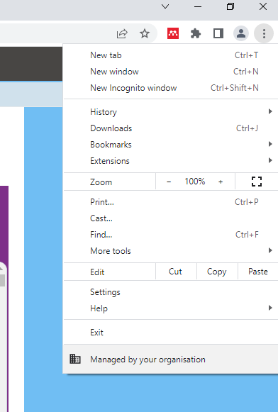

The Chrome settings page will open. Select the ‘Languages’ tab to view you spell check settings.
Ensure that ‘Check for spelling errors when you type text on web pages’ is enabled:
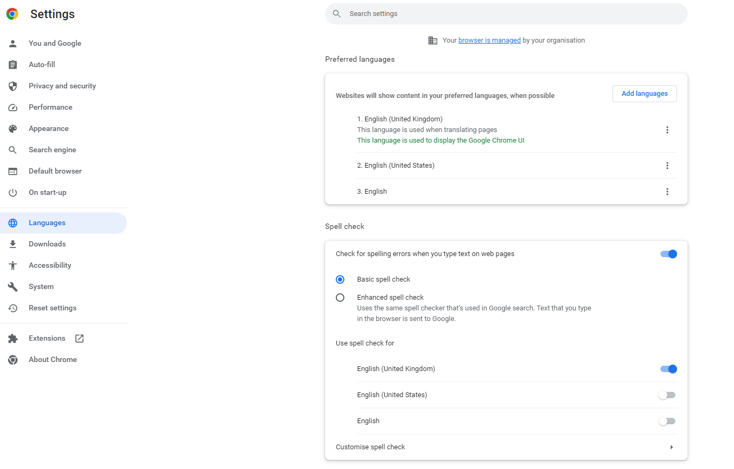
Spelling errors will show with a red underline when typing in a portal form text field:
