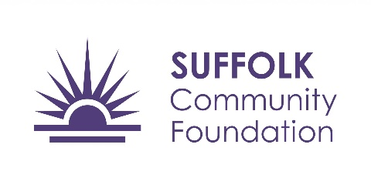

Who we are
St Giles Trust have been running as a charity for 60 years, working with a quarter of a million children, young people and adults to live safe, and positive lives. We specialise in uniquely employing, developing and professionalising incredibly passionate and dedicated people with first hand experiences of the issues the clients we work with face, and this is what makes the support we provide so effective to our clients. The mission of SOS+ is to prevent children and young people becoming involved in gangs and youth violence by equipping them with tools, knowledge and support delivered by experts with lived experience
What we can offer
Our aim is to reach 30 schools in the remaining academic year with assemblies/sessions raising awareness about gangs, exploitation and serious violence.
We can offer your school one fully-funded day consisting of up to a maximum of three sessions/assemblies exploring the risks associated with County Lines.
You will also benefit from our Enhanced Presence - our facilitators will be available during the day/in between sessions for students to speak one on one with our experienced facilitators.
Other important information
As a condition of this funding we are required to collect certain information from schools including information on the students attending the sessions and feedback from students and staff. More information on this will be provided to you when booking your sessions.
When are these available?
We will be able to deliver these between January 2023 and June 2023
Contact us to book your session: sosplussuffolk@stgilestrust.org.uk

