The Schools RSHE Portal
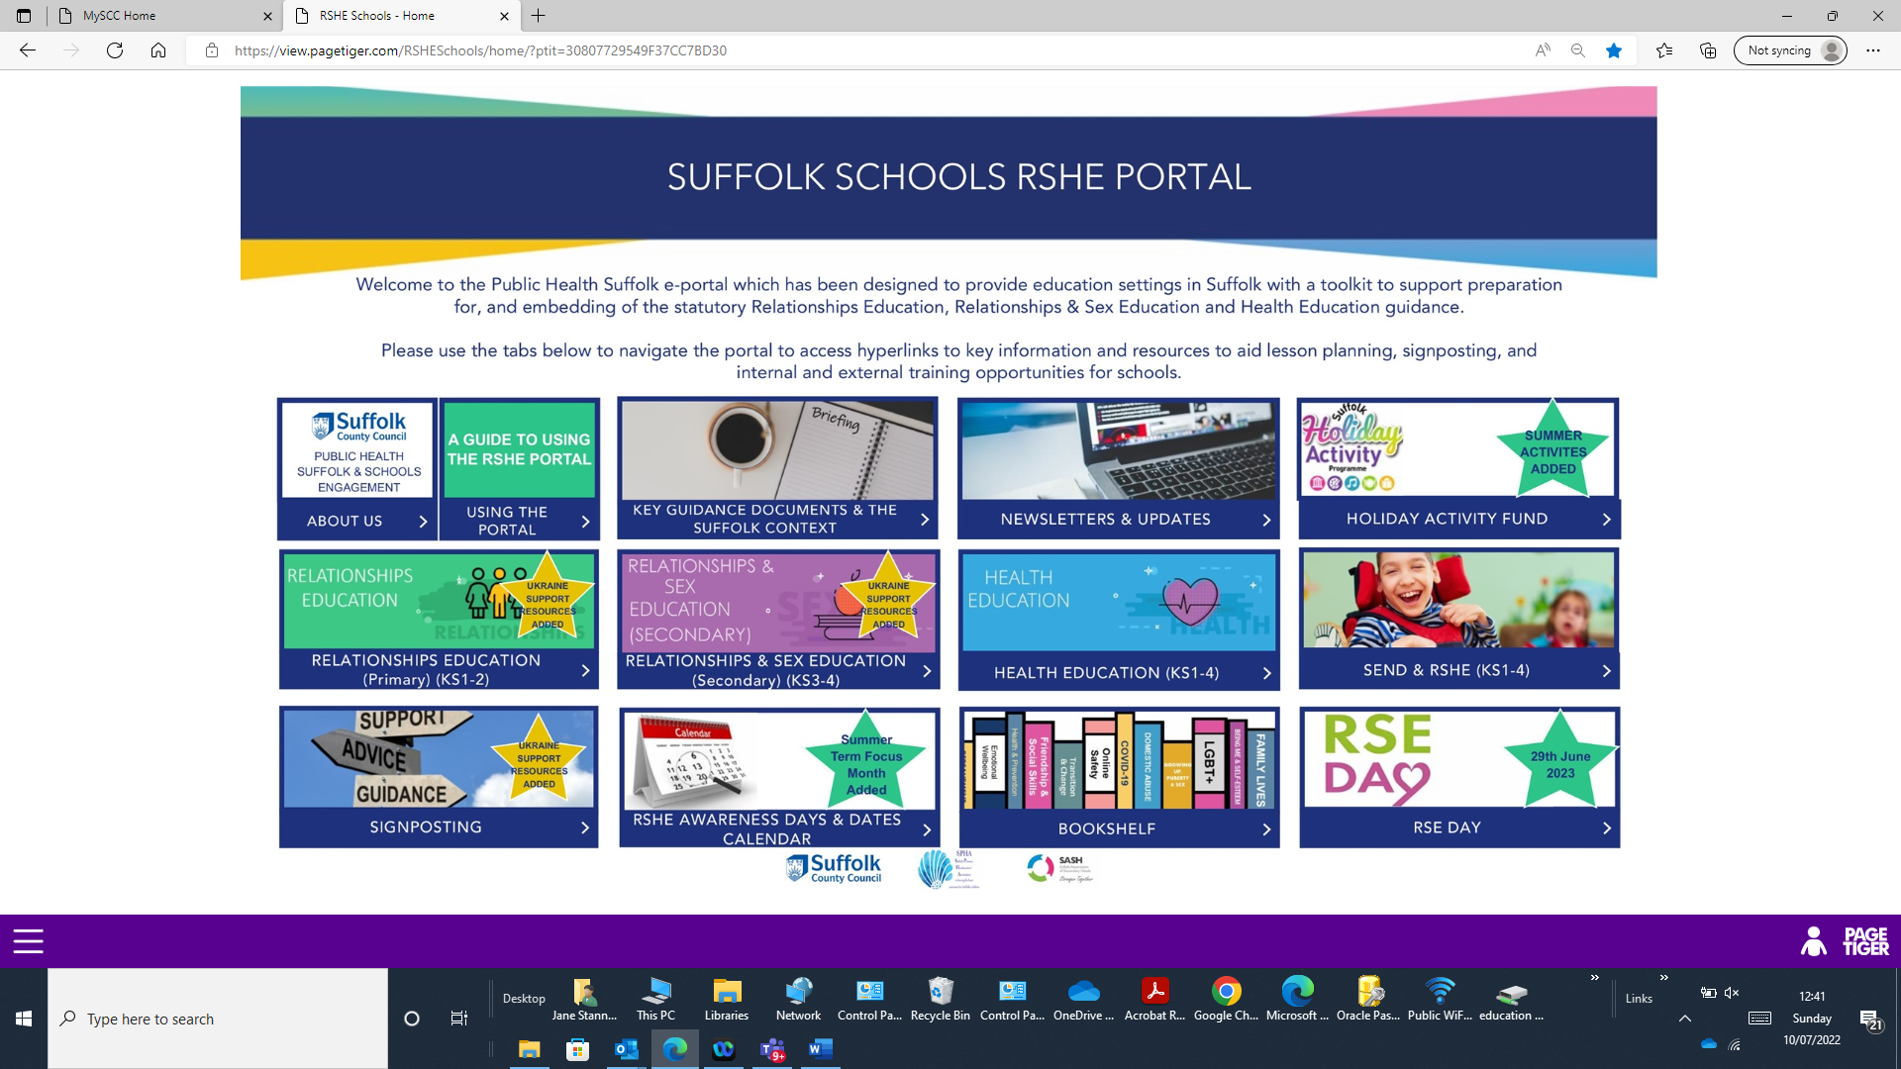
What is it?
The Schools RSHE Portal is a FREE hub provided by Public Health & Communities (part of Suffolk County Council) available to ALL Suffolk schools. The Portal is a centralised pool of resources, holding key information and documents to support schools with preparing for, and embedding statutory RSHE, assisting with understanding the legislation and how it impacts schools, and, on a practical level, supporting schools with their curriculum and lesson planning, as well as the wider support of pupils. The Portal is not a set piece and as such, is a constantly evolving hub which is regularly updated to keep content current and has been described by one school as “a really well organised Google search”. The portal was launched to the Early Adopter Schools in May 2020, then rolled out to all schools across Suffolk in June 2020. At the start of each academic year, the Schools Engagement Manager contacts the RSHE/PSHE network across Suffolk schools to capture any new starters or changes of role to keep the network as current as possible.

Why is it in place?
Public Health & Communities vision was to set the RSHE Portal up to support schools during their preparation for statutory RSHE and then to be used as an ongoing tool, embedding the guidance, and teaching from the point at which the statutory guidance went live in September 2020. Not every setting is able to fund a scheme of work, so the vision with the Portal was not only to support schools in this position, but also to act as another toolkit in the armoury of all schools in Suffolk, which can be used alongside any existing schemes of work or your own bespoke plans. It is worth noting that whilst you may have invested in schemes of work, their resources may not always work for every cohort, and if schools need alternative resources, the Portal is at your disposal for this reason too.

Who is it for?
Ninety-nine percent of Suffolk schools have access to the Portal, often with multiple users in each setting (there are currently approx. 2000 users across the county). The Portal is designed to be used as a professional resource and is not accessible to pupils, parents/carers or the wider public. Whilst it was set up with RSHE/PSHE Leads in mind as the main users, this resource has wider application to staff in education settings, including (although not limited to):
- Senior Leadership Teams
- Anyone teaching RSHE/PSHE or any of the elements of it
- Linked subject teaching like Science, PE, IT etc
- Designated Safeguarding Leads
- Pastoral Support Teams
- Domestic Abuse Champions/Leads
- Online Safety Leads
- Mental Health First Aiders/ Champions
- Chair of Governors and any Governor with responsibility for RSHE
- Anyone else in your setting who you feel may benefit from access

When would I use it?
The Portal can be used for many aspects of statutory RSHE planning. Whilst it was set up with lesson planning and the key guidance being the primary focus, the Portal also contains a range of resources that would also be useful for planning assemblies, marking key awareness days/dates, getting involved in local and national initiatives to support RSHE and signposting pupils and/or their families to relevant services and resources, including the DfE funded Holiday Activity Fund. The information and materials contained on the RSHE Portal are provided in good faith and do not constitute any endorsements. Schools are advised to make their own individual decisions about the suitability of resources for use within their settings.

Where do I find it?
The Portal is not publicly searchable on the world wide web, and as such, those wanting to access it would need to request access from the Schools Engagement Manager who will then send a link to access the Portal.

How do I access it?
To gain access to the portal, schools will need to contact the Schools Engagement Manager, Jane Stannard at jane.stannard@suffolk.gov.uk and request access providing the name, job role and school email for each member of staff requiring access. Whole school logins are not available, and each individual user will need their own login. A school email will be required for access as personal emails cannot be used. It is politely requested that users do not allow their login to be used by others and that the link is not shared (it will not work unless the Schools Engagement Manager has registered individuals as users first). When providing emails for new registrations it is politely requested that emails are checked thoroughly for the correct spelling of names and that there are no typing errors to prevent inaccuracies being passed on and delaying Portal access. If school email formats change, please also remember to advise the Schools Engagement Manager who can get logins changed and ensure continuity of access (although your email systems may convert old to new emails, the Portal will not recognise an unregistered email address).

What happens next?
A login run is made once a week, usually late on Fridays or early the following week and any new logins are added to the system. As soon as the Schools Engagement Manager has been advised the logins have been set up, she will email all new users. This email will contain the details of how to register as either a first-time user or if your email address has changed since first registering.

Testimonials:
“I, as many people in education, do not have time to trawl through umpteen online resources and I am often sceptical about whether something will be practical or useful in practice, or worth the time spent on trying to use it. I was incredibly surprised by the wealth of resources, guidance, links and help there was in one place within the portal. The portal will indeed help us to not have tunnel vision with our current PSHE scheme, using the additional resources and ideas to enliven the learning. The sections given are logical, navigable and useful: the Ofsted section with everything SLT would need to know for PSHE and RSE (both schools are due), the safeguarding section which lists and hyperlinks the organisations' support that we can access (many sources of support that I was not aware of before) and the mental health section in particular, I can see will also be beneficial to support staff and our families. Along with the theory, policies and protocol information, I found very practical resources in supporting schools and I am looking forward to dipping into this frequently. I would recommend looking into this, you will not be wasting your stretched and valuable time.”
“We haven't used the portal in school before as we get most, if not all, of our PSHE resources from One Decision (our chosen scheme) but there are so many useful things we've been missing out on!”
“I have previously explored the portal and honestly find it one of the best resources I have come across - it is easily accessible and well laid out.”
“The portal has proved invaluable to launching our new RSHE Programme. Offering current resources and links, it is easy to navigate and user friendly. Having access to the portal allows our staff to plan using up to date material and keep lessons fresh and interesting.”

“We are loving the portal and have made great use of it - in school and online lessons, Awareness Day activities, courses. I have been recommending it all over the place!!!”

“It’s brilliant – easy to navigate and find things, plenty of useful resources and I love the newsletters. It’s so comprehensive.”

“What you have created is simply amazing! I can’t tell you what a support this will be in allowing us to full implement the new statutory, but moving forward, allowing us to also keep up to date and deliver the very best education we can.”
“I have enjoyed exploring the RSHE Portal and the wealth of information all brought together within one easy to access portal! I was teaching Year 6 in the autumn term of this academic year and would have found this invaluable when teaching health and relationships units as part of PSHE. I have used many of the links in the past and it is so good for colleagues to have a description of the link to help them navigate more easily. The clear navigation to primary/secondary is useful and especially useful for Y6/7 teachers who can see the progression of areas where relevant. The news section is excellent and the importance of bringing the curriculum area ‘to life’, I see real value in sharing these (age-appropriately) with the children as part of RSHE lessons.”

“Thank you for this resource. A great way to quickly access the raft of stuff out there!”
“We are really enjoying developing our PSHE/RSE and are getting to a place where we feel really proud of our offer - much of that is down to your support and the great portal so thank you VERY much.”
“I just wanted to say a big thanks for your efforts and in particular, the PSHE Portal. We have attended your training on it and use it frequently to support our teaching. The range of resources, reassurance, and inspiration that it gives us is invaluable.”
“You have put so much work and effort into it. It is a wonderful resource!”
“PHSE is one of the most important topics that we cover and given a high profile. The skills it covers are vital for our vulnerable pupils and thus the Suffolk RSHE portal has been invaluable. It is up to date, materials cover every subject and regular updates mean we can stay on top of the latest ideas and directions and our teaching stays fresh. It simply saves us a great deal of time.”
“I do signpost staff to the portal because it is so useful. I plan my assemblies using some of the resources and links. I find it a really valuable resource- thank you!”
“I found all the things you showed me on the portal extremely useful and easy to navigate. You have put so much into it and should be justly proud.”
“Just wanted to say a huge thank-you. Just after spending five minutes after you left having a quick navigate, I can already see how hugely useful this portal is going to be.”
“I have accessed the portal and am finding it both interesting and helpful.”
“We have been using the Jigsaw programme this year and so our focus is getting to grips with that. The portal is great though and looks like I'll be able to find any extra support/info/resources on there.”

“Regarding the Portal, I haven't attended any of the training as I feel comfortable using it and finding my way round it. This is all credit to you for making it so user friendly. When it was first opened I spent time navigating my way round it to see what was on there and where, which I have found has helped me in the long run when I need to refer to it.”

