SCHOOL NAME

ONLINE BANKING POLICY

Date first written:
Last review date:
Last reviewed by:
Next planned review date:
Chair of Governors name:
Headteachers name:
Date minutes referenced:
Names of Staff with Access | Access Granted From

Overview:

Commercial Banking Online will allow the schools’ designated persons to access the school’s Online account, enabling them to run and print statements on an ad-hoc basis, thereby the school will be able to present an accurate and an up-to-date position to the finance and leadership teams, governors and the local authority as and when required.

Within this document we, (School Name) have outlined some guidelines which individuals must follow and adhere to when acting as a ‘Reviewer’ on the school’s behalf within the schools Commercial Banking Online Bank Account.

Each of those individuals listed with online viewing access ‘Reviewers’ must complete the appropriate sections identified throughout this document. This will act as confirmation that they are fully aware of their individual and school related responsibilities.

Although we have laid down some guidelines within this document, individuals must also be aware when agreeing to this policy, that it is also in conjunction with any other schools purchasing policy documents previously agreed by Governors and may link other areas including the current Record of Financial Responsibility (RoFR) which will need to reflect the Governors decisions and any delegation arrangements which have been agreed. This policy and annexes must be consistent with the current RoFR

- Schools Online Banking Authorisation Guidance

    - Authorisation to access and use the Online banking system can be delegated to the Headteacher/Business Manager when agreed by Governors with the new delegation arrangements being noted in the meeting minutes

    - Governors will be informed of any additional/new Reviewers’ granted access to the school’s Online account

    - The schools Online bank account must only be accessed by those with designated permissions as previously agreed by Governors and/or the Headteacher as per the reviewer list

    - Where the approval responsibility is agreed Governors must still be notified of any changes

    - It is assumed the reviewer list would be made up of no more than 3 members of staff, and ordinarily from either the leadership or finance teams

    - Governors were informed in the first instance when the school was granted access to Online banking, and will be notified of any subsequent changes in functionality in a timely manner

- Designate Responsibilities

Note: Within this section we will attempt to outline some of the individual designates responsibilities when acting on behalf of the school, however, this list is not exhaustive and may be subject to change locally with agreement from Headteacher/Governors

    - Each individual who is set up to access the online accounts must sign and date a copy of the school’s Online Banking Policy document

    - Individuals must securely retain a copy of their completed Online Banking Policy document, including a copy of the Commercial Banking Online Banking Declaration form – Appendix A attached. The original documentation and declarations must be kept securely in the school office and thereby available if subject to audit or statutory monitoring at a later date

    - Individual login details must not be written down, or shared with other individuals under any circumstances

    - Each individual is responsible for ensuring the security of their account login details and must take all reasonable precautions to prevent misuse including the following:-

      - Account holders must not allow others to use their login details

      - Never write their login details down

      - Always ensure their PC screen is locked if logged in and leaving their working environment/desk

    - All existing financial procedures must be adhered to as appropriate

      - Notify the Headteacher/Business Manager/Account Administrator where any identified improvements to the schools Online security or existing financial procedures can be made

      - Individuals would be expected to report any suspected breaches in security as per the school’s existing financial regulations

- Security

    - Appendix A - Commercial Banking Online Banking Designate Declaration must be completed by individuals, and agreed prior to access details being granted to individuals, and only those staff members directly employed by the school are permitted to be granted access

    - Only the Governing body can designate the Headteacher to be responsible for the establishment and maintenance of all secure central records in relation to the school’s online bank account

    - Access will not be issued to, or online account be used by, any member of staff who has not signed a copy of this policy document and had access rights agreed

    - Where a breach of security may be suspected, individuals must report this to the Headteacher/Chair of Governors in accordance with the school’s ICT, Disciplinary and other relevant Policies held in school

- Change of Access/Permissions/Nominated Staff

    - If leaving the employment of XXXXXXXXXXXXXXXXXXX School, individual’s accounts must be cancelled

    - It is the responsibility of the account administrator to ensure Appendix B be completed for all leavers, with the full cancellation process completed as indicated with in the Commercial Banking Online Banking Designate - Cancellation Declaration form below

    - Appendix B must be completed as soon as it is known that an individual is leaving or changing roles and in advance of their leave date, with their access rights amended and deleted as appropriate

    - Where it is the account administrator that is leaving or changing roles, Appendix B must again be completed, with Lloyds also being informed by following the link and guidance within the Commercial Banking Online Banking Designate - Cancellation Declaration form below

    - Where a new account administrator is required, a new application to Lloyds will be required, plus a revisit to the schools banking policy ensuring it fully reflects changes agreed by Headteacher/Governors

- Accessing Statement Information and Reconciling Your Accounts

    - All relevant printed documentation/statements must be retained if used to reconcile the schools bank account. This is in line with the monthly Lloyds printed bank statements issued at the end of each month, with all to be retained for the standard 6 years plus current

    - The online printed statements if being used to reconcile FMS and bank must be entered on FMS within 5 days of printing

- Forgotten Password/Access

    - Inform the Headteacher as soon as you suspect your account login has been inappropriately accessed, ensuring new passwords are issued for all users

    - When an account administrator leaves, it is recommended that all individuals passwords are changed

    - Where a password is forgotten, individual users should be able to reset these themselves via the main login page and following on screen instructions

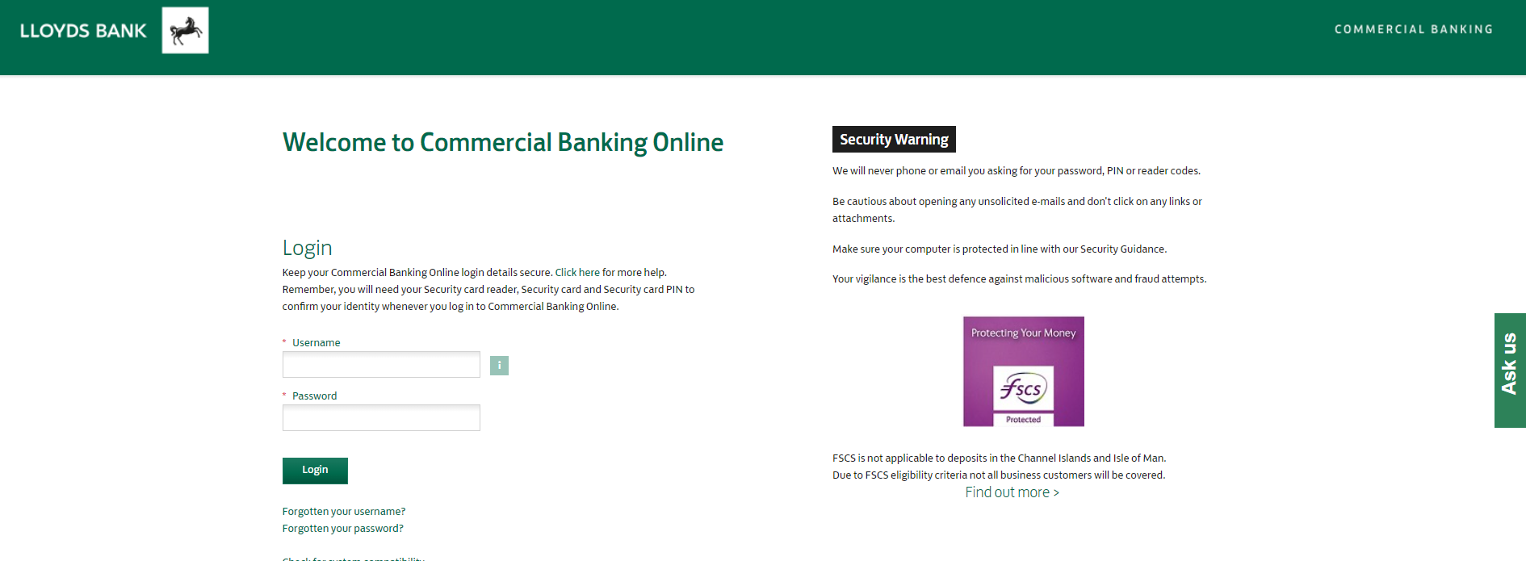

- Monitoring by the Local Authority

The Local Authority reserves the right to contact the Headteacher and/or the schools online account administrator to maintain an independent record of the processes and policies maintained in school and to ensure a secure process is in place

Agreed Online Banking Designate Signatures/Approval

I have read and understood the Online Banking Policy document, and can confirm that I
will adhere to the guidance in the use of the schools Commercial Banking Online Banking account

Designate Signature

Job Role ……………………………. Online Role – Administrator? Yes / No

Print Name…………………………………………………..Date…………………….

Headteacher / Chair of Governors Signature ……………………………………….

Print Name…………………………………………………..Date…………………….

I have read and understood the Online Banking Policy document, and can confirm that I
will adhere to the guidance in the use of the schools Commercial Banking Online Banking account

Designate Signature

Job Role ……………………………. Online Role – Administrator? Yes / No

Print Name…………………………………………………..Date…………………….

Headteacher / Chair of Governors Signature ……………………………………….

Print Name…………………………………………………..Date…………………….

I have read and understood the Online Banking Policy document, and can confirm that I
will adhere to the guidance in the use of the schools Commercial Banking Online Banking account

Designate Signature

Job Role ……………………………. Online Role – Administrator? Yes / No

Print Name…………………………………………………..Date…………………….

Headteacher / Chair of Governors Signature ……………………………………….

Print Name…………………………………………………..Date…………………….

APPENDIX A
Establishment: School Name

Commercial Banking Online Banking Declaration

Surname:
First Name(s):
Post:
Department:
Office Location:
Work Telephone Number:
Work e-mail Contact:

I declare that:

- I have received my Commercial Banking Online Login details, and will not retain a written copy;

- I have read the guidance throughout this document and agree to comply with its requirements;

- I accept responsibility for the security, safe-keeping and confidentiality of the schools Online account details;

- I will use the Commercial Banking Online system solely on behalf of - School Name;

- If I leave the school, I agree to complete the Leavers Declaration form;

This Online Banking Declaration and Policy document will be applied in accordance with the school’s ICT, Disciplinary and other relevant Policies held in school

Designates are advised to regularly read and refresh themselves of the above guidance.

Signed:
Dated:

APPENDIX B
Establishment: School Name

Commercial Banking Online Banking - Cancellation Declaration

Surname:
First Name(s):
Post:
Department:
Office Location:
Personal Telephone Number:
Private e-mail Contact:
Effective Leave date

I declare that I no longer require access to the schools Commercial Banking Online Banking Account granted to me as above because; (* - Please indicate reason):

- I am changing job and my responsibilities in school;*
- I am leaving the schools employment;*
- Other (please specify)* -------------------------------------------------------------------------------------

Signed (Designate):
Dated:
Signed (Designates Manager):
Print Name:
Dated:
** Lloyds notified by:
** Date Lloyds Aware:

Once completed and signed please return this document to Schools Accountancy team sat@suffolk.gov.uk whom will process the cancellation.

