I am writing to you all to introduce our plans for National Hate Crime Awareness Week (NHCAW) 8th October to 15th October. We understand during these times we may not be able to come and meet you within your school settings, but we are still very keen to keep in touch with you all.
The week of action sees the Police continuing its work with Community Safety Partnerships in Suffolk, Norfolk and Suffolk Victim Care, Suffolk County Council and Crimestoppers.
Officers will be involved in a range of activities across the county, visiting schools and markets to further raise awareness and encourage reporting of hate crime.
The tag #NoHateInSuffolk will spearhead the digital messaging. You can follow the campaign on social media/Twitter where we would love to see what you have been up too, so please do post your events, activities or pictures.
Your School Liaison Officers (SLO’s) have our “One Cop Stop” presentations on hate crime awareness and some inputs have already been arranged. The team can also provide Hate Crime Awareness leaflets and PDF versions are attached to this letter.
Later in the week the force and our partners, will also be launching the third annual HOPE Awards to celebrate the positive contributions that young people make within the county. The winners of Hope Awards 2021-22 will be receiving their awards during HCAW, which the SLO’s will be involved with across the county, and those winners will be announced on Monday 17th October.
The team will also be launching a new student safety survey in the coming weeks, and we need your help. Your SLO’s will be reaching out to you so they can arrange appropriate engagements to carry out the surveys with a good cross section of your students. The results of these surveys will be crucial in reviewing and setting priorities, support and services for our young people, in partnership with Suffolk County Council, to help them feel safe and address emerging issus.
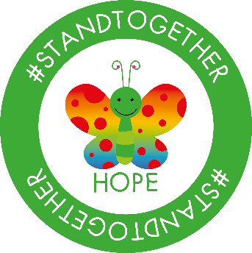
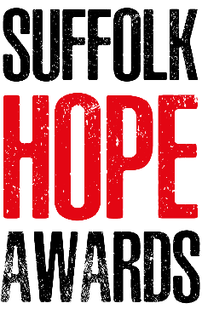
We won’t be able to achieve this without the help of your schools so please support your SLO’s when they make contact. The surveys are short and can be carried out at the end of structured inputs that they deliver, at informal engagements such as walk-arounds at lunchtimes and break-times- let’s be creative and work together.
Thank you all for your continued support

Insp Kirsty Graefe

