Our Ref: NFI – Schools
Date: 8 August 2022
Enquiries to: Christos Constantinou
Tel: 01473 265887
Email: christos.constantinou@suffolk.gov.uk

LMS Document
No. 2022-05

Dear Head teacher,
National Fraud Initiative
Suffolk County Council is required by law to protect the public funds it administers. It may share information provided to it with other bodies responsible for auditing or administering public funds, in order to prevent and detect fraud.

The National Fraud Initiative is a data matching exercise run by the Cabinet Office every two years to help prevent and detect fraud through cross–system and cross-authority comparison exercises. Full details can be found at: https://www.gov.uk/government/collections/national-fraud-initiative.

To comply with the requirements of the National Fraud Initiative, the County Council will be extracting and submitting the requested data to the Cabinet Office in October 2022. This includes data pertaining to your school and includes employee personal data (including names, addresses, bank account details, payroll information) and details of payments made by the school. For more information on how data will be handled please go to https://www.suffolk.gov.uk/about/privacy-notice/audit-data-matching-and-national-fraud-initiative-privacy-notice/.

There is no action for you to take as we can extract all the required information ourselves.

Schools who use Schools’ Choice as your payroll provider, with our data sharing agreements we have in place, Schools’ Choice will be able to provide us with the information we require without any further data provided from your school. Schools who do not use Schools’ Choice will be contacted individually.

Individual members of staff will be informed via a message on their payslips during August and September 2022.

Other required information will be extracted from the Council’s finance systems.

If you have any questions regarding this request, please do not hesitate to contact Christos Constantinou, Counter Fraud Manager, on 01473 265887, or via email at: christos.constantinou@suffolk.gov.uk.

Thank you for your assistance and cooperation in this exercise.

Yours faithfully
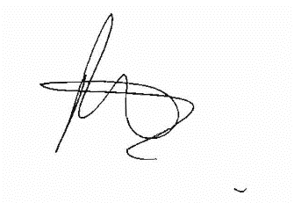
Peter Frost
Head of Internal Audit & Counter Fraud

