CASH GIRO SLIPS
Background
The following screens have been designed to replace completing coding information on paying in slips when depositing cash at the Post Office into Suffolk County Council account. You will still need to complete the front of the paying in slip for the Post Office but the coding information should be completed as outline in this document. DO NOT SEND THE PAYING SLIPS TO INCOME TEAM TO PROCESS.

When you have logged into the Suffolk Partner Portal the landing page will be displayed. The list of options displayed will be dependant on the on-line payment services your school has signed up to. You will only be able to access details relevant to your school.

Select Banking Income to enter banking slip details.

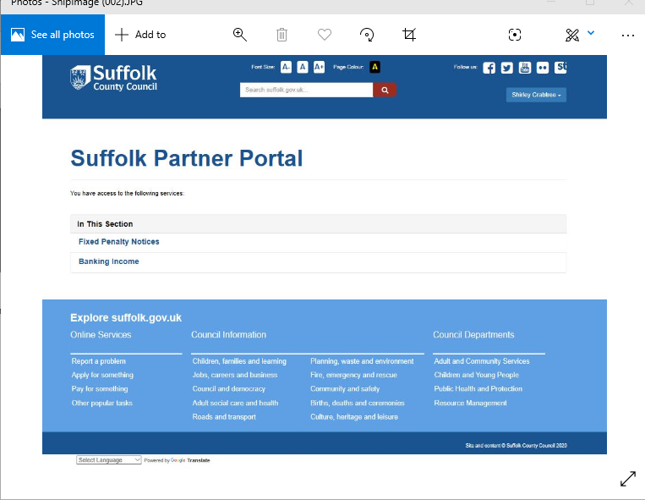

Entering Cash Giro Details

- To enter a new banking click on the New Banking button
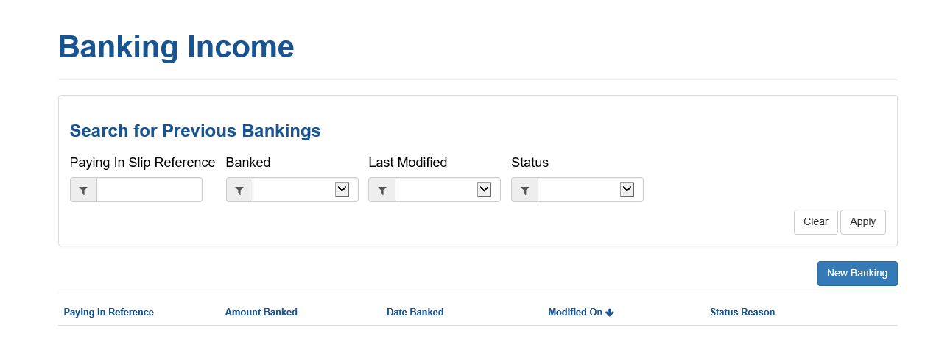

- The next screen provides instruction on how to enter details. Please read and click Continue to move to the next page
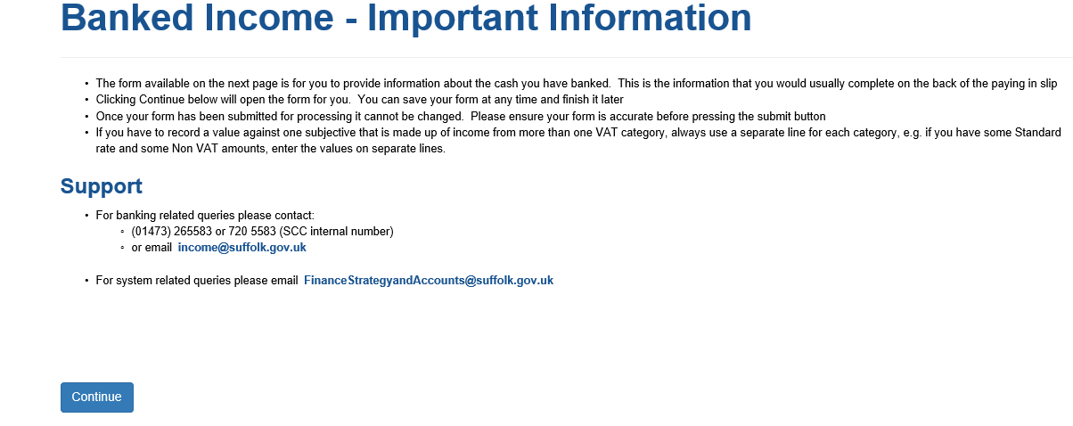

- From your signing in details the form will be populated with your school cost centre.
The other fields should be completed as follows.
Date Banked – This is the date the money will be taken to the bank/post office. A future date can be entered if the form is completed in advance of the cash being taken to deposit The date should be in the format DD/MM/YYYY
Amount Banked - Enter the Amount to be banked in format £999.99
Paying in Reference – This is the number from the paying in slip (6 digit number)
Bank/Post Office – Click on Post Office to indicate the cash is being paid in at a Post Office

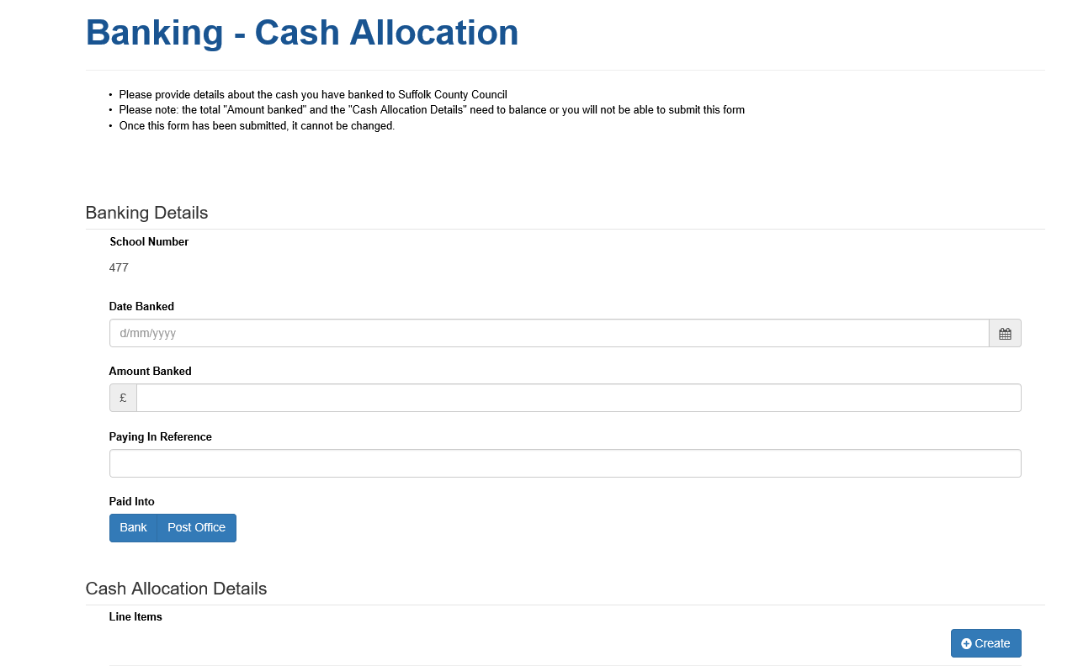

- When the banking slip details have been completed click on Create to enter the Transaction details for the income .
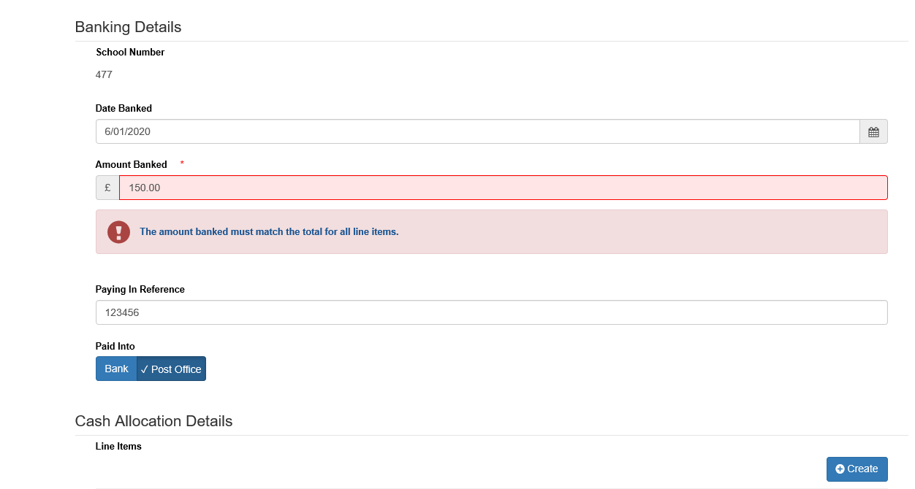

- You need to select the subjective for the income (ie to indicate what the income is for) . Click on the Search button to display the list of values.
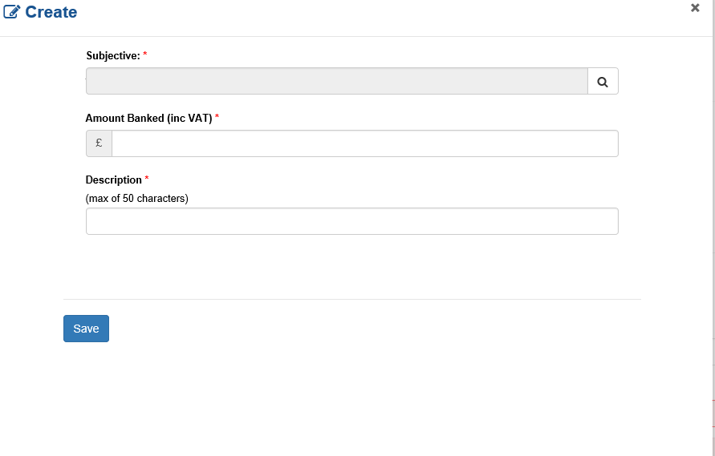

- From the list of values click on the required code for the income. The details displayed for the subjective are the narration and the SIMS code. Click on Select to continue.
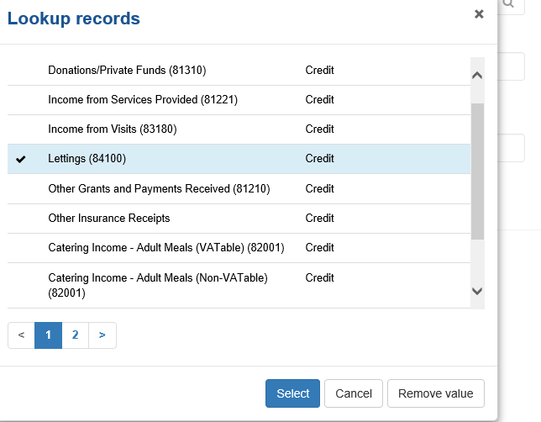

- The following screen will then be displayed

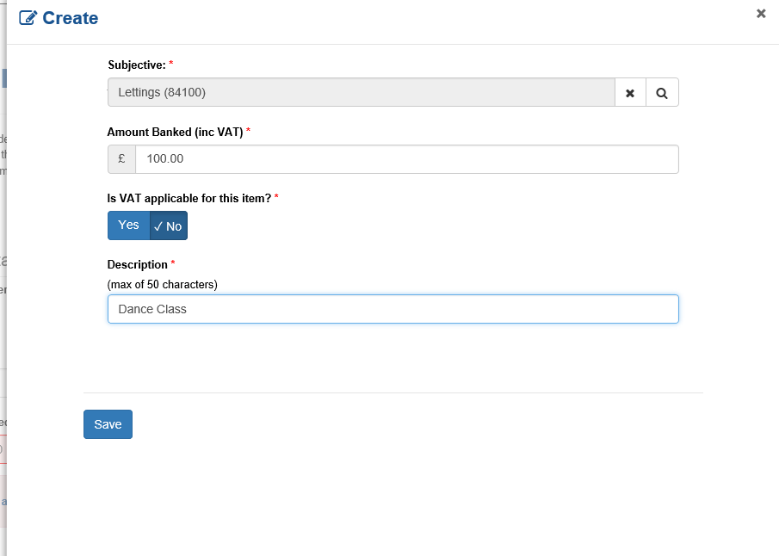

Click on the buttons to indicate whether the income has VAT applied to it. Note, the amount entered should be inclusive of VAT
Enter the Description for the Income – this will appear in Oracle/Sims against the transaction.

Click SAVE to continue

- To enter income for another subjective click on Create

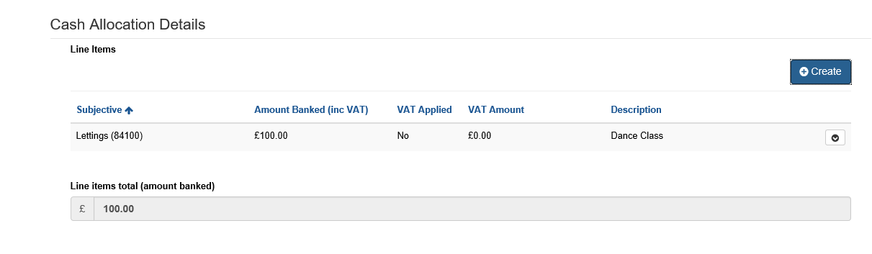
Please note that if any of the cash received has been used for an expenditure item this should be recorded against the Expenditure Subjective. It should not be common practice to use income received to purchase goods & services which is why only one generic expenditure subjective is available.

- When all transaction lines have been entered there are 2 options
SUBMIT – This will transfer the banking details to Oracle as part of the overnight processing.
Save as DRAFT The details can be saved and the form added to another day.

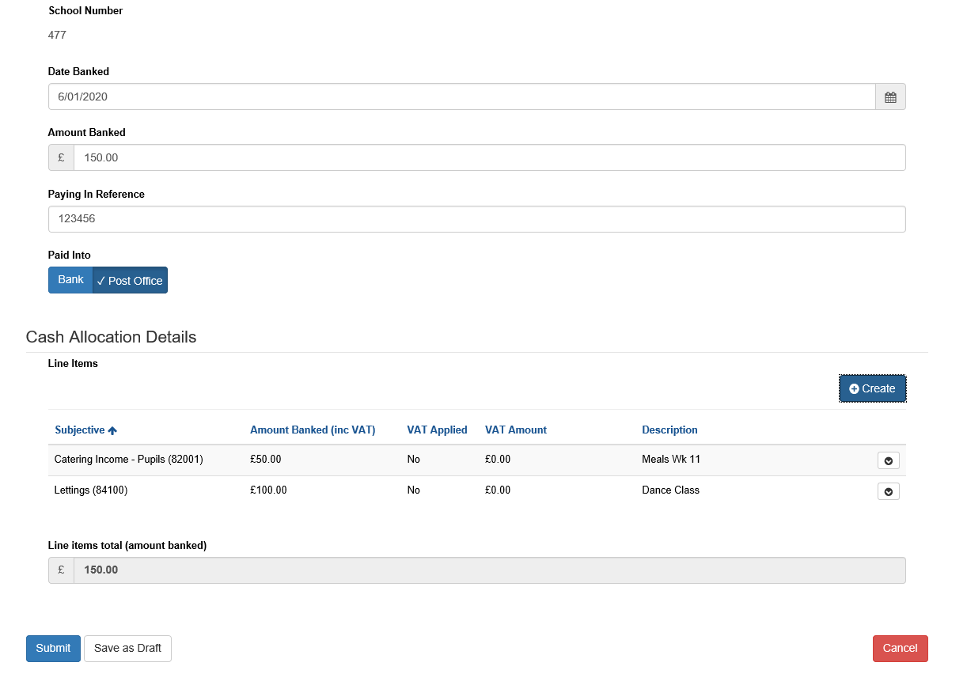

- To enter details for another paying slip click on New Banking.
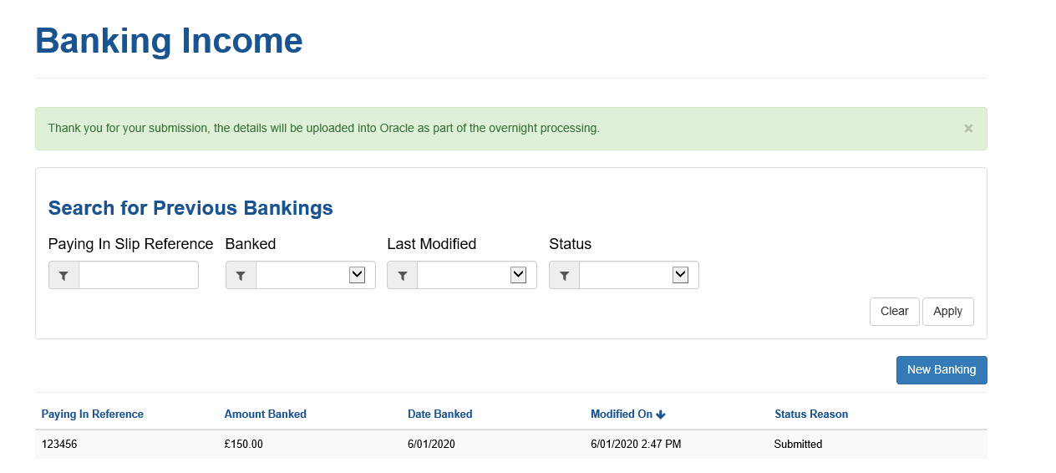

- Details of previous bankings enter will be listed.
There are 3 Status Reasons
Draft – Form has been started but not Submitted - it can be amended/added to
Submitted – Form has been submitted for processing. It can no longer be amended
Transferred to Oracle – The details have been transferred to Oracle and will be included in the Extract process run the following week (Run on a Monday)

