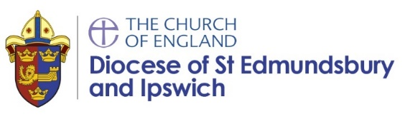
SACRE Report from Diocesan Schools Adviser 05.07.21
Religious Education
- My first RE network meeting via zoom was held on the 20th May at 4pm and was attended by 35 schools and 5 community primaries/academies. I updated subject leaders on the headlines from the Ofsted RE review and highlighted some of my new resources and training. Discussion took place about the challenges of RE in small schools and some of the possible creative solutions. There was a clear consensus that RE was still being given the expected curriculum time across all the schools this term post lockdown. Break out groups were used to discuss generally how well RE is going and identify what works well and even better ifs – summary below:
WWW | EBI
Links with our church  Scrapbooking  Really proud of our RE books  Staff confidence with RE  Teacher enjoying teaching RE  RE being well taught  Children enjoying RE lessons  RE curriculum  The solo taxonomy hexagons for assessment  RE literacy week each term which has a positive impact on writing  We are using Seesaw to record verbal explanations of concepts if this can’t be written down  Increased confidence with teaching EP  The knowledge organisers  An Easter stations of the cross prayer trail outside. It was really lovely and shook up the way we normally do prayer stations (inside in the warm and dry!) | Making units engaging  Improve assessment – seven people agreed with this!  All staff having RE training  How can I use reflective areas with covid?  How we evidence learning in books  scrapbooks  Prayer space opportunities and spiritual development  Need to improve evidence recording and catching up on missed units  Pupil perception surveys

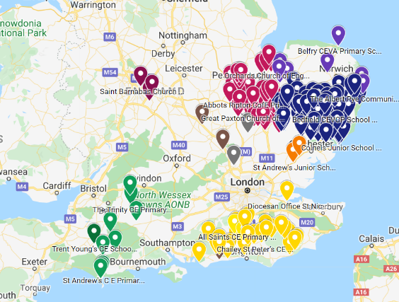
This map shows which schools have purchased The Emmanuel Project 2020 – currently over 200! My webinar giving a ‘free’ introduction to the resource to those schools who have purchased the scheme was well attended by over 50 teachers. Another is to take place later this term.
- Please find my latest DARE newsletter Summer 2021 available here: https://www.cofesuffolk.org/schools/school-leaders/religious-education/

- Excitingly, a selection of short videos should be available in the Autumn term to supplement the Christian Emmanuel project units. These videos feature Christians in Suffolk answering the main enquiry question from each unit and are currently being recorded. I hope to report on progress in our next meeting.

Gemma Kingston
Diocesan Schools’ Adviser

