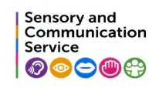
The Communication Chain

Communication is a complex process. A child with communication difficulties may struggle with one or more of the elements of communication.
Let’s consider the skills needed to communicate:
Have ideas and decide what to say
Expressive
Language
Receptive
Language
Speak fluently
We call this the Communication Chain. Communication is a two-way process, combining receptive and expressive language skills.
Speak
fluently
The Receptive Language side of the Communication Chain requires a child to:
- Look at the person speaking and attend to what is being said

- Interpret non-verbal communication e.g. facial expressions, gestures and body language

- Listen to what is being said and how it is being said

- Remember what has been said (auditory memory)

- Understand words (semantics) and sentence structure (syntax) e.g. vocabulary, grammar, word order

- Understand the meaning of language, both literal and non-literal e.g. sarcasm, jokes, idioms

The Expressive Language side of the Communication Chain requires a child to:
- Have ideas and decide what to say

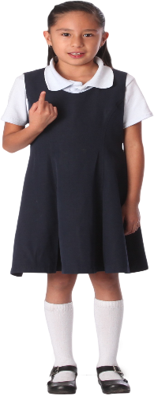
- Choose the words (semantics) to use and plan the words so that they make appropriate sentences (syntax/grammar), using the relevant vocabulary in a grammatically correct way

- Consider the impact the communication will have on others and
its appropriateness e.g. will I upset my friend if I say……

- Modify the message so that it achieves its purpose

- Select the sounds needed to form the words in the message
(phonology)

- Articulate the sounds so that their speech is clear to others

- Speak fluently and confidently

- Self-monitor so that they know, for example, when to stop speaking, whether the listener is interested in what they have said, whether they need to elaborate or explain.

