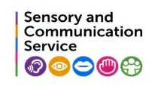
Memory Skills

A child with language difficulties can have difficulties remembering information, leading to feelings of frustration/ panic/ irritation, resulting in misunderstood behaviours.
Children:
- may find it very hard to find the right word at the right time (word finding difficulties)
- may have difficulty learning and remembering all words, particularly if delivery is quick and the child is expected to use listening only.

- How can we organise information to help children remember?
- Repetition. Revisit ‘over and over again’
- Child explains it to someone else
- Active learning
- Make it real. Real situations/ real objects/
- Do it! Act it out
- Visual/ draw/ it see it/ watch it
- Vocabulary maps
- Mind maps
- Write it down
- Give it a context and make it meaningful/ relevant to the child and interests
- Make it fun!

- Why is mind mapping so helpful for supporting children’s memory?

- Helps organise ideas (Teacher/ TA/ Child)
- It is visual/ does not rely on reading writing
- Excellent for planning
- Excellent for revision
- Excellent for sharing learning with home
- Includes only essential information
- Pupils with SLCN with reading difficulties can be helped to recall information and demonstrate their knowledge without depending on reading and writing
- Pictures and colour use the pupil’s strengths to support weaker areas of reading, writing and language
- Objects can be used on a large floor/ tabletop mind map
- Excellent for assessing progress when used before/ during/ after learning
- Great visual support when used in displays
- Mind mapping software
- They are enjoyable and generate discussion in groups
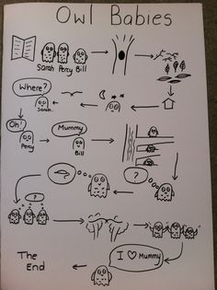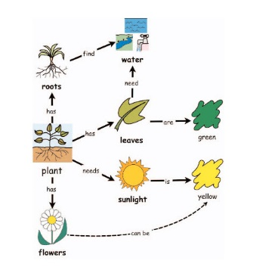
Mind maps use visual memory to support the successful storage of information in your brain by

- Linking ideas together, making connections.
- Making these connections visual, your memory is using another sense other than listening and writing
- Language = left side of brain but language and vision together = left and right brain working together

- How do we help a child work and complete tasks independently?

- Make verbal instructions visual enabling child to see and look back to check
- Visual rules and visual timetables (may need to use photographs of the actual class/ child)
- Symbols and words together (Widget/ Communicate in Print)
- Images and words (Clip Art/ photos)
- Activity planners and visual frameworks/lists
- Preparation (resources ready? Checked vocabulary is understood? Explain each step at a time with a space between? Have you modelled working through each step?)
- With familiarity the child should be able to do ‘next step’ independently
- Teach child to ‘check’ back
- As independence increases adult modelling can be phased out

