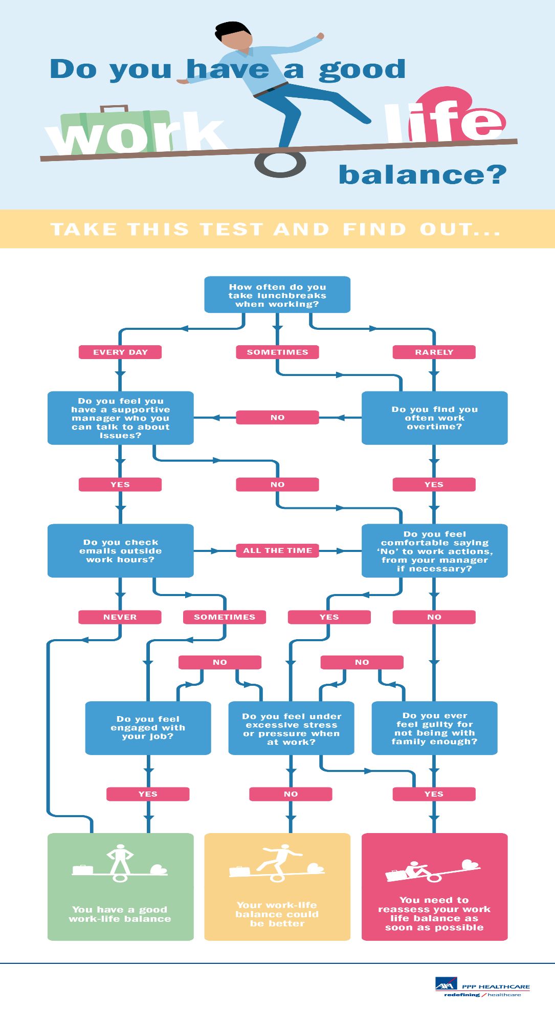
Getting the balance right between work and family time can be difficult. Long work hours, colleague expectations and the desire to progress can all have a detrimental effect on an employee’s health and wellbeing. However, getting the balance right can lead to an increase in productivity, motivation to succeed, better workplace cultures and a happier family lifestyle.
To help employees find out whether they should reassess their work-life balance, AXA PPP healthcare have built this simple visual quiz.
If you find out you might be suffering from an out-of-kilter work-life balance, these practical steps by Psychological Health expert Eugene Farrell will help you get back on track.
CAVEAT: It is difficult with most school-based jobs to have flexible hours, and SOME of the tips below are focussed on jobs where working hours and annual leave can be chosen by the employee. However, many of the items of advice can pertain to any employee, so use the ones you can!
- Prioritise work tasks rigidly and stick to doing the most important first.
- Schedule work into the day in time slots as you would with meeting appointments and work to that time.
- Take regular breaks, get up every hour and walk. Go and get some water or a drink and return to your work refreshed.
- Ensure you take a proper lunch break away from your desk where you can eat and drink.
- Take all of your annual leave each year, with a least one full week, and preferably disconnect from work once a quarter.
- Use out of office message and a nominated cover when you are away from work so that you don’t have to check emails all the time.
- Understand your limitations of work that you can successfully and reasonably achieve.
- If you feel uneasy about saying no to more work from your manager, then negotiate taking on the work whilst delaying something else.
- Being fit for work is as important as work – get good sleep, eat healthily, exercise, spend time with family and friends.
- If you are a leader of people, set the example and send the right message.
For more tips and guidance on achieving a work-life balance, visit AXA PPP healthcare’s Work Life Balance portal.
Sourced from:
https://www.shponline.co.uk/wellbeing-quiz-do-you-have-a-good-work-life-balance/?cid=%3FCID%3Dema-Newsletter_SHP%20Plus%20Weekly-21st%20February%202018-Resource-

