Schools’ guide to professional fire precaution checks – frequencies and items
Item to be tested or inspected | Extinguishers and blankets | Emergency lighting | Smoke detectors and heat detectors | Fire alarm and fire panel testing | Call points | Sprinkler systems
Frequency | Yearly | Yearly | Six monthly | Quarterly for batteries and six monthly / yearly for other parts | Yearly | Six monthly
How should I expect the test to be recorded? | Date of check should be added to the item’s sticker – may look like this:  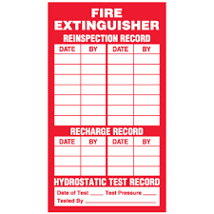 | The inspector should give you a document to say that the item has passed its check. Please file this in your fire log book or ‘Fire File’. In addition, and to assist your clarity of diarising the next inspection, you should note the inspection within the fire log book with the date and your initials / signature. The Suffolk Fire and Rescue Service log book details this, which can be found at: https://www.suffolklearning.co.uk/leadership-staff-development/health-safety-wellbeing/fire-precaution-information  Dates of professional checks for ‘users’ and ‘competent persons’ (i.e., the professional) can all be found in the SFRS log book in addition to this sheet.
Who can carry out this check? | There are any number of companies who can carry out these checks. Schools are at liberty to choose who they have to do these checks, but they must be registered and approved by an overarching body such as the IFE, BAFE or other professional bodies, which means they will be independently audited and are competent. Additional assurances can be made via a ‘Third Party Certification’ scheme. This is where an independent certification body (accredited by the Government body called ‘UKAS’) inspects the company on an annual basis. They will check the management systems of the company, including the training given to the employees, to see if they provide what they say they will and to high standards. If you have any concerns, please contact your Property Advisor or your Health and Safety Advisor.
What do I need to do about the results of the test? | The company who carries out the check should notify you (in writing) of any deficiencies within any of the systems or precautionary measures, which you must ensure are corrected. Please see that any corrective action is taken as a high priority.

