How to carry out simple visual checks on electrical equipment –
A guide for School Staff

Users of electrical equipment should check that there are no signs of damage, interference or tampering etc.. before it is used and when (and if) it is moved to a new location. A simple visual check can detect most potential problems. These checks also apply to extension leads and associated plugs and sockets. Examples of typical faults or damage are shown below.
Electricity can kill. Do not take unnecessary chances.
If you are unsure whether any electrical equipment is unsafe or if there are signs that could indicate the equipment is faulty or damaged, DO NOT USE IT and REPORT IT TO YOUR PREMISES RESPONSIBLE PERSON IMMEDIATELY.

Areas to check | Example photograph | Description of photograph
Damage to the cable sheath (apart from light scuffing) | 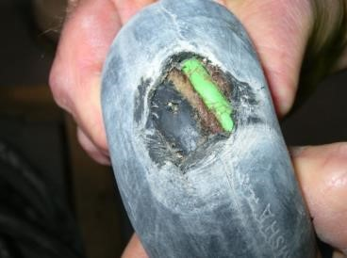 | Outer insulation of the cable is broken. Inner cables or wires are visible.
Damage to the plug casing and lack of insulation on bottom two pins | 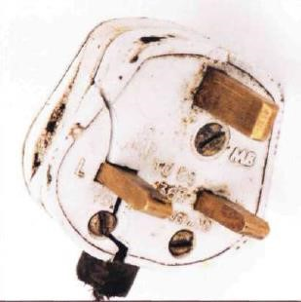 | The plug casing is broken. Also, the bottom  two metal pins are fully exposed and have no insulation (black sheathing which covers one half of each bottom pin, closest to the plastic casing of the plug).
Damage to the casing of the electrical equipment | 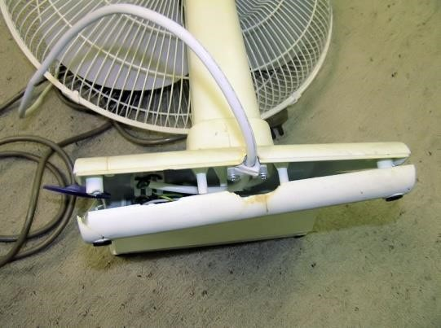 | A portable fan with a broken base. Internal connections and wires are exposed.
Signs of unsafe connections | 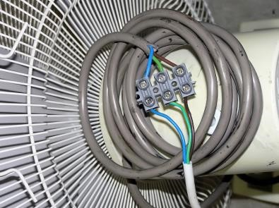 | Electrical cable connectors have been used to join two separate pieces of cable in order to extend the overall length of cable.
Damage to cable grip | 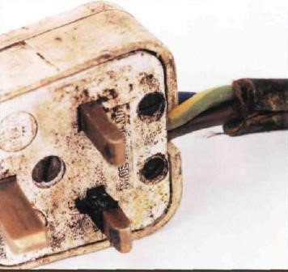 | Outer insulation cable is not gripped inside the plug casing. Internal cables are exposed.
Lost earth connection | 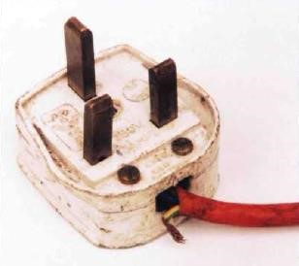 | The earth wire has become detached from inside the plug casing.
Overloaded socket (1) and ganging of extension leads (2) | (1)  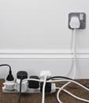  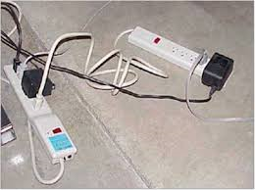  (2) | An overloaded extension lead which is being used to supply electricity to multi-way plugs and other adaptors. Picture two shows one extension lead being plugged into another. Both very dangerous practice.
Overloading and multiple wiring of socket | 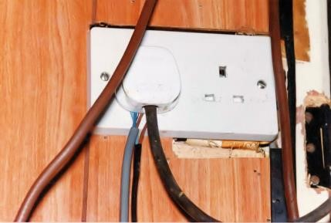 | The wall mains socket is overloaded. Multiple  items of electrical equipment have been  wired into one plug; this is highly dangerous.
Overloading and wiring of second item of equipment onto pins outside protective casing | 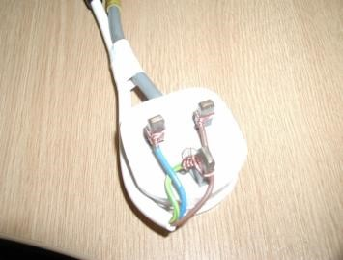 | Wires are exposed. Two items of equipment are being run off a single plug; this is highly dangerous.
Evidence of overheating | 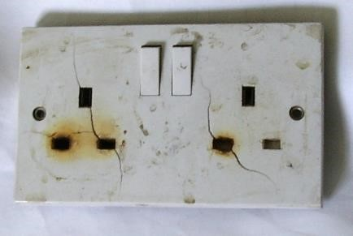 | Scorch or burn marks on socket casing due to either a poor connection in the socket or in the equipment which is plugged into the socket.
Unsuitable conditions –  inside | 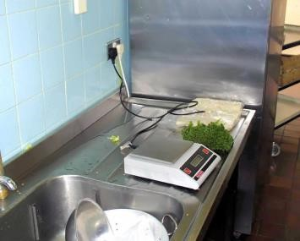 | Electrical weighing machine used on kitchen  sink. Potential contact between water and electricity.
Unsuitable conditions – outside | 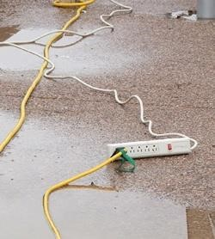 | Electrical extension leads used outside in wet conditions.
Unsuitable conditions – poor housekeeping | 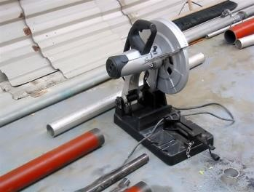 | Electrical cable is likely to be cut by the circular saw.
Overloaded sockets | 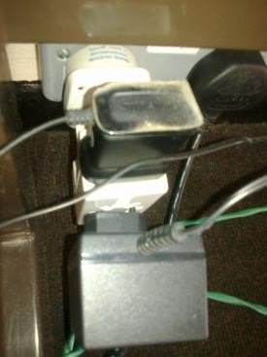 | Multiple appliances connected to inappropriate adaptors, plugs or extension leads.  Suffolk Fire and rescue Service state that adaptors should NEVER be used.
Unsuitable conditions - poor housekeeping | 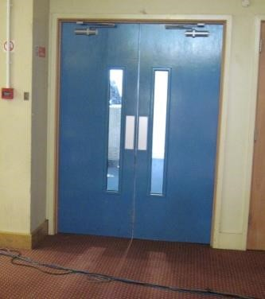 | Cables are lying across the floor in front of a doorway. Likely trip hazard – this can force pressure onto the socket and damage the internal area.

Continued……
Other helpful advice includes the socket overload calculator which can be found at: http://www.twothirtyvolts.org.uk/socket-overload/?hdpi=1

Other examples of hazards:
- Trip hazard where cables are covered by carpet or rugs – the wires get ‘forgotten’ and unchecked, alongside being trodden on and potentially damaged.

- Heavy furniture or equipment with sharp edges is put on top of cables. This could lead to damage to the outer insulation of the cable or wiring inside the cable.

^{i} Sources of information and photographs:

- University of Essex – H&S document – Visual checks on electrical equipment
- Maintaining portable electrical equipment (HSG107) - http://www.hse.gov.uk/pubns/books/hsg107.htm
- “DIY (not)” – forum regarding electrical safety at: http://www.diynot.com/forums/viewtopic.php?p=1784842
- Fermilab: http://news.fnal.gov/2015/03/extension-cord-and-power-strip-safety/

