In the second part of a two-part series, IOSH Education Group Chair Fiona Riley looks at how schools manage health and safety brought about by winter.
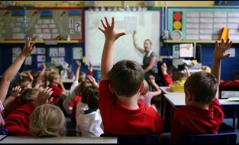
While a huge number of schools in recent years have expanded into new buildings, there are still many which operate in old buildings and porta-cabins. With these types of accommodation comes the potential for all kinds of costly problems.
Chief among these at this time of year, is boiler breakdowns. When this happens, schools often have to close as you can’t have children – or staff – working in a freezing cold environment and the Education (School Premises) Regulations require a classroom to be at a minimum of 18°C.
Burst pipes can be an equal problem, particularly during cold snaps. I have had experience before of a school being flooded by a burst pipe during a winter shutdown.
Staving off these potential problems in old buildings isn’t easy. Having regular maintenance schedules is one way to mitigate the risk, but this does not provide a guarantee that problems will not arise.
It isn’t just cold conditions which can bring about building problems for schools. The potential for storm damage is heightened at this time of year. This can cause significant disruption.
Strong winds, for example, have the potential to cause damage to the roofs of schools, providing a health and safety risk should anyone be outside at the time. Another risk is that of trees being uprooted.
Early years settings in particular can experience problems with storms and strong winds. They have a lot of outdoor play equipment, which can be damaged. One such issue I’m aware of was when winds lifted up a pagoda and threw it 400 yards across a playground.
Schools obviously cannot control the weather. It is important, therefore, that they have a bad weather plan and are well prepared for any bad conditions which can be thrown at them.

Travelling to and from school
It is not just the weather which brings health and safety risks at this time of year. The closer you get to the Christmas break, the shorter the hours of daylight get.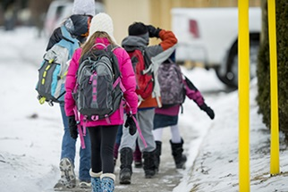
In December, it is dark as children make their way to school in the morning and dark again when they leave.
There are stark health and safety risks presented by streams of children making their way to school alongside busy roads.
Many local authorities, faced with having to make cutbacks to services, have withdrawn the provision lollipop men and women.
With this in mind, it is as important as ever that children are well educated on road safety, so they walk to school in a calm and sensible manner and are mindful of how to cross roads safely. It is also important to remind parents and carers who are dropping children off in their cars to be very vigilant when driving near schools.
Many children, of course, remain in school much later in the day as they attend after-school clubs.
This is especially the case in late November and December when there are nativity plays and concerts to prepare for. Having children on site later in the day provides another challenge for schools.
These are but a few of the array of health and safety issues which schools must contend with during the winter. There are many more which I haven’t mentioned here.
There are different ways of controlling the risks. But it is an important starting point to have strong, robust management systems in place.
Key to these systems being successful is having strong leadership, which particularly means that senior staff in schools should lead from the front. From them safe ways of working can be cascaded down throughout the staff and the students.
Also published in Education Business magazine, November 2017.

