Appendix B
Record of concern about a child/young person’s safety and welfare
Part 1 (for use by any staff – must be handwritten and legible)
Pupil’s name: |  | Date of birth: | Class/Form:
Date & time of incident: |  | Date & time  (of writing):
Name (print): Job title:
Signature:
Record the following factually: Nature of concern, e.g. disclosure, change in behaviour, demeanour, appearance, injury, witnesses etc. (please include as much detail in this section as possible. Remember – the quality of your information will inform the level of intervention initiated. Attach additional sheets if necessary. Complete body map if injury/marks seen)
What is the pupil’s perspective?
Professional opinion, where relevant (how and why might this have happened?)
Any other relevant information. Previous concerns etc. (distinguish between fact and opinion)
Note actions, including names of anyone to whom your information was passed and when
Check to make sure your report is clear to someone else reading it.
Please pass this form to your DSL without delay
Record of concern about a child/young person’s safety and welfare
Part 2 (for use by DSL)
Information received by DSL: | Date: |  | Time completed: |  |  |  | From whom:
Any advice sought, if applicable | Date: |  | Time completed: |  |  |  | From: name/organisation:
 | Advice received:
Action taken with reasons recorded  (e.g. MARF completed, monitoring advice given to appropriate staff, CAF etc) | Date: |  | Time completed: |  |  |  | By whom:
Outcome | Date: |  | Time completed: |  |  |  | By whom:
Parent/carer informed? | Y | Who spoken to: |  | Date: |  |  |  | Time: |  |  | By whom:
 | N | Detail reason:
Is any additional detail held, if so where?

Prior safeguarding history | No of previous records of concern:
 | Has the child been subject of CAF/Early Help assessment?
 | Currently on CP Plan (CPP) / Child in Need Plan (CiN)
 | Previously on CP Plan (CPP) / Child in Need Plan (CiN)
 | Is child known to other agencies? |  |  |  |  | Y / N
Name of DSL: |  |  |  |  | Signature:

Appendix C

BODYMAP
(This must be completed at time of observation)

Name of Pupil: |  |  | Date of Birth:
Name of Staff: |  |  | Job title:
Date and time of observation:

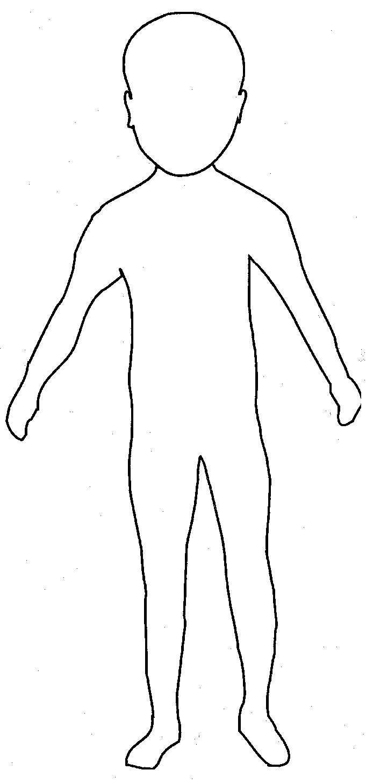 | 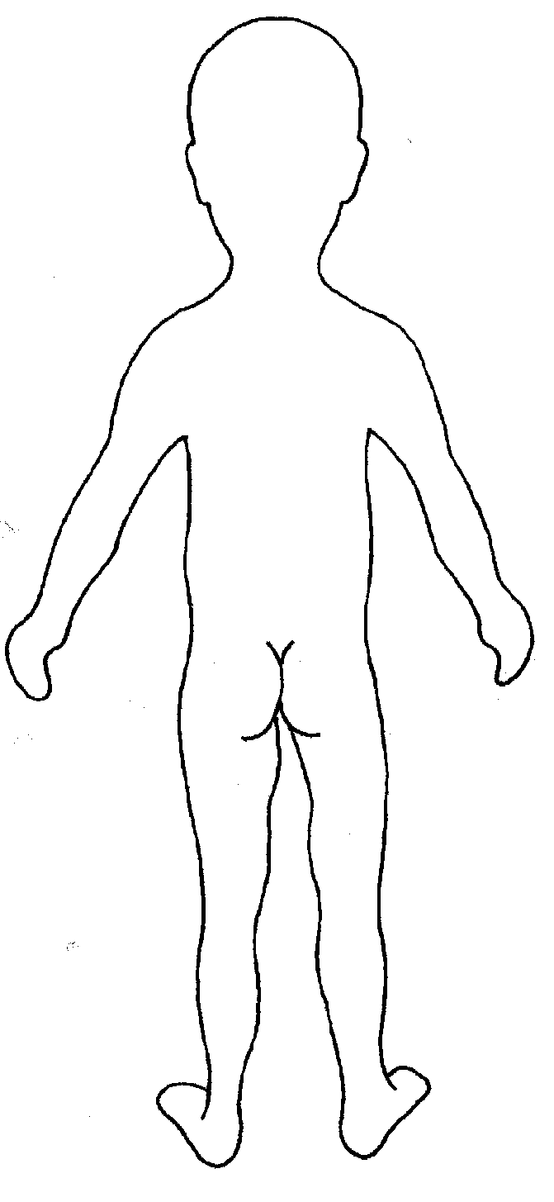

Name of pupil: |  |  | Date and time of observation:
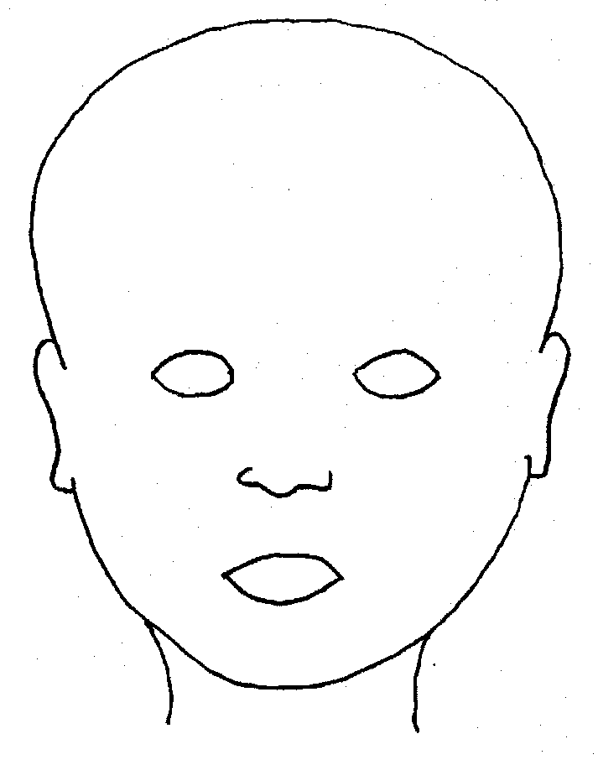 |  | 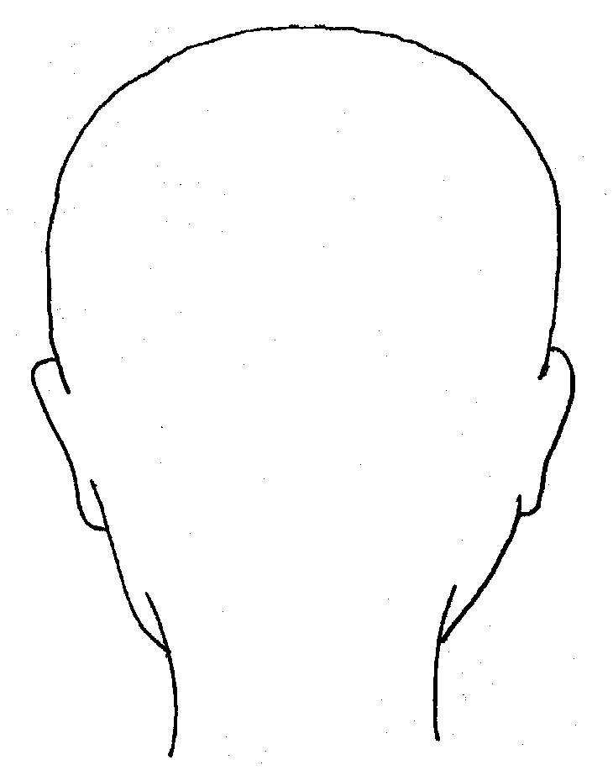
FRONT |  | BACK
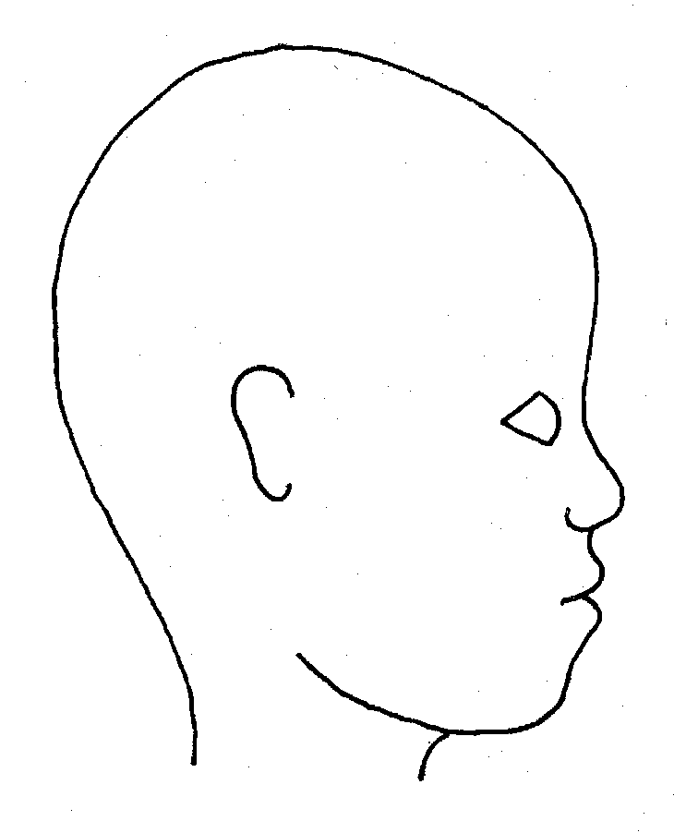 |  | 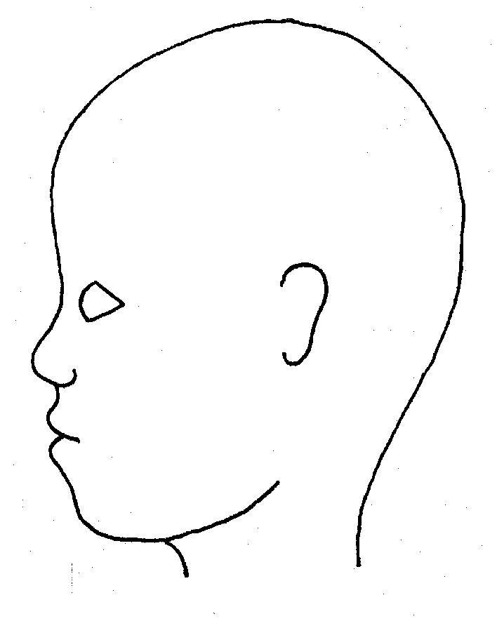
RIGHT |  | LEFT

Name of pupil: |  |  |  |  |  |  | Date and time of observation:
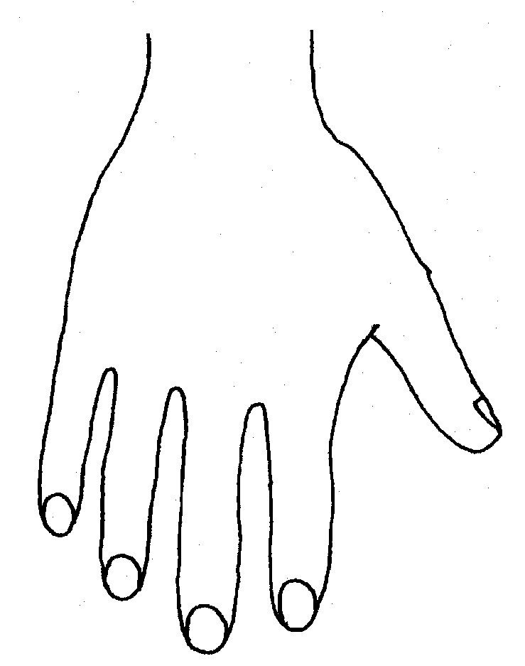 |  |  |  |  |  | 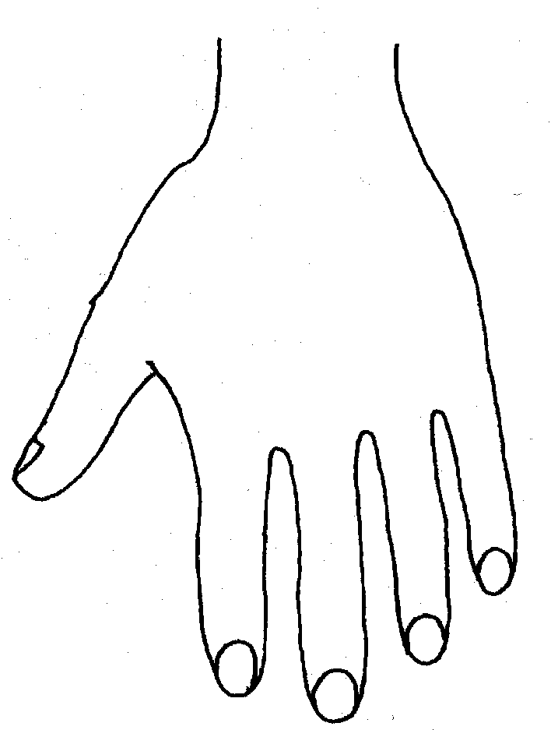
R |  |  |  |  |  | L
BACK
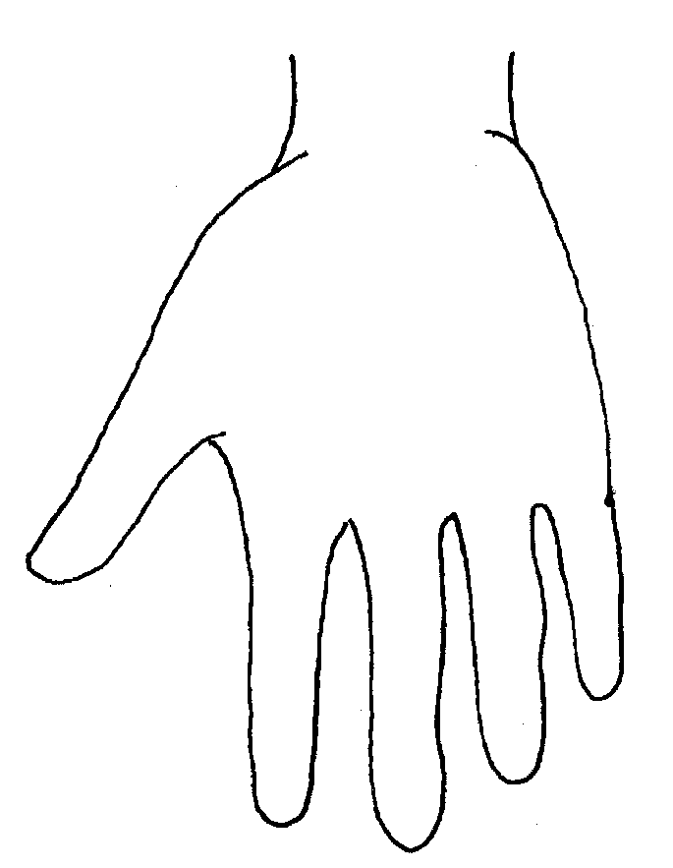 |  |  |  |  |  | 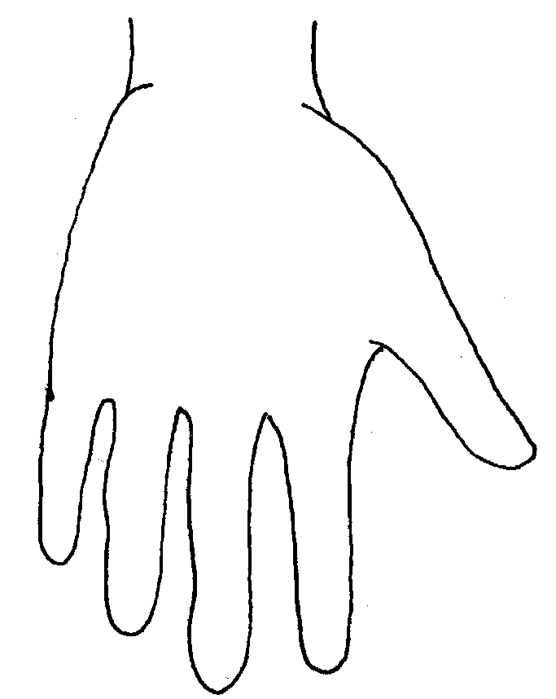
Name of Pupil: |  |  |  |  |  |  | Date and time of observation:
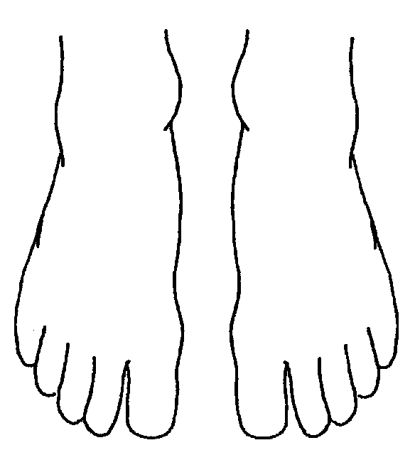 |  |  |  |  | 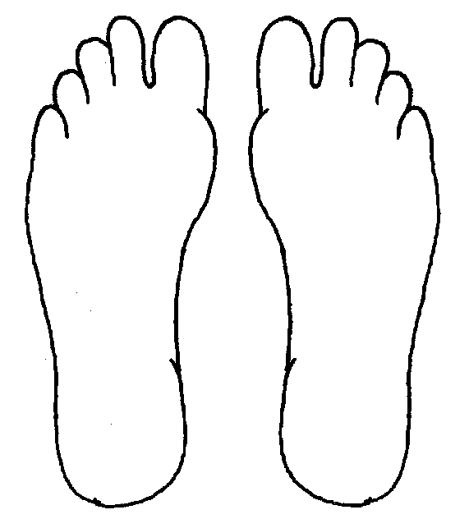
R | TOP |  |  | L | R |  |  | BOTTOM |  |  |  | L
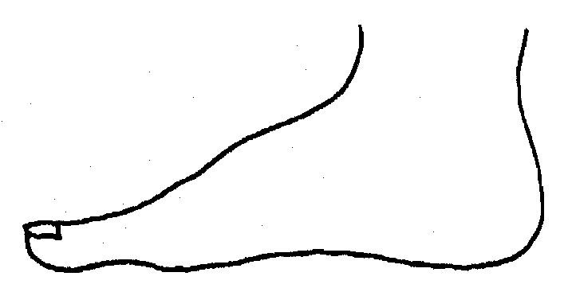
R |  |  |  |  | L
INNER
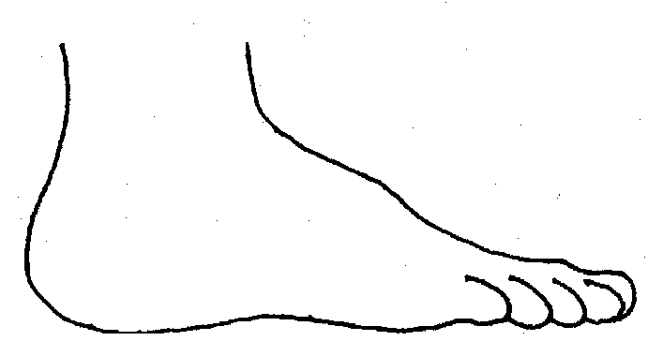 |  |  |  |  | 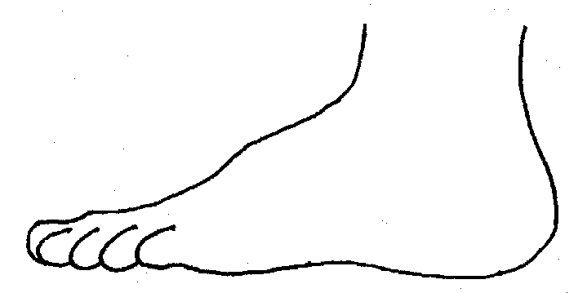
R |  |  |  |  | L
OUTER
Printed Name, Signature and Job title of staff:

