Phonics autumn 2020 data collection: input sheet guide

November 2020

Contents
Version history 3
1. Introduction 4
1.1 Overview 4
1.2 Using the spreadsheet 4
1.3 Exporting the spreadsheet 5
2. Completing the spreadsheet 6
2.1 School identification details 6
2.2 Individual pupil identifiers 6
2.3 Surname and forename 6
2.4 Unique pupil number 6
2.5 Gender 7
2.6 Date of birth 7
2.7 Year group 7
2.8 Check mark – result qualifier (NM) 7
2.9 Check mark – result outcome (NY) 7
2.10 Copying data from another spreadsheet/source 8
3. Removing pupil records from the spreadsheet 9
4. Creating an export file 10
5. Missing data on export 11

Version history
Version | Change history | Author / date
0.1 | Changes to the guide for the 2020 phonics autumn collection input sheet guide have been made as listed below: | Mark Eynon 10/11/2020
- Amend dates
- Remove reference to year 1 pupils

1.0 | Document created for the 2020 phonics autumn screening check for year 2 pupils. | Mark Eynon 10/11/2020

Introduction

Overview
This spreadsheet is for the 2020 phonics autumn screening check collection. The spreadsheet can be used to create a CSV export file for the collection of phonics results for up to 150 pupils in your school / funded setting.
The spreadsheet is provided in Excel 97 – 2003, if you are using Excel 2010 and you convert the spreadsheet to a 2010 version, you must save it as an xlsm (Excel Macro-Enabled Workbook). This will retain the macro functions of the spreadsheet. You can still save it as xls (Excel 97 – 2003 Workbook).
If you receive the spreadsheet as an email attachment or on disk, you are advised to copy the spreadsheet on to your hard drive or into a folder on a network and use the copied version to make your entries.

Using the spreadsheet
On opening the spreadsheet, select the ‘enable macros’ option.
It is recommended you set your keyboard to upper case before making entries as some fields are case sensitive.
You can use the keyboard tab key to move automatically to the next box / row to be completed.
You may need to use the View, Zoom option to reduce the print size in order to show more individual pupil rows and columns on screen.
If you wish to close the spreadsheet at any time and save the data you have entered, click on the ‘Save’ button; note the location of the file and save the sheet. It is recommended you ‘save’ the spreadsheet in a separate location to the original sheet. You may rename the file each time you save it if you wish or simply overwrite the previous version. Re-open the sheet to continue to make entries / amendments as necessary - always select the ‘enable macros’ option on opening. You may use the ‘save’ option as often as necessary.
When you are satisfied that all the pupils in your school required for the phonics screening check have been included and all entries are complete, it is recommended you take a back-up copy of the final results by clicking on the ‘Save’ button.

Exporting the spreadsheet
When you have saved a back-up copy of the spreadsheet, click the ‘Export’ button and follow the on-screen instructions; entering any missing details as directed. The 'Export' button converts the spreadsheet to an export CSV file called ‘PHONICS_<Local Authority No. School Estab No. >_20.CSV’ (e.g. PHONICS_2103999_20.CSV) and will allow you to save the file to a location of your choosing before forwarding to your local authority, with the following message:
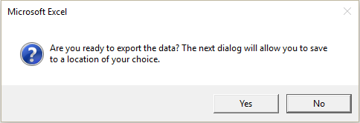

Please do not amend or re-name this CSV file otherwise your local authority will be unable to process it.
If you wish to amend any of the details for any pupils after you have created the export CSV file, go back to the saved back-up copy of the file and follow the procedures from paragraph 1.2.
The local authority / agency will inform you of the date by which it will require the CSV export file and provide any other relevant instructions. If you need further assistance, please contact the local authority / agency.

Completing the spreadsheet

School identification details
Unless already entered for you, enter your
- school name,
- local authority number, and
- Department for Education school number (i.e. the 4 digit code), as prompted on-screen.
Do not enter commas in the school name otherwise the CSV export file will not load correctly.

Individual pupil identifiers
Using a new row for each pupil assessed enter the appropriate identifying details.
PLEASE NOTE: If you populate the spreadsheet with pupil identifying data by pasting from an existing Excel sheet, use the ‘paste special - values’ option or paste the data as ‘text’.

Surname and forename
Enter the surname by which the pupil is known and the first forename. Do not separate any names by commas otherwise the CSV export file will not load correctly into the local authority / agency database.

Unique pupil number
In local authority maintained schools, if any pupil does not have a permanent unique pupil number, please allocate a temporary number - but it is suggested you contact your local authority in the first instance in such cases.
The 13 character number must be entered for any pupil where this has been allocated. If an invalid unique pupil number is entered, the following warning will be displayed:
Please re-enter the correct unique pupil number in such cases.

Gender
Enter the pupil’s gender as either M or F. The data can be entered manually (using upper case) or you can use the drop down option provided in the cell.
You will not be able to enter a different value.

Date of birth
Enter a date of birth between 01/09/13 and 31/08/14. You will be able to enter a data of birth outside of this range however you will see a warning message if you do. As below;
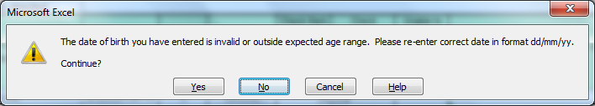
Clicking ‘Yes’ will allow you to enter the out of range DOB.

Year group
Enter the pupil’s year group. The data can be entered manually or you can use the drop down option provided in the cell.
If you enter a year group other than 2 you will see a warning message.

Check mark – result qualifier (NM)
Enter a value between 0 and 40. The spreadsheet will not accept values outside this range, and will only accept whole numbers.

Check mark – result outcome (NY)
Where the result qualifier is filled, the result outcome should be left blank. If a pupil is unable to access the check, schools should report the result outcome as one of the following absence codes:
A – Absent
Q – Maladministration
D – Disapplied
L – Left
NOTE: The spreadsheet will generate an error message if both a check mark and an absence code are entered against a pupil. This will stop you from exporting the spreadsheet.

Copying data from another spreadsheet/source
If you need to enter data from another spreadsheet and do not wish to manually enter all the data, you can paste the information direct into the input sheet. Please use the ‘Paste Special’ option and select ‘Values’. This will ensure that any data validation is retained.

Removing pupil records from the spreadsheet
If you need to remove any pupils and associated data from the spreadsheet, you will need to clear each cell in the rows separately. It is not necessary to move-up remaining data to fill the empty rows.

Creating an export file
When you are satisfied that all eligible pupils are included in the spreadsheet, you will need to create an export file for your local authority (see section 1.3). The local authority / agency will give instruction on the means by which the results’ file is to be submitted.
Please Note: the department for education cannot accept the CSV export file directly from a school. The file must be processed and formatted by the local authority / agency for submission to the Department.
IMPORTANT NOTE: Whilst saving the workbook you may see the following warning:
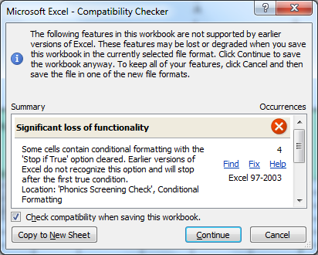
If you click continue the spreadsheet will save and the functionality will be unaffected. Unticking the ‘check compatibility when saving the workbook’ box will stop this message from appearing again.

Missing data on export
You will not be able to create an export file if any school or pupil identifying data is missing.
On-screen messages will appear if any data is missing or inappropriate each time you click on the ‘Export’ button. Please enter the missing data or correct the inappropriate levels as prompted and follow the instructions to re-create an export file.

© Crown copyright 2020
This publication (not including logos) is licensed under the terms of the Open Government Licence v3.0 except where otherwise stated. Where we have identified any third party copyright information you will need to obtain permission from the copyright holders concerned.
To view this licence:
visit www.nationalarchives.gov.uk/doc/open-government-licence/version/3
email psi@nationalarchives.gsi.gov.uk
write to Information Policy Team, The National Archives, Kew, London, TW9 4DU
About this publication:
enquiries www.education.gov.uk/contactus
download www.gov.uk/government/publications
Reference: [000-000-000]
 | Follow us on Twitter: @educationgovuk |  | Like us on Facebook:  facebook.com/educationgovuk

