Personal Safety – Schools’ information
Personal Safety refers not only to a person’s physical safety, but also to your emotional and psychological safety. Therefore, this includes the freedom from concern about any form of victimisation by hostility, aggression, or harassment. The core theme is an umbrella term which incorporates several interlinking subjects including lone working, violence and aggression, harassment​​​​​​ and bullying, domestic abuse, hate crime, stalking (including digital stalking) and social media safety.
Your personal safety should be considered as part of the risk assessments carried out on your role, task and work activity. It should be considered when driving or travelling for work, visiting children and parents at home or in the community, when dealing with members of the public either face to face or over the telephone, when working away from your usual school, even using social media – in fact everything you​​​ do. Personal safety is not just a lone working issue.
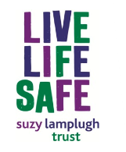
Th​e Suzy Lamplugh Trust provide guidance on a range of topics which can be viewed by clicking the following link. They can provide lone worker training if required. Have a look through their extensive website for more information. They also run a National Stalking Helpline which you can call on 0808 802 0300. More information on this service can be found at: https://www.suzylamplugh.org/contact-the-helpline

What is Lone Working?
The HSE has a succinct and easy definition of lone working: “Lone workers are those who work by themselves without close or direct supervision for any part of the working day...” (or night!). These types of roles may include:
- Staff who get in early to work before others
- Staff who leave after others
- Caretaking staff
- Maintenance staff
- Staff need to take pupils to other bases in their car or in a taxi
The list of course is not exhaustive. One of the biggest risks that lone working staff face, is that of possible injury or threat – and then not being able to call for assistance or not being found. It is therefore important that a system is in place to respond if you are not returning or responding at expected times. This system could be a local 'buddy system' or it could be an automated system run by a specific company.

Personal Safety Devices and Solutions
Suffolk County Council staff and our partners can now purchase Personal Safety Devices and Solutions through our new provider, Skyguard Ltd. The Framework offers a range of solutions for Personal Safety and lone worker needs, not only providing devices and apps, but also a dedicated response service for users of the solutions. With the exception of apps (which would be downloaded to an individual's smartphone), the devices can be "pooled" or shared, thus removing the requirement to purchase one for each staff member and reducing costs.
Full details of the range of devices and solutions available, pricing and instructions for ordering can sought from Helen Muddock – email details are: Helen.Muddock2@suffolk.gov.uk .
The appointment of Skyguard is the result of a robust procurement process, following the publication of the contract notice in the Official Journal of the European Union (or 'OJEU') in July 2017. Skyguard has been selected for their experience and ability to provide products and a service that combine quality and value for money. For the duration of the contract, the purchase of any lone worker or personal safety devices or solutions must be made through this Framework via P2P, and must contain the sentence "This is a call off order under SCC Framework Agreement CD1167". Please read the Purchasing Guide for full instructions.
Within the SHAW Arrangements Policy (see the SCC H&S Policies and Good Practice page at https://www.suffolklearning.co.uk/leadership-staff-development/health-safety-wellbeing/suffolk-policy ) safe working is detailed. At appendix seven, you will find the Lone Working Policy. You will see that there is a good emphasis on risk assessment, and communication with your staff.
Personal Safety training
SCC schools can book individual places on the courses that are organised by Corporate H&S or each school can have a group session.
For non-maintained schools there is a charge of £199 for a half day or £299 for a full day. The facilitator is happy to work with the school to meet the particular needs of each school. Again, please contact Helen.Muddock2@suffolk.gov.uk for more information.
Violence at Work
Violence and abuse is never acceptable. If you are a manager of staff that are likely to face this risk, you should familiarise yourself with the Managing Violence and Aggression at Work policy statement. This can be found within the SHAW Arrangements Policy (at https://www.suffolklearning.co.uk/leadership-staff-development/health-safety-wellbeing/suffolk-policy ) at appendix eight.
You might also consider Conflict Management training for individual staff members, or your whole team. This is Recommended for all employees who deal with people who can be demanding (either within the school or externally) lone work. For instructions on how to book places, download a booking form from the Health and Safety Training page on Suffolk Learning and email it to healthandsafety@suffolk.gov.uk ; However, if you want full team training and need to contact Helen Muddock , please ensure you let Nina Bickerton know as well.
Do not forget BellsCroft Training who offer behaviour management training courses. They can assist in positive behaviour strategies, and are designed to support staff within education, social care and families. Personal safety assistance for lone workers is also a feature of their training. There is a focus on de-escalation, early intervention, and risk assessment planning, all of which aim to reduce the need for physical interventions or restraints. The consultants are a team of qualified professionals who have many years’ experience in a variety of service sectors. They hold a nationally recognized qualification in restraint training and are accredited on a yearly basis with National Federation of Personal Safety (NFPS Ltd).

Domestic Abuse - A Workplace Response
Suffolk County Council is committed to a policy of zero tolerance towards abusers and to address the issue of domestic abuse for staff who are victims and for the children, young people and the vulnerable adults, whom we serve. You can find out more about the policy and how managers can support employees by reading the Domestic Abuse Policy (A workplace response) – on the Personal Safety page of Suffolk Learning’s health and safety information.

If you are being abused, threatened, harassed or physically or sexually assaulted by your partner, former partner or some-one who is or has been close to you, there are a number of things you can do. Your abuser may blame you and blame other things like being drunk, pressure of work, unemployment and minimise or deny what they are doing. These things can put a strain on a relationship but are not a cause for abuse.
Always remember, you are not to blame and there is help available to you. There is help for women, men, young people and those who are threatened by forced marriage on the following website: New Dawn Suffolk .
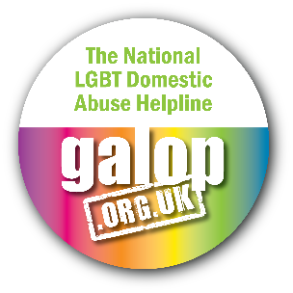
GALOP is the LGBT+ anti-violence charity who host a national LGBT Domestic Abuse Helpline: 0800 999 5428. Their website is at: www.galop.org.uk and they assist people who have experienced domestic violence, hate crime or sexual abuse, amongst other services.

This confidential helpline and organisation helps men from all over the UK who suffer from domestic violence or domestic abuse. They provide emotional support and practical information and receive calls from male victims across all age ranges and professions. They also welcome calls from relatives and friends of male victims seeking information, alongside local authorities and police forces. Call them on 01823 334244 or have a look at their website via: http://new.mankind.org.uk/
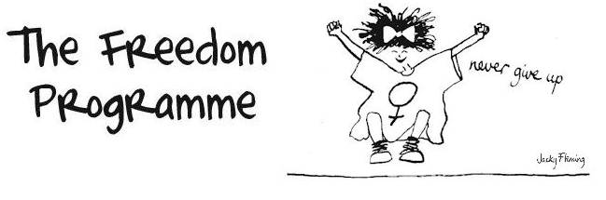
The Freedom Programme is a domestic violence programme which was primarily designed for women as victims of domestic violence. However, the programme, when provided as an intensive two-day course, is also suitable for men, whether abusive and wishing to change their attitudes and behaviour or whether victims of same sex domestic abuse themselves. Find out about the online course and local face to face courses by visiting www.freedomprogramme.co.uk

In an emergency always call 999.

