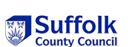

Early Years and
Childcare Service

Transforming Behaviour Guidance

August 2021

Contents

Content heading | Page number
What is behaviour? | 3
The legal framework and guidance | 4-5
Possible underlying causes for behaviour | 6-7
Exploring and finding out more about underlying causes | 8-12
Needs being displayed through behaviour | 13-14
How do you feel? | 15
Neuroscience- what brain state is the adult and the child in? | 16-17
Understanding self- regulation and the adult’s role as co-regulator | 18-19
Key skills in transforming behaviour | 20-22
Procedures and ABC / STAR strategies | 23-25
Working together with parents | 26
Example resources | 27-28
Sample Risk Assessment template for distressing and unsafe behaviour

WHAT IS BEHAVIOUR?

A simple definition is, the way that someone or something behaves in a particular situation (https://dictionary.cambridge.org/dictionary/english/behaviour).

Behaviour is a very emotive subject and means different things to different people. It can change according to how we are feeling, to situations, people we are with and places we are in. Behaviour is always a response to feelings. The way behaviour is responded to can have either a positive or negative impact on the personal, social, emotional, and cognitive development of adults and children.

What is crucial is that the way behaviour is ‘taught’ and responded to must be seen to be ‘fair’, to both adults and children. For that to happen, a shared understanding needs to be agreed about what behaviour looks like in your early years setting.
What rules are important in your setting?
What do you want the children and adults to do and why?
Who makes the rules and who agrees with them?
Are the rules the same inside and outside?
Do all adults and children put the rules into practice? If not, why?
How are rules (the what) and expectations (the why), communicated, understood, and agreed between adults and children and families?
How do they become embedded into what happens daily?
What are the consequences if the agreed behaviour(s) are happening? Or not happening?
Do adults require help to develop more knowledge, skills, and confidence in:
- Being conscious and aware of the impact of their perception of the behaviour, body language, beliefs, and feelings?
- Developmentally appropriate expectations and typical milestones for development for the age of children they are working with?
- Practical ideas for helping children to do more of what you want (safe behaviours) and less of what you do not want (unsafe behaviours)?
- Understanding and talking about the theories behind behaviour?
- Neuroscience?
- Sharing the behaviour policy with parents and carers, so they do not feel judged and are reassured that you will keep their child safe?

LEGAL FRAMEWORK AND GUIDANCE

It is the responsibility of all settings to follow statutory guidance for ‘Managing Behaviour’ as outlined in the Department for Education ‘Statutory Framework for the Early Years Foundation Stage Setting the standards for learning, development and care for children from birth to five. Effective from 01/09/2021 https://www.gov.uk/government/publications/early-years-foundation-stage-framework--2

Managing children’s behaviour
3.53. Providers are responsible for managing children’s behaviour in an appropriate way. 3.54. Providers must not give or threaten corporal punishment to a child and must not use or threaten any punishment which could adversely affect a child's well-being. Providers must take all reasonable steps to ensure that corporal punishment is not given by any person who cares for or is in regular contact with a child, or by any person living or working in the premises where care is provided. Any early years provider who fails to meet these requirements commits an offence. A person will not be taken to have used corporal punishment (and therefore will not have committed an offence), where physical intervention was taken for the purposes of averting immediate danger of personal injury to any person (including the child) or to manage a child’s behaviour if absolutely necessary. Providers, including childminders, must keep a record of any occasion where physical intervention is used, and parents and/or carers must be informed on the same day, or as soon as reasonably practicable.

The Personal, Social and Emotional Development area of learning in the 2021 statutory framework:
Children’s personal, social and emotional development (PSED) is crucial for children to lead healthy and happy lives and is fundamental to their cognitive development. Underpinning their personal development are the important attachments that shape their social world. Strong, warm, and supportive relationships with adults enable children to learn how to understand their own feelings and those of others. Children should be supported to manage emotions, develop a positive sense of self, set themselves simple goals, have confidence in their own abilities, to persist and wait for what they want and direct attention as necessary. Through adult modelling and guidance, they will learn how to look after their bodies, including healthy eating, and manage personal needs independently. Through supported interaction with other children, they learn how to make good friendships, co-operate and resolve conflicts peaceably. These attributes will provide a secure platform from which children can achieve at school and in later life. (p.8-9)

Development Matters Non-statutory curriculum guidance for the early years foundation stage includes observation checkpoints. Using these, alongside milestones of typical child development, will support you to identify what skills children require additional support to develop so that you intervene early to help them by talking to parents and other professionals.
https://www.gov.uk/government/publications/development-matters--2

SAFEGUARDING
When considering possible underlying causes of behaviour, focus on the following questions:
- Are there any safeguarding issues in the home/setting such as emotional abuse, physical abuse or neglect?
- Is the child witnessing domestic abuse in the home or seeing inappropriate material through electronic games or the internet?
Further information on safeguarding issues is available at the Suffolk Safeguarding Partnership Home » Suffolk Safeguarding Partnership (suffolksp.org.uk)

The way that Ofsted inspects the effectiveness of settings in implementing the Statutory requirements is explained in the Early years inspection handbook for Ofsted-registered provision for September 2021 https://www.gov.uk/government/publications/early-years-inspection-handbook-eif/early-years-inspection-handbook-for-ofsted-registered-provision-for-september-2021

Below is an exert from the guidance for Ofsted inspectors on inspecting safeguarding in early years settings
https://www.gov.uk/government/publications/inspecting-safeguarding-in-early-years-education-and-skills

“Children and learners feel secure and, where they may present risky behaviours, they experience positive support from all staff. Babies and young children demonstrate their emotional security through the attachments they form with those who look after them and through their physical and emotional well-being. Staff respond with clear boundaries about what is safe and acceptable and they seek to understand the triggers for children’s and learners’ behaviour. They develop effective responses as a team and review those responses to assess their impact, taking into account the views and experiences of the child or learner. Positive behaviour is promoted consistently. Staff use effective de-escalation techniques and creative alternative strategies that are specific to the individual needs of children and learners. Reasonable force, is only used in strict accordance with the legislative framework to protect the child or learner and those around them. All incidents are reviewed, recorded and monitored and the views of the child or learner are sought and understood. Monitoring of the management of behaviour is effective and the use of any restraint significantly reduces or ceases over time.
Adults understand that children’s poor behaviour may be a sign that they are suffering harm or that they have been traumatised by abuse”. (p.8-9)

Possible underlying causes of behaviour

Are the child’s basic needs being met (thirst, hunger, warmth, rest) to allow learning to take place?
Maslow’s ‘hierarchy of needs’ (1943, 1954) stated that ‘people are motivated to achieve certain needs and that some needs take precedence over others. Our most basic need is for physical survival, and this will be the first thing that motivates our behaviour. Once that level is fulfilled the next level up is what motivates us, and so on.’ Maslow's Hierarchy of Needs | Simply Psychology. The ‘hierarchy of needs’ (below) is adapted to consider children’s needs.

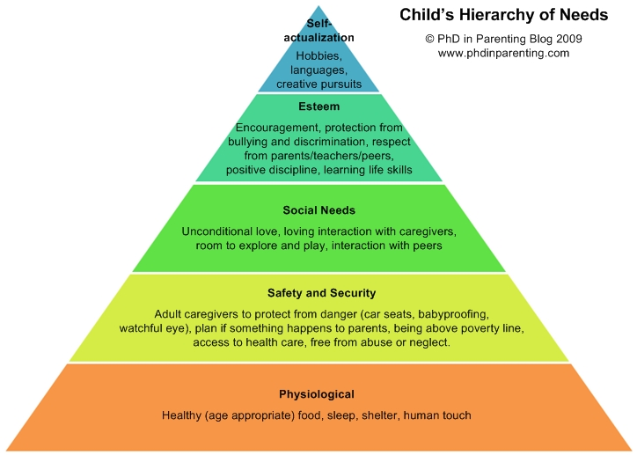

Possible underlying causes of behaviour

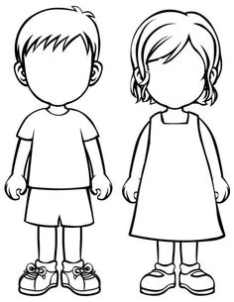
Expectations

Demands
Physical/
sensory needs

Self-esteem

Confidence

Understanding

Opportunities
Attention
Emotional stressors
Relationships
Skills and abilities
Self-concept
Family
Personality
Previous experiences
Levels of development
Possible underlying causes of behaviour explored

Behaviour | Useful things to know about the child’s lived experience. | Suggested things for you to find out more about. | What will you do differently?
Relationships | Was the child born at full term or pre-maturely?  What is the child’s previous experience of being left?  How did the child respond when their parent left them in the past?  What special friendships or connections to other people (or pets) has the child formed? | Attachment theory.  The importance of drop off and pick up- http://suzannezeedyk.com/childcare-practice-suzanne-zeedyk/  Penny Tassoni offers an approach called Settling in without tears-https://www.youtube.com/watch?v=mF7UcRVqdGo  How relationships are developed from the first meeting with parent to first time being left at the setting. | For example:  Settling in plans to ensure that child and KP have an established bond before the child is left for the first time.  Connection-is the KP ‘there’ for the child on arrival and throughout the child’s time at the setting?
Family  Developing honest, non-judgemental, sensitive relationships with the family is crucial.  Be aware of using correct terminology. | Are the basic needs of the child and parent / carer being met?  Are the family being supported by other health, social care, housing or other services? In the past or now?  Have any changes happened or due to happen to the family structure?  What languages are spoken at home? | What need is not being met currently?  Maslow’s hierarchy of needs.  Joint working with multi agencies.  What this means for the child’s routine.  Culture, home rules and expectations.  Essential key words in home language to get their needs met.
Previous experiences | How many different partings has the child experienced before starting at your early years settings?  What, if any trauma has the child experienced? | What were these like for the child? What would the parent like to happen?  Planning an arrival and parting routine with the  parent / carer.  Find out more about adverse childhood experiences (ACE).
Expectations and demands | How does the child cope (or not cope) with routines and the many transitions that happen in a day?  What upsets the child?  How do they show this?  How much time is the child given to process an instruction and respond?  How easy is it for the child to co-operate?  How does the child manage with being asked to stop something that they are enjoying doing to follow a request? | How consistent and predictable are routines?  How are rules and expectations are communicated?  Are expectations fair and understood by the child?  Visuals?  Are routines helping or hindering the child?  Adult understanding of self-regulation and their role as co regulator.  What is the balance between adults giving attention to the positive things that children are doing versus the unwanted behaviours?
Levels of development | So far, is the child’s development progressing as typical for their age?  Has the 2-year-old check highlighted anything to watch out for?  What are you helping the child with now?  Speech, communication and language,  Physical development and self-care, Personal, emotional and social skills?  Has the Health Visitor or GP been consulted about anything? | Staff knowledge and skills in understanding: Child development, Stages of language and communication, Personal, social and emotional wellbeing.  The uniqueness of the individual child.  Do the resources available match the level of development, interests and offer appropriate challenge?  Staff skilled in observation and recognising levels of emotional wellbeing & / or signs of anxiety?  Leuven scales of wellbeing and involvement.  Peer observations.
Attention | What does the child enjoy doing at home?  How long are they able to focus on something that they are interested in?  Does the child have enough sleep at night?  Does the child take a nap in the daytime?  Does anything make the child anxious? | Is the environment and choice of resources interesting and stimulating for the child?  Is the environment overstimulating? Too much noise, too many images and too much choice?  How strong is the Key Person to child attachment and connection?
Understanding | Has the child had a recent hearing / sight test?  Has the child had Speech and language Therapy?  Has a Wellcomm pack assessment been undertaken? | Is the child understanding words?  Are instructions at the right level for the child?  Are you giving the child pre warning of what is to come? Using objects, photos or pictures to support?  Ask your Early Years Advisor or Worker for the loan and demonstration of a Wellcomm pack  Book on training ‘Using visuals in your setting training’
Emotional stressors | Are the needs of adults being met? What upsets the adult? What support is there for the adult?  Are the needs of children being met? What upsets the child? What comforts the child? | Leader/manager connection and support for the adult?  KP connection with the child.  Recognise and reduce any stressors.
Physical & / or sensory needs | Does the child avoid or need a lot of stimuli such as  touch, sound, taste, sight, movement? | Is the environment inside and outside providing the right amount of sensory opportunities and the chance to move in different ways (for this child)?  Proprioceptive and vestibular senses being planned for.  Knowing about hyper or hypo sensitivities.
Opportunities | How does the child express what they feel and need?  How much do you do for the child that they might be able to do for themselves? | Opportunities to be independent.  Visual support  Being given choices  Being listened to
Skills and abilities | What is the child good at?  What does the child find difficult?  What and how is the child being supported now? | Appropriate risk and challenge?  Child characteristics as an effective learner.  Adult characteristics as an effective teacher.
Self-esteem | Is the child confident and at ease with themselves?  How is the child’s name pronounced?  How does the child deal with things that so not go their way?  The child’s culture and heritage | How do adults show that they like being with the child?  The impact of body language and spoken language.  How children are made to feel unique and special.  How are children supported to develop mastery in what they do?
Self-concept | How would you describe the child?  What is the child’s view of themselves? | Are you seeing these characteristics when the child is in your setting?
Personality | How are children learning about their character? | How is the child being helped to understand their developing characteristics (intrapersonal) and their peers (interpersonal)?  How does the family see their child?
Self Confidence | Able to engage in what they are doing?  Positive actions noticed?  Given choices and opportunity to be independent? | Leuven scales of wellbeing and involvement

What need is the child displaying through their behaviour?
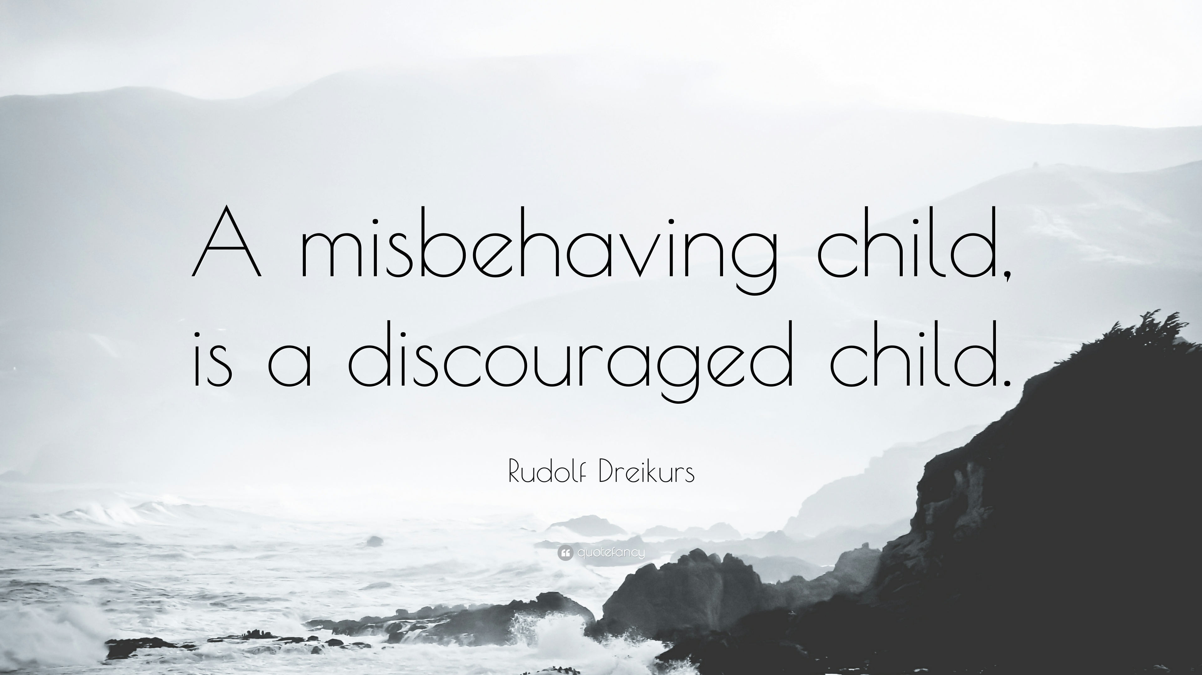

Child psychiatrist and educator, Rudolph Dreikurs (1897-1972), believed that people are motivated by their need to belong. When a child misbehaves, he suggests, that this is a result of feeling a lack of belonging to the social group and that the child will act from one of four ‘mistaken goals’. These four ‘mistaken goals’ are: the need for attention; power; revenge or avoidance (inadequacy).

The need for attention
The child’s belief is that ‘I only belong when I am being noticed.’ The child will misbehave in order to get the adult’s attention, even when this is negative attention.
The adult can feel annoyed and irritated by the child’s frequent misbehaviour and will often give attention to the misbehaviour.
What can the adult do?
The adult can ignore the attention-seeking misbehaviour, when possible (providing there is no risk to the child, others or the environment). Give attention for positive behaviours. Distract the child from attention-seeking behaviour by giving alternative actions or choices, e.g., ‘Come over here and help me set up the train set.’

The need for power
The child’s belief is that ‘I only belong when I am in control or am the boss, or I am proving no one can boss me!’ The child will refuse to follow adult instructions.
The adult can feel angry and provoked that their authority is threatened and will often give in or ‘fight’ back in an attempt to remain in control.
What can the adult do?
The adult should withdraw from the conflict, as the moment they engage in a battle for power, they have lost. A child who learns to gain power with misbehaviour will escalate that behaviour until the adult gives up in frustration. Instead, the adult should use the child’s need for power constructively, by enlisting their co-operation and help’ (giving a duty such as a monitor, or responsibility for a job), e.g., ‘Could you help me getting the fruit ready for snack today?’ This is known as legitimate power.

The need for revenge
The child’s belief is that ‘I only belong by hurting others, as I feel hurt. I cannot be loved.’ The child who seeks revenge is really hoping to find love. Their vengeful behaviour is a way of showing us that they feel so bad about themselves, and so misunderstood, that they are resorting to wanting others to feel what they feel.
The adult can feel deeply hurt and may retaliate in an attempt to ‘get even’. This is also the case when the adult is responding to a vengeful behaviour from one child to another.
What can the adult do?
The adult should avoid feeling hurt and wanting to retaliate. They should not engage in a power struggle and should remove ‘the audience’ (peers, other adults) and should use logical consequences, such as ‘I can see that you are really upset that you couldn’t play with the trains, but Billy is playing with them now. Come over here and let’s play with the cars instead, until the train set is free.’ The adult should be directive and assertive, but in a caring manner.
They should build a trusting relationship with the child, convincing them that they are loved.

The need to display inadequacy (avoidance)
The child’s belief is that ‘I only belong by convincing others not to expect anything from me; I am unable; I am helpless.’ The child has given up on himself or herself and their behaviour takes the form of ‘not’ doing e.g., not cooperating, not participating in activities.
The adult can feel despair and hopelessness and wanting to ‘give up’ and may find themselves agreeing with the child that nothing can be done.
What can the adult do?
The adult should stop all criticism of the child and encourage any positive attempt, no matter how small, by helping the child to find small successes. Help the child to understand that failure is acceptable and the way in which we all learn, recognise small achievements and use the phrase ‘tell me more’. This will encourage the child to notice their small successes.
Most importantly, the adult should not be ‘hooked into’ pity and not give up on the child.

Further information on ‘the Four Misdirected Goals of Behaviour’ by Rudolf Dreikurs

Dreikurs R and Soltz V (1992), ‘Children: The Challenge’, Penguin Books Ltd
Dreikurs R and Cassell P (1990), ‘Discipline without Tears’, Penguin Books Ltd

https://www.open.edu/openlearn/health-sports-psychology/supporting-childrens-development

How do you feel?

Disrespected, exhausted, de-motivated, judged, uncertain, un-supported, emotional, angry, annoyed, de-skilled, upset, worried, stressed, challenged, helpless

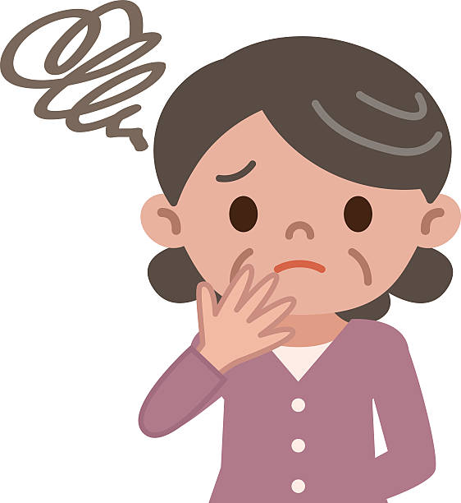

When responding to children’s behaviours, it is important for the adult to consider how the behaviour is making them feel. In order to support children and act as a co-regulator, adults need to be in a calm state, demonstrate positive body language, be consistent and fair.

If the adult feels threatened, challenged or stressed the survival state of the brain may be alerted and they may respond to the child’s behaviour inappropriately. See section below on brain states.

Neuroscience- what brain state is the adult and the child in?

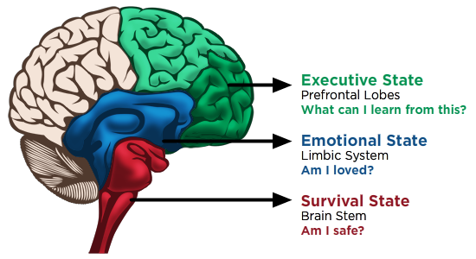

https://sarahtuckett.com.au/why-i-get-you-to-move-and-breathe-in-your-session/triune-brain/

Step 1 Survival State (Safety)
The reptilian brain is all about survival and being safe. In response to stress, the hormone cortisol is released. When this part of the brain is on alert it can shut down higher order thinking. Often this can be a non-verbal state (fight, flight by running, freeze by withdrawing, submission). Being conscious of how you are feeling is the first step to making a connection with a child who is feeling emotionally unsafe. Recognising and regulating your brain state will have the biggest impact on your ability to support a child.
If adults are not feeling safe and secure in knowing what is expected of them in their role, it will be difficult for them to help a child who is feeling out of control and in flight or fight mode. Agreed routines and expectations and adults who feel well supported themselves will be able to be a co regulator; to help a child to feel physically and emotionally safe. Visual images and adults who react in a calm manner can help children become aware of what is happening. Children in a fight or flight state need calm reassurance from adults who are assertive and feel in control. To be able to help a child move from the survival brain state the adult needs to be a higher brain state than the child. Taking a deep breath can help you to move out of your survival state.
Step 2 Emotional State (Connection)
- The limbic system (brain stem) is about emotions and our sense of identity. We all need to feel connection to others, to know that we are cared for and that we matter. We all need to not be criticized or judged but to be helped. Our emotions are a natural response to a physical feeling, and they need to be recognised and named. We should not be blamed for our behaviours because these are mostly unconscious and driven by our spontaneous response to what could be a threat to us. Giving positive choices and being shown empathy is important to help us to feel more in control and ready for processing thoughts and actions. Change does not happen quickly though.
- Hormones surge around our bodies for hours. It is important for us to help children move out of the survival fight or flight state as soon as we can. This is the time to model and teach emotional intelligence (naming and recognising the feeling “I can see that –got on the bike first and this has made you feel angry”). This is not the time to try to help the child problem solve. Asking too much of the child when they are in this brain state will not work yet.

Step 3 Executive State (Problem Solving)
- Higher order thinking and problem solving will be more effective when both adult and child are in a state of calm. You will know the child and be able to see when they can focus and engage (it may be much, much later) but will be more successful then. “Do you remember when---happened? Have you got any ideas what you could have done instead?” Mine Conkbayir (2017) has described the impact of too much cortisol as a “roadblock to higher order functioning.”

“Executive function and self-regulation skills are the mental processes that enable us to plan, focus attention, remember instructions, and juggle multiple tasks successfully. Just as an air traffic control system at a busy airport manages the arrivals and departures of many aircraft on multiple runways the brain needs this skill set to filter distractions, prioritize tasks, set and achieve goals, and control impulses.” (Center on the Developing Child, Harvard University, cited by Grenier, J. 2020)

Information about recognising and supporting children who are in fight, flight, freeze or submission http://www.innerworldwork.co.uk/wp-content/uploads/2017/04/What-Survival-Looks-Like-At-Home.pdf
and http://www.innerworldwork.co.uk/wp-content/uploads/2017/04/What-Survival-Looks-Like-At-Home-Quick-Printout.pdf

Understanding self-regulation and the adult’s role as co regulator.

The behaviours that we see are forms of communication, driven by feelings and emotions that children’s self-regulatory systems are not able to cope with yet. It is about a child’s ability to cope with feelings that are fuelled by stress.

“Developing self-regulation, like many elements of development and learning, is not something children do by themselves. It is a process that grows out of attuned relationships where the caregiver and baby or child are closely attentive to each other and engage in sensitive, responsive exchanges”. (Birth to 5 Matters: Non-statutory guidance for the Early Years Foundation Stage p.20)

Dr. Suzanne Zeedyk explains self-regulation and how adults can help children.
Foundation Years LED events: Self-regulation in the early years - Dr Suzanne Zeedyk - YouTube
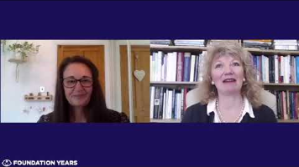

It might be useful to know the Early Years Foundation Stage Profile (EYFSP) Early Learning Goal for Personal, Social and Emotional Development. This statutory assessment takes place at the end of the reception year to ascertain what children who have reached an expected level of development, will be able to do.
ELG: Self-Regulation
Children at the expected level of development will:
Show an understanding of their own feelings and those of others and begin to regulate their behaviour accordingly.
Set and work towards simple goals, being able to wait for what they want and control their immediate impulses when appropriate.
Give focused attention to what the teacher says, responding appropriately even when engaged in activity and show an ability to follow instructions involving several ideas or actions.

Our role is to help children realise their full potential, to have their emotions and response to their feelings validated and teach them skills to cope with these feelings and emotions that can often be totally overwhelming for them (and for adults too!).

To support children to develop self-regulation and emotions here are a few things that you can do:
- Take a slow deep breathe to regulate your brain state which may be in survival (fight, flight or freeze.
- You are having a normal reaction to a stressful situation. This will give you a moment to
- become self-aware, recognise your own emotional state and reset your body language. This will help you to move from a flight or fight or freeze state yourself so that you will be able to
- notice the child’s physical actions, name the emotion (not the behaviour), and validate that feeling.
- Step into the shoes of the child to begin to see things from their perspective. Try to avoid the behaviour becoming a power struggle.

Elizabeth Montero-Cefalo advocates a ‘DNA approach’:
D=Describe what the child’s body is doing “Your hands are all tight like this”
N=Notice the feelings and name them “You seem angry”
A= Acknowledge the child’s intention “You hoped that you could play with the blocks longer, that was hard for you to be told it was tidy up time”. Wait for a response and if none, “You can choose to tidy up the blocks with me now or in 5 minutes”.

David Whitebread was a principal researcher into self-regulation in young children. Here are the key things that he believes adults can do to make a difference to children’s ability to self-regulate:
- Provide emotional warmth and secure attachments
- Provide opportunities for appropriate cognitive challenges
- Provide a sense of autonomy and feelings of control
- Provide for metacognition by support children to reflect, plan and monitor how they are getting on
David Whitebread - How can you support the development of self-regulation? - Siren Films
https://www.sirenfilms.co.uk/library/david-whitebread-how-can-you-support-the-development-of-self-regulation/

Dr Mine Conkbayir refers to self-regulation as knowing how to manage your emotions and behaviour in any situation you might find yourself in. Mine and Ursula Kryek Walton discuss the importance of self-regulation for child development, and the strategies you can bring into your settings to put the child’s emotional wellbeing first. A Self-Regulation Revolution - Why we should focus on it (famly.co)
https://www.famly.co/blog/mine-conkbayir-ursula-krystek-walton-self-regulation

Key Skills in transforming behaviours

- Recognise how the behaviour is making you feel.
- Check your body language and the way you speak to children. Keep calm. Be positive and confident. Use language carefully.
- Be consistent. All staff need to know and use the same strategies/approach.
- Manage your own behaviour. Model play, language, sharing, how to handle difficult situations.
- Plan for safe behaviour. Establish and teach simple rules and expectations – be clear.
- Catch examples of safe behaviour. Give descriptive feedback.
- Be positive – focus on what you want. Describe the behaviour you want. Give positive choices.
- Separate behaviour from the child. The behaviour is unacceptable, not the child.
- Pre-empt unsafe behaviour. Find out if the child may be internalising something that happened earlier in the day. Notice any changes in body language (‘rumblings’).
- Re-direct when you can. Be confident knowing the behaviours needed, communicate these with clear and calm tone of voice and confident body language.
- Give clear and simple instructions, giving reasons. Be prepared to repeat them. Use the child’s name first to gain attention, get close, lower your voice, and speak directly.

Strategies

Specific Praise:
This is a very easy and effective strategy, stopping the child only receiving attention when something goes wrong and the child only receiving negative feedback from adults. Research shows that when adult interaction is 75% positive it has the most beneficial impact. Tip: remember the ‘hand’ rule – 4 positive comments to 1 negative.
- Encourage safe behaviour not only with the child concerned but with all the children and avoid making comparisons.
- Give children lots of descriptive praise/feedback when they have worked as a group without any incidents.
- Praise safe behaviour by giving descriptive feedback to the child. Use the child’s name and the action that is being praised. For example, ‘’ Billy, you are keeping the train on the tracks, well done.’’
- Praise the child using non-verbal communication – smiles, thumbs up, high five!
- Keep a positive diary to share with parents/carers. Encourage 2-way ‘good news’-sharing.

Ignoring the unsafe behaviour / selective attention:
- Can the behaviour be ignored? For example, if it is not disruptive or harmful to themselves or other children.
NB: If the behaviour is attention seeking, you could be reinforcing unacceptable behaviour by paying attention to it.

Pre-empt unsafe behaviour:
- It can be possible to anticipate unsafe behaviour or to intervene before it occurs. Review your routines and transitions and make changes. Cascade knowledge of anything that may trigger a reaction and know what physiological changes may demonstrate that the child is feeling stress.

Supporting the child to recognise their feelings:
- Supporting the child to remove themselves from the situation can take the heat out of the problem and gives the child time to calm down.

State what has happened, empathise and acknowledge the child’s/children’s feelings:
- Help the child who has demonstrated unacceptable behaviour to find a place away from the situation or relocate the other children. Provide discreet adult support to ensure the children are safe. Allow enough time for the child to regain control. (The emphasis is on helping the child to become calm and not a punishment).
- Once the child is calm, praise for demonstrating acceptable behaviour. Support the child to choose appropriate activities.
- Plan to focus on building the child’s skills to manage their behaviour e.g., taking turns.

Offer choices:
- If a child is offered a choice they will feel like they still have some control and are more likely to respond to your request rather than give a blanket refusal. The choices given can be all things you want the child to do i.e., they are ‘forced choices’ (I need you to sit down. Will you choose the blue or the red cushion?)
- Choices can be used as a distraction method, offering the child something you know they really like BEFORE the behaviour becomes unacceptable, for example ‘’Sally, will you give one of the trains back to Fred or come and paint with me?’’.
- If unacceptable behaviour has occurred, use choice as a way of leaving the child with some feeling of control but direct them to something you want them to do.

Helping children to resolve conflicts:
- Approach calmly and confidently and be aware of body language. Prepare yourself for a positive outcome. Empathise and acknowledge the child’s feelings (e.g. Billy, you seem angry/sad/upset/ very upset). Give children time for their feelings to subside, and then let them know that you think that they can work out a way to solve the problem.
- What do they need? Listen carefully to each child’s details and needs; they are the key to finding the solution. Identify the problem.
- Restate the problem and check that both children agree.
- Help the children to find solutions/ make plans and choose one together.
- Give follow-up support. Check with each child that the problem has been resolved and recognise their efforts.

Change the adult:
- As soon as the adult has recognised that they are not in a calm place, this is the time for another member of staff to become involved, to relieve pressure on individuals and to give a consistent message about expectations.

If unacceptable behaviour is linked to times of the session:
- Refer to a clear visual timetable.
- Have a few simple rules and routines. Be consistent in making sure they are kept and, demonstrated.
- State and demonstrate what you expect clearly. For example, “James, water stays in the water tray, you can use this jug to pour it”.
- Make sure all children are given sufficient warning of when an activity is due to change using verbal, objects of reference (e.g., sand timers), visual and/or auditory cues.

Points to remember:
- Concentrate on one behaviour causing most concern.
- Define the behaviour clearly.
- Empathise and acknowledge the child’s feelings, “I can see you feel……”.
- Be consistent, calm, and clear about the message you are conveying.
- Provide more of what the child likes (refer to the positive diary/observations).
- Give strategies a chance.
- Have a few simple positive rules and ensure that all staff model and set these.

Using ABC and STAR approaches to observing behaviours.

ABC This observation method enables practitioners to identify the antecedent (the trigger) to the behaviour, to describe the behaviour itself and then to consider the consequences for the behaviour. Once the ABC observation is completed, the aim is to consider ways to change the antecedent, the behaviour and the consequence.

A – the trigger to the behaviour. What specific actions set off the behaviour? The behaviour may have occurred due to a change in activity, new instruction, the child’s perceived threat or because they were hungry, tired or unsure of the expectations.
B – a description of the observed behaviour, ensuring that this is objective not subjective. For example, ‘John snatched the train out of Raheem’s hand’, rather than ‘John was not playing with the trains nicely with Raheem.’
C – this is the consequence, or result, which immediately follows the behaviour. It can be positive or negative, such as gaining attention from another person (even if the attention is negative) or getting control of an activity or game.

By completing an ABC observation after each occurrence of an unsafe behaviour, the practitioner may be able to recognise a pattern in terms of when the behaviour occurs, for example, the day or time, particular children, resources or activities. Refer to the table below for possible strategies and interventions.

Suggested possible ‘ABC’ strategies and interventions
What led up to it? | Behaviour | What happened next?
Changing the Antecedents  - Avoid situations until you have taught the child how to cope with that situation.  - Use distraction– offer alternative activity in an age-appropriate way.  - Ensure that instructions can be understood, provided verbally and visually– be aware that non-compliance may indicate poor understanding of verbal instructions.  - Practice the rules frequently with children, so that they understand the expectation.  - Give clear rules/say what the rule is/show what behaviour you expect and explain why the rule is needed.  - Give an early warning of activity change. Support with visual clues e.g., sand timer.  - Have realistic expectations - age/stage appropriate.  - Look at the environment. Does the layout/routine/range of equipment need adjusting/is there enough choice and challenge/do you need signing/symbols for communication?  - Offer positive choices, “Do you want to have a go yourself, or would you like some help?’  - Get the child’s attention before giving directions. Cue individual children in first. E.g., say their name, use touch or a visual cue card  - Pre-empt with positive attention, or additional adult support.  - Add an element of fun/humour.  - Analyse observations - are there personality clashes/unacceptable noise levels/particular times in the session children find difficult.  - Liaise with parents; find out what the child’s specific triggers/ motivators are.  - Use rule reminders frequently to encourage expectations of behaviour.  - To encourage resilience in the child, try saying “I know this is difficult but have a go”. | Changing the Behaviour  - Teach alternative behaviour and give praise accordingly. E.g., asking for a toy instead of snatching,  - State what you want, not what you don’t e.g., ‘Don’t throw the toys’ becomes ‘Put the toys away into the box, so we are all safe.’  - Model positive behaviours.  - Use “I” messages which communicate adult feelings. Emphasise the effect of the behaviour and not the child.  ‘I feel worried when the toys are left on the floor, as someone may hurt themselves.’  - Provide additional adult support (particularly important with unsafe behaviour e.g., biting). Look at the need behind the behaviour. Provide a safer alternative e.g., a biting object.  - Also look at the examples in ‘changing the antecedents’ as this will also support changes to behaviours. | Changing Consequences  - Give selective attention. Ignore behaviour (where it is safe to do so, e.g., will not harm people or property), praise agreed behaviour.  - Catch the child following rules and agreed behaviours and give praise. Be specific – e.g., remembering to put the toys away when finished with them. Use the child’s name.  - Be a good role model. Name emotions, model self-calming, promote empathy, think out loud and don’t over-support.  - Be consistent with all children and for every member of the staff team. At first, every incident of unsafe behaviour needs dealing with, just as every example of safe behaviour needs encouraging.  - Reflect after the event and review what the behaviour is telling you (the child’s need). Change the adult response, the environment, the resources, routines.

STAR This observation method identifies the setting context in which the behaviour occurs, the trigger to the behaviour, it refers to the behaviour as an action and the consequence of the behaviour as a result. It is used in a similar way to the ABC to observe behaviour and to consider ways to change each element of STAR. This observation method is often used to observe the behaviour of children with Autism.

Zarkowska E and Clements J (1994) Problem Behaviour and People with Severe Learning Disabilities: the STAR Approach. London: Chapman and Hall. 2nd Edition.
Clements J and Zarkowska E (2000) Behavioural Concerns and Autistic Spectrum Disorders: Explanations and Strategies for Change. London: Jessica Kingsley Publishers.

S – settings are defined as the general context in which behaviour occurs and can be internal or external to the child:
Internal – anxiety states, communication difficulties, pain, ill health, tiredness or hunger
External – environment, temperature, activities, life events such as family changes.
T – triggers are the signals which set off specific actions and occur just before the behaviour. These either increase a personal want, suggest a likely threat, or signal the availability of a desired reward, such as:
- another child joining established play may be seen as a threat to the game and trigger a response.
- too many children in proximity at circle time might trigger the need for personal space.
A – the actions are the actual behaviour observed. Such as:
- hitting, kicking, pushing
- screaming, swearing, shouting out
- biting others or self, pulling hair
- running, climbing, throwing
R – the result is the consequence which immediately follows the behaviour. Such as:
- gaining attention from another person (even if this is negative attention)
- sensory reward (enjoying the sensation of biting something)
- gaining a toy or control of an activity
- gaining control of people or getting their own way.

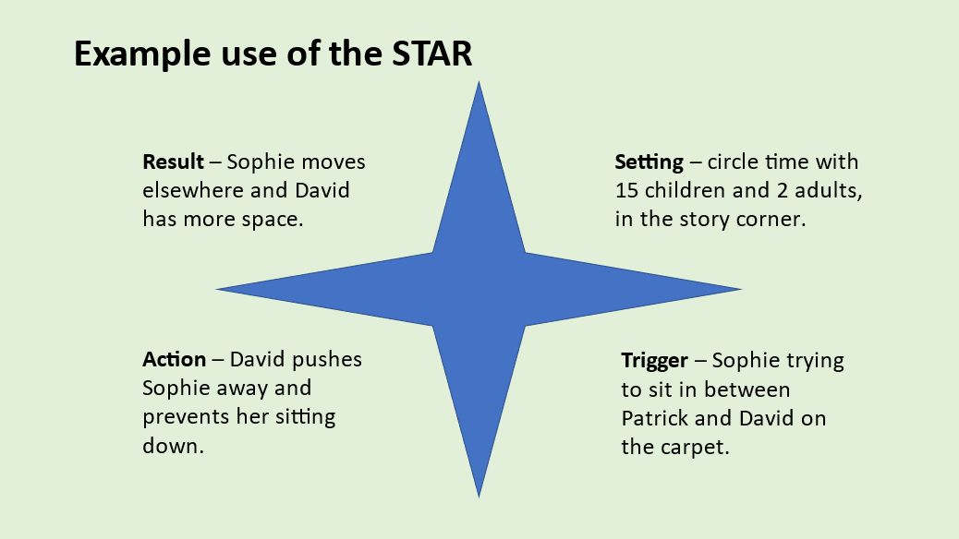

Working together with parents

The 2021 ‘Statutory Framework for the Early Years Foundation Stage Setting the standards for learning, development and care for children from birth to five states:

1.12 Throughout the early years, if a child’s progress in any prime area gives cause for concern, practitioners must discuss this with the child’s parents and/or carers and agree how to support the child.

Some resources that may be helpful to share with the parents:

https://www.nhs.uk/live-well/sleep-and-tiredness/how-much-sleep-do-kids-need/

https://www.bbc.co.uk/cbeebies/grownups/help-your-child-try-new-things

How to talk to your child about emotions - CBeebies - BBC

How to look out for your child's mental health - BBC Tiny Happy People

Keep Your Cool Toolbox - Home | Keep Your Cool Toolbox

For practitioners new to implementing a daily schedule and for sharing with parents for support at home: https://www.facebook.com/ConsciousDiscipline/videos/visual-daily-schedule-with-elizabeth-montero-cefalo/846910072480409/
The Parent Hub | Suffolk County Council
What else you have found useful?

Examples of further resources (there are masses out there to choose from):

Videos:
Alfred & Shadow - A short story about emotions (education psychology health animation).
 https://www.youtube.com/watch?v=SJOjpprbfeE

Three core concepts in early childhood development:
https://developingchild.harvard.edu/resources/three-core-concepts-in-early-development/

Flipping your lid video:
Keep Your Cool Toolbox – The Handy Brain Model

Starting with understanding and being kind to ourselves as adults:
https://www.facebook.com/LauraFishTherapy/videos/1661024767395059/?t=1

Know your own emotions to understand your behaviour:
How Can We Rethink Children’s Attention Seeking Behavior? | Famly

Elizabeth Montero-Cefalo offers some practical step by step tips for bringing a child from a survival brain state to an emotionally safer place
https://youtu.be/3t-yLg4buj4

Managing challenging behaviour in early years settings – YouTube
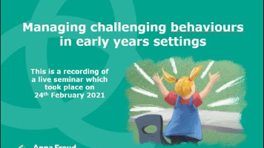 https://www.youtube.com/watch?v=EqpuY_It5X4

Early Years Bereavement Seminar
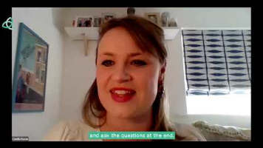

Supporting children in early years settings who may have experienced trauma or abuse
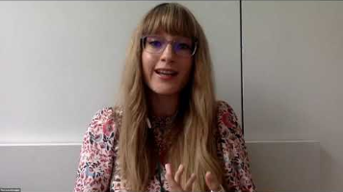

Why telling upset children “you’re okay” never works | Famly

Mindfulness

https://laurafishtherapy.com/resources/MindfulnessInTheClassroom-pt1.pdf

https://www.laurafishtherapy.com/resources/MindfulnessInTheClassroom-pt2.pdf

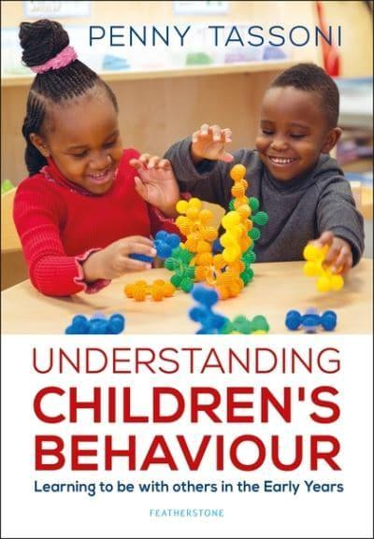
A few examples books from a very wide range that are available:
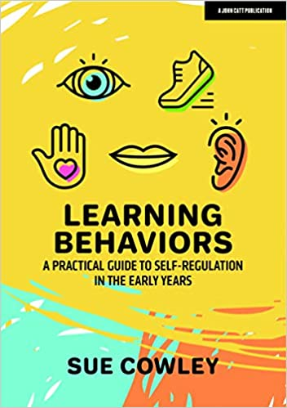
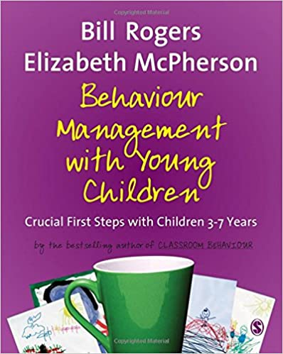

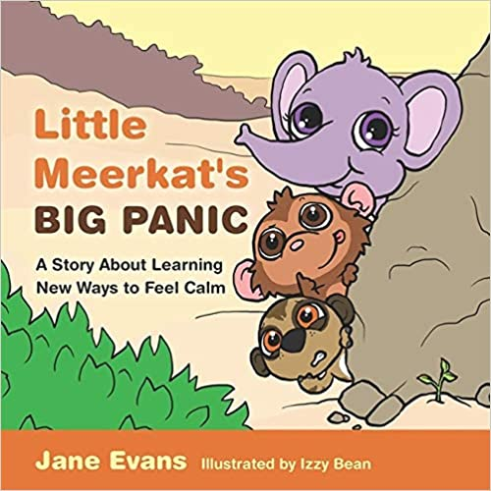

Example: Individual Risk Assessment – Distressing and Unsafe Behaviour
Risk | Likely outcome | Level of risk Low/Medium/High | How risk is controlled | Action to be taken

Date Completed ……………………... Completed by ……………………….. Next review date ……………………
Date Completed ……………………... Completed by ……………………….. Next review date ……………………
Parent Signature ……………………..

Example - Behaviour Support Plan INCORPORATE RISKS A WITHIN THIS WITH STRATEGIES

Behaviour Support Plan
Child’s name: | Date of plan: | Review date:
Behaviour to reduce:

Prevention:  Staff will | If an incident occurs:  Staff will
Parent’s views / comments: | Date agreed:  Signed:  Parent/carer: __________________________________  Practitioner: ___________________________________

