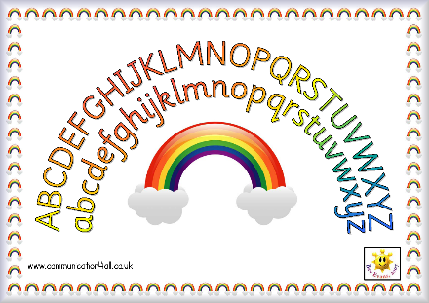

Activities for developing sequencing skills:

Information for parents/carers

Children with dyslexia can find it difficult to remember verbal information in sequence, which often makes it difficult to recall everyday sequences such as, the alphabet, days of the week and months of the year in the correct order. Confidence with these important life skills will boost your child’s self-esteem. This Newsletter has ideas for multi-sensory games and activities to do with your child to help them to practise these sequences.

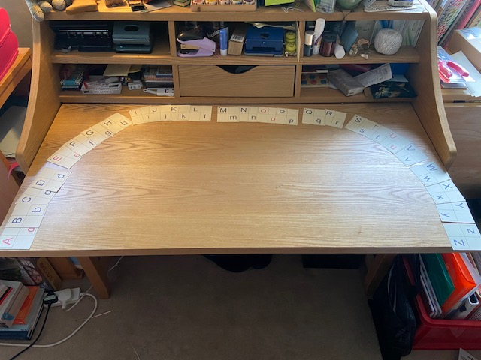Alphabet Sequencing

The Alphabet Arc

Set out an alphabet arc, as above, using the letter cards.

The vowels (**a e i o u**) are highlighted in red.

Set into chunk patterns: ABCD EFGH IJKL MNOP QR STUV WXYZ. It may help to make a coloured dot on the front printed letters A, E, I, M, Q, S, W to make the start of each chunk pattern more obvious.

Model saying the alphabet pausing between each chunk to encourage saying the sequence using the ‘rhythm’ of the chunk patterns. Note that the centre of the alphabet is between M/N.

Children often recite the alphabet by singing the ‘alphabet song’ which is a useful strategy, but being able to recite the alphabet from different points, or say which letters come before and after a particular letter, is more difficult than always starting from letter A.

Games to practise letter recognition and alphabetical order:

* Play **‘The Alphabet Pattern Game’**: A Game for two players. The aim of the game is to collect the most sets of alphabet patterns. E.g. ABCD; EFGH; IJKL; MNOP; QR; STUV; WXYZ. Put all the letters in a bag. The players take turns to take a letter from the bag, building up patterns as they go. The player can use the alphabet arc below to support where necessary. Each player has three swap cards. ‘Swap’ will need to be written on 3 post-its / pieces of paper for each player. A swap card can be used to swap a letter with the other player.
* Play **Battle of the Alphabet**: MN remain at the top and the alphabet arc prompt card below is always visible. The 2 players decide who will take the A and who will take Z. The rest of letters (excluding M/N) are shared between 2 players: encourage each player to name the letters as they take them. The players then take turns placing down as many letters as they can which either follow the alphabet sequence after N or before M working backwards, so the arc is reconstructed. The visual prompt card can be used at any time to support the players, verbally reminding them of the relevant chunk patterns will also help the reconstruction of the arc. The winner is the first player to use up all their letters.

Other activities

Allow your child access to the alphabet arc prompt card below to support these activities where necessary.

* Ask your child to say which letter follows another letter in the alphabet
* Remove some letters from the alphabet arc and close the gaps. Ask your child to say which letters are missing.
* Ask your child to complete alphabet patterns or insert missing letters from patterns. For example EF_ _ , MN_ _ , _ _ UV
* Reciting the alphabet from any letter. Ask your child to start reciting the alphabet from any letter.

Alphabet Arc Prompt card to cut out and use: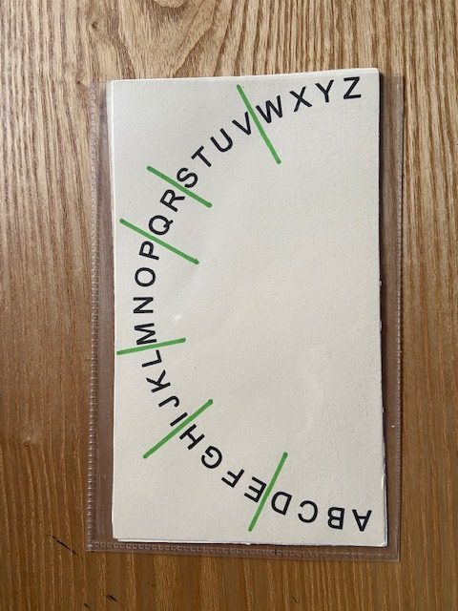

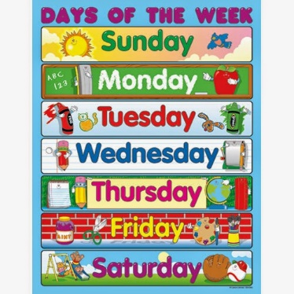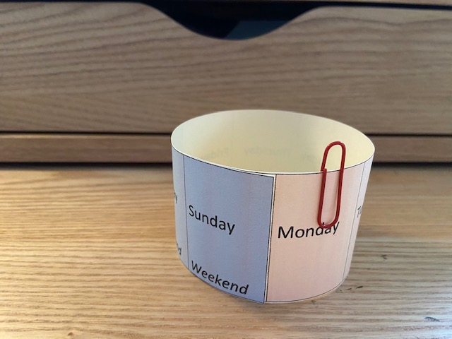

Days of the Week

As well as having a visual prompt of the days of the week as a list, it will help your child to see the days of week as a circle, to reinforce that the days follow on and repeat.

Cut out and make a ‘Weekly Circle’ using the template provided. Use a paperclip to highlight ‘today’.

Encourage your child to use the following words: ‘yesterday’, ‘today’, ‘tomorrow’, ‘weekend’, ‘before’, ‘after’ using questions such as the following when looking at the ‘Weekly Circle’:

* Which day comes after… / before…
* What did we have for tea yesterday? What are you hoping to have for tea today / tomorrow?
* What day was yesterday? What day is today?
* Do you have a favourite day of the week? Which day comes before / after your favourite day?
* How many days until the weekend begins? How many days until…?

Months of the Year

As for the days of the week, it will help your child to see the months of the year as a circle, to reinforce that the months follow on and repeat.

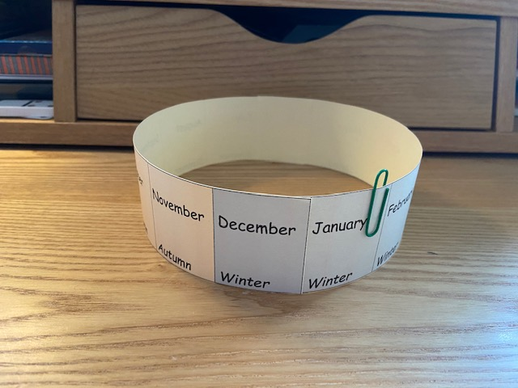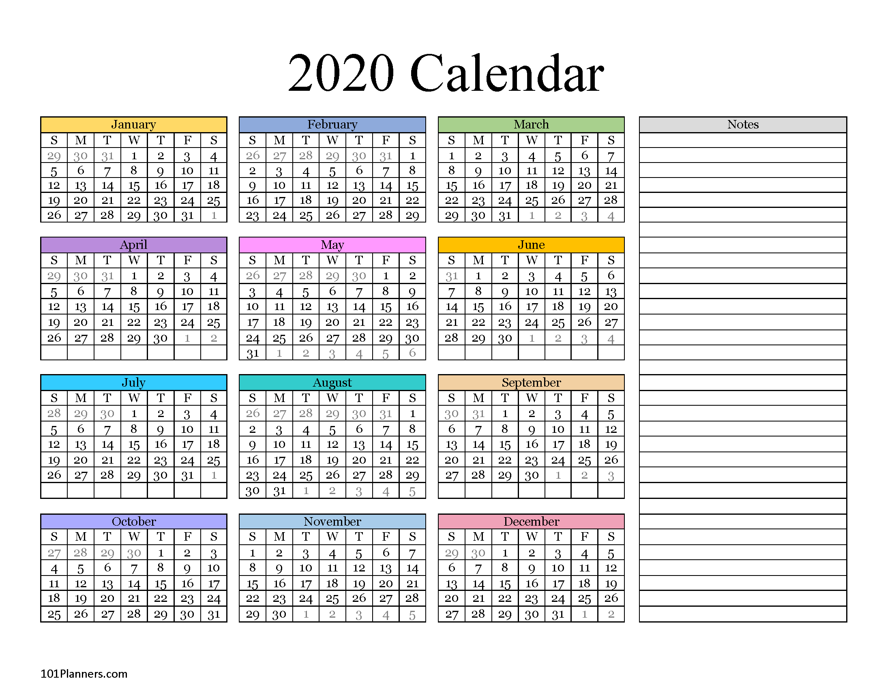

Cut out and make a ‘Yearly Circle’ using the template provided (Document C in the resources folder). Use a paperclip to highlight the current month.

You may wish to use different coloured paper clips to highlight birthday months etc within your family. Encourage your child to use the following words: ‘before’, ‘after’, ‘last’, ‘next’, ‘season’ using questions such as the following when looking at the ‘Yearly Circle’:

* Which month comes after… / before…?
* When is your birthday? How many months until your birthday?
* In which season does the month of January fall?
* In which season does your / my etc birthday month fall?
* Which month starts the school year after the summer holidays?

