Games for developing phonological awareness: information for parents/carers

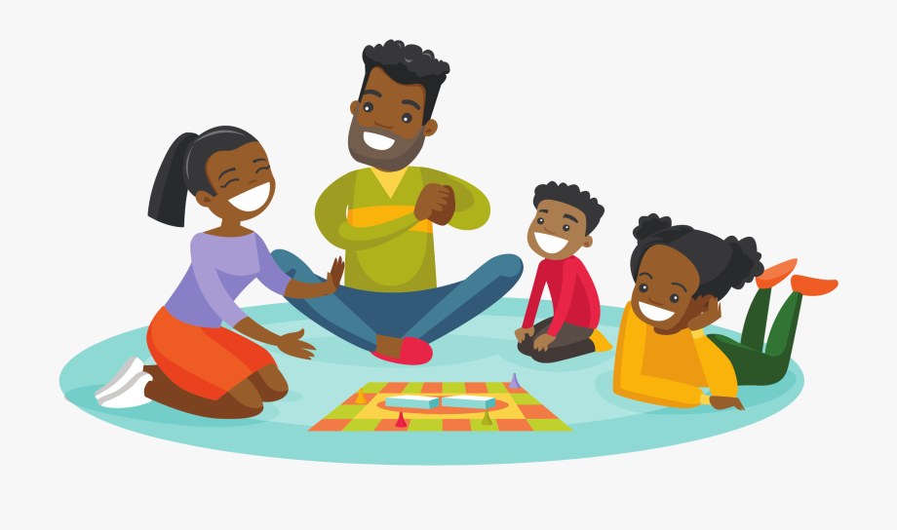

Dyslexia and Phonological Awareness
Phonological awareness is our awareness of the sound units that make up the words in a language. This includes an awareness that speech consists of words; the ability to detect the number of syllables in a word; to detect rhyme and generate rhyming words and to recognise and manipulate sounds in words.
Children begin to develop phonological awareness during pre-school years and studies have found that a child’s level of phonological awareness on starting school is linked to the ease with which he/she will learn to read. Phonological awareness is therefore an important skill but children with dyslexia can have difficulties with automatically developing these vital skills. This newsletter sets out some simple games to play with your child to help to develop their phonological awareness.

Pre-school children
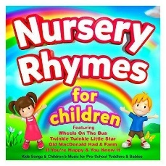Singing and reciting nursery rhymes with your young child is a great way to develop an awareness of rhyme. Some nursery rhymes, such as ‘Pat a Cake,’ also encourage the clapping or tapping of beats (syllables).

There are many CDs of nursery rhymes available to buy, which you can listen to at home or when travelling in the car.
To encourage an awareness of letter sounds, you could play a game where you take turns to make up ‘silly’ sentences where all or most of the words start with the same letter sound (alliteration) e.g. seven sizzling sausages sitting in the sun.
‘I Spy’ is another great game to develop awareness of initial letter sounds in words, e.g. ‘I spy with my little eye, something beginning with t (letter sound).’

Older children

Syllable games

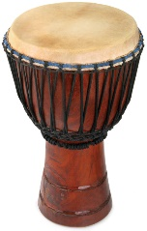The ability to split words into syllables or beats is an important skill which will help your child read and spell longer words. When playing syllable counting games, it’s best to use pictures, as this will support your child’s memory. If you make your own picture cards, you can personalise them to reflect your child’s interests, which will make games more fun!
Counting syllables: - use a drum, clap beats, or put a hand under your chin to feel the number of times your chin moves down when saying a word, e.g. pen, chin moves once (1 syllable); table, chin moves twice (2 syllables). The hand under chin method will encourage your child to count beats, rather than sounds in words. Your child can also use their whole body for counting syllables by stamping, hopping, or jumping each syllable. You can help older children to say and spell longer subject-specific words, by including pictures of these in syllable counting games.
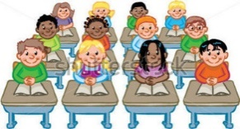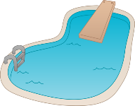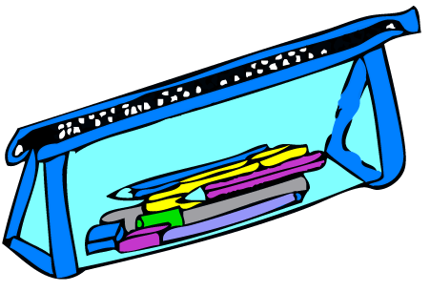Odd-one out: - make or buy some picture cards. Write the number of syllables in each picture on the back of the cards. Put out three cards (two with same number of syllables) and ask your child to say each word aloud, count the syllables and pick the odd-one out. They can look at the numbers on the back of the cards to check if they were correct.

Syllable picture and number matching: - add number cards to the picture cards you are using. Spread out both sets of cards face upwards. Take turns to pick a number card and then to pick a matching picture card, with same number of syllables. Use the numbers on the back of the picture cards to check and if correct, keep both cards. The winner is the person who collects most pairs of cards.
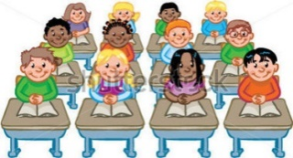
2

Talk in syllables: - take turns to choose a picture card without the other player seeing the card. Say the word in its syllables, with a short pause between each syllable, e.g. pen-cil case. The other player blends the syllables and says the complete word, looking at the picture to check if correct.

Rhyme Games
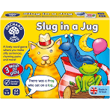
Again, you can make rhyming picture cards which reflect your child’s interests, or you can buy rhyme games, such as ‘Slug in a Jug’ (Orchard Toys).
Rhyme Pelmanism: - put the rhyming pictures cards face down and take turns to turn over two cards. Say the words aloud to see if they rhyme. If so, keep the cards; if not, turn them over again. The winner is the one who has collected the most pairs at the end of the game.
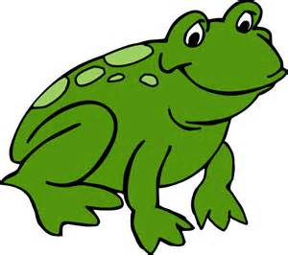
Rhyme Generation: - it is more difficult to generate a rhyming word than to match words which rhyme, so once your child is confident with matching rhyming words, take turns to choose a picture, say the word aloud and then say a new word which rhymes.

Writing and Spelling
When your child is starting to write, he/she may need help to understand that spoken language is made up of individual words. You can teach this awareness by using a numbered grid and some counters. Start by saying short sentences of two or three words, e.g. ‘Sit down’, ‘Have a drink’. Get your child to repeat the sentence aloud and push a counter into the grid as he/she says each word, thereby counting the number of words in the sentence. Using a grid and counters is also a good visual

way of helping your child to identify the separate sounds in words before they try to spell them.

Sit down
1 | 2 | 3

You can use a visual way to help understanding of the concepts first, last and middle as they apply to words in the sentence.
first middle last

