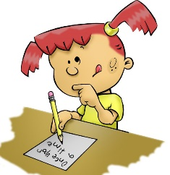

Part 3: Writing
In Part 2 (Issue 8) we looked at alternative methods to recording; in this newsletter we will be looking at ways to support learners to record their ideas in a written format.
Here are some different strategies you may like to use if your child is having difficulties getting their ideas down on paper.

Planning
Having conversations with your children about what they want to write is a good first step. You could use puppets to help act out stories or animate stories on apps such as “Toontastic”. You can scribe their ideas for them or encourage them to record their ideas on a phone or tablet. They can then listen back to their ideas to remind them of what they said or to edit their work.

Writing at home should be fun, don’t get distracted by spelling and grammar concentrate on ideas and letting the writing flow. Use pictures or cartoons with speech bubbles or Post it notes to help get thoughts down on paper. These could also be cut out and rearranged to help sequence their ideas.

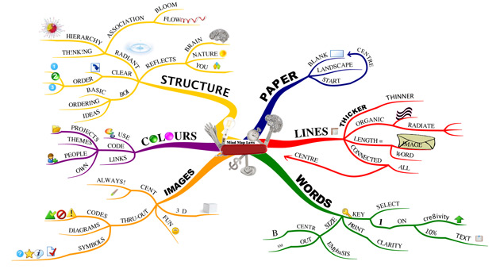
A mind map is a graphical way to represent ideas and concepts. It is a visual thinking tool that helps structure information, helping you to better analyse, comprehend, synthesise, recall, and generate new ideas.
Be visual: use colours, drawings and symbols.
Keep the topic labels short, a single word or picture.
Vary text size, colour and alignment. Vary the thickness and length of the lines. Provide many visual cues.

Writing Frames
Writing frames are a good way to help your child organise and sequence their writing.
Providing side boxes with notes for extra vocabulary and character development can help too.

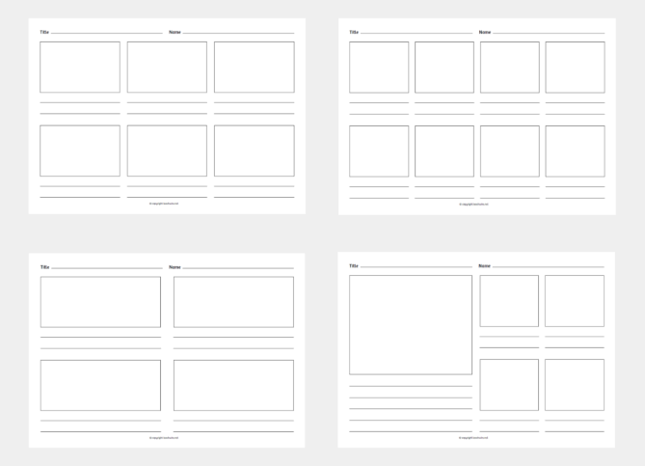
Storyboards are useful for recording key points. Children can illustrate their work too.
For some writers providing sentence openers or sentences to fill in will provide them with the confidence to start writing.
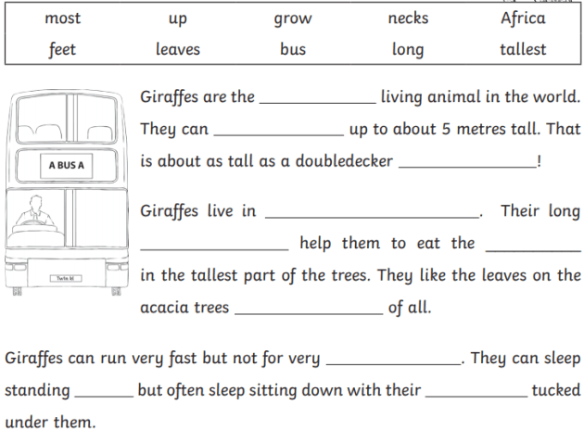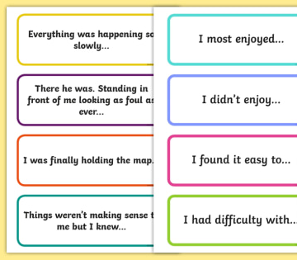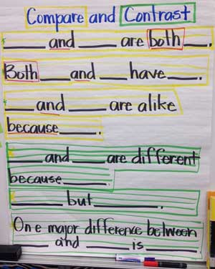

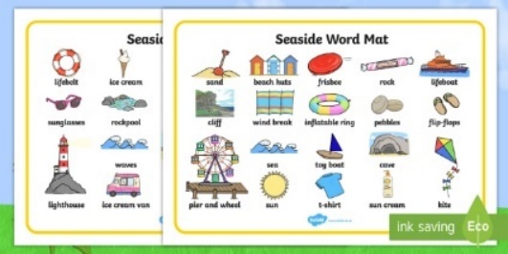
Word banks and lists of key words or alternative words can be useful to have alongside your child as they write. The words provide them with confidence and can prompt them should they get stuck.
Encourage your child to write lists or menus or to make books, like a zigzag book on a subject they love, like dinosaurs, monster movies, football or baking.
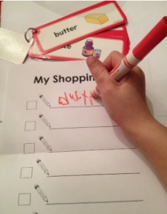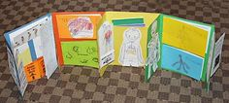
Encourage your child to write and post letters to friends or family members, or keep a journal and write about special events that have happened.
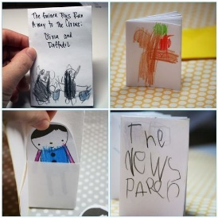
Try to spend time talking about what they will write and scribe their ideas for them.

Remember to look back at Part 2 (Issue 8) for ideas on alternative methods for supporting your child’s writing.

