Handwriting: Part 1

When learning to read, children first must link the shape of the letter on the page with the sound it makes. Then, when it comes to writing, they must recreate that shape back onto paper. It is a complex task that demands fingers and wrist coordination as well as the ability to remember shapes and get them in the right direction.
For children with dyslexia, decoding these patterns and making these links can often be very difficult. As a result, it can be hard to develop the automatic flow of writing which will help them to express themselves clearly and easily in writing.
Developing handwriting is a complex process, so take your time and stay positive.

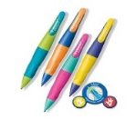

Handwriting tips

- Timed sessions - Keep to short, timed sessions so your child can maintain concentration without becoming bored or uncomfortable. Use sand timers, count downs on iPads/tablets or Google/Alexa devices.

- Sitting position- Make sure your child is sitting comfortably when they write, with their feet firmly on the floor. If it's helpful, try using a slanted writing surface.

- Grip - Help your child to learn to grip the pen/pencil properly using the tripod grip (thumb and fingers). This allows the fingers and wrist to move freely without putting pressure on the hand. It may be useful to explore different pencil grips, pencils or pens may help.

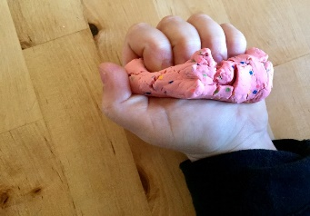
- Muscle strength - Help your child strengthen the muscles in their hand by using play dough or performing hand exercises. It can be useful to warm up their hands before they begin i.e. stretching out fingers, pretending to play the piano on the table.

- Letter formation - Introduce your preferred letter formation through skywriting – use your hand to form the letter in the air whilst talking through the formation. Model this to your child and then do it together – make it fun! You can also help your child with formation by giving them tracing and dot to dot exercises.

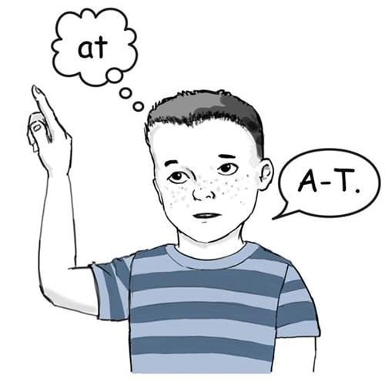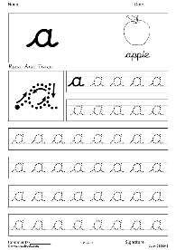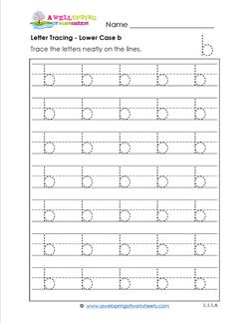

- Recognition - Help your child recognise similar looking letters. Ask them to say their names and sound as they write them. Teach them sayings for remembering the formation: “first the bat then the ball” or “First the drum then the stick”. Or give visual clues “bed”. You can find these resources on this website

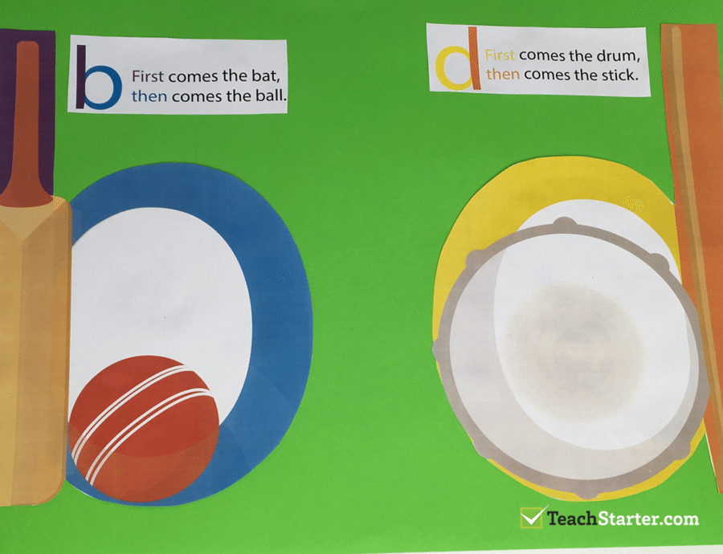

- It's recommended that most children learn to write using continuous cursive handwriting, so they don't have to learn how to form letters twice when they need to write more quickly later on. It may be a good idea to check with your child’s school for the type of cursive writing they use. For some children with fine motor skills difficulties joining up letters can be very challenging. If this is the case focus on printed letter formation.

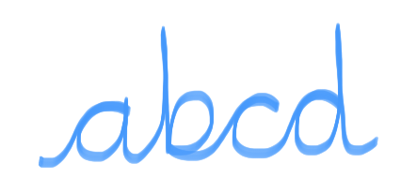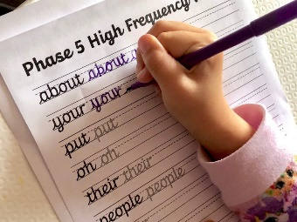

Resources
There are lots of resources on the internet, here are a few to get you started.
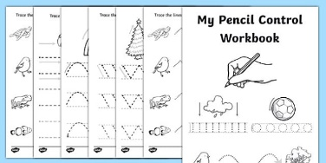 | Twinkle has lots of handwriting worksheets some of which are free.
Teach Handwriting has many videos, ideas and advice for parents

https://www.teachhandwriting.co.uk/handwriting-resources-children.html

 | Handwriting without Tears is an award-winning scheme to help those children who are perfectionists:
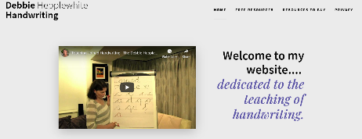 | Debbie Hepplewhite has an excellent selection of free resources and a video explaining how to teach cursive writing.

Apps
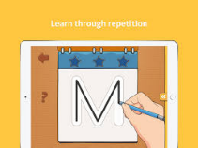 | iTrace (handwriting for kids)
 | Writing Wizard - Handwriting
Please see Part 2 (Issue 8) for information about Alternative Methods of Recording.

