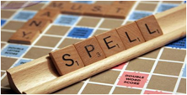

Supporting your child with spelling: Part 2

Tips to help your child with spelling at home

- names – teaching your child how to spell their name (first name and surname) will boost their self-esteem. Using plastic or wooden letters is a fun way to do this. If names are longer, learn to spell each part separately and then join together. Have a self-check prompt on hand for them to refer to if necessary.

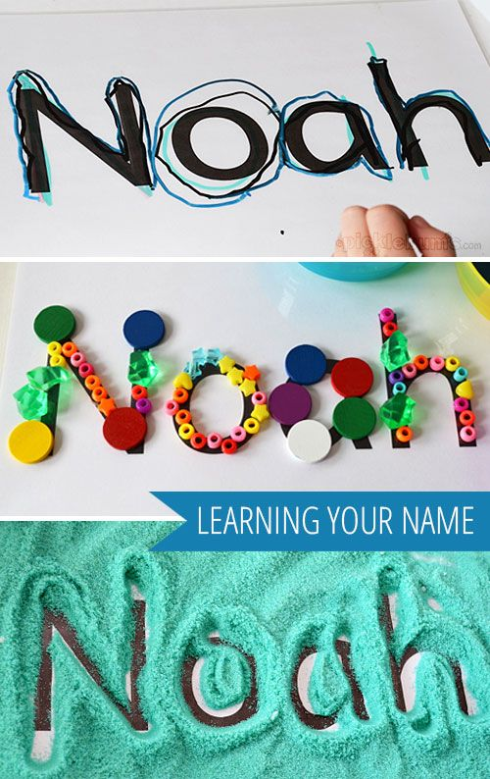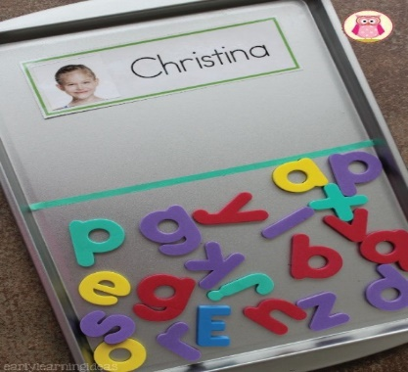

- school spellings - when helping your child to learn spelling lists from school,

- it’s best to keep the activity short and to use a multi-sensory approach, building in time for lots of revision. Remember that practising spellings does not always have to be done with pencil and paper. Introducing a tactile approach uses another of the senses and could include using plastic or magnetic letters, writing the word in sand or making it from Playdoh. If your child is finding it difficult to learn school spelling lists because there are too many words or the spelling pattern is too difficult and he/she is becoming disheartened, it’s worth speaking to the class or form teacher to find a solution. This might be reducing the number of words to learn and/or focussing on common or high frequency words.
- common words - the number of words that we use regularly is relatively small. These are the ones to concentrate on when helping your child learn common words for spelling. Learn new words one at a time and try different ways of learning (as suggested below). Repetition is key; the aim is for your child to be able to spell the word automatically. As you move to new words, make sure you recap previous spellings to check they haven’t been forgotten.
- use voice – encourage your child to ‘talk’ spellings. This might be saying a ‘tricky’ word in an exaggerated way to support spelling, e.g. Wed-nes-day or saying silent letters, like k-nee, or saying a regular word aloud and then splitting it into its separate sounds.
Wed-nes-day
- syllables - when your child is learning to spell longer words, show them how to speak the word in syllables first and then to spell each part, e.g.
re-mem-ber.
- use rhyme – encourage your child to think about ‘word families’ of words which rhyme. For example, taking our word sail, if your child knows it rhymes with mail (which they can spell) they can use the -ail rhyme.

Tricky words: using a multi-sensory approach
- movement - your child may prefer to learn spellings while ‘on the move,’ so you could try placing plastic letters or cards with letters written on, around the room to collect and assemble in the correct order.
- mnemonics - your child may like to make up a mnemonic (mnemonic comes from the Greek word for memory and can be anything which is an aid to memory). Examples of commonly used mnemonics are Sally Ann Is Dancing = said and Big Elephants Can Always Understand Small Elephants = because. Mnemonics can be verbal or visual but it’s important that your child makes up his/her own mnemonic to make it more memorable.
- use visuals - using visual ways to learn spellings is likely to be beneficial for your child. Examples are visual mnemonics and using different coloured pens or pencils to highlight the difficult part of the word. Drawing boxes for your child to write each sound of the word gives a useful visual prompt to support the process of segmenting words into individual sounds.
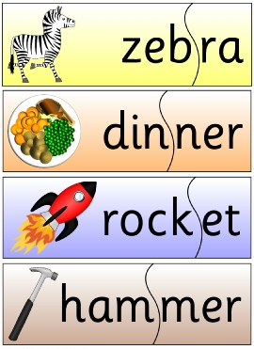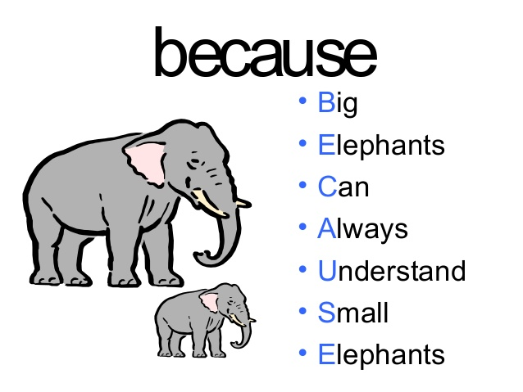
- spelling rules – ask your child’s teacher which spelling rules they have been learning and practise these at home. Going back to our word sail, it might help your child to know that ai is in the middle of this one syllable word and that ay is at the end of the word day.

- prefixes and suffixes – teaching your child the meaning and spelling of common prefixes, e.g. pre, un, dis and suffixes, e.g. s, ed, ful will help them to see how words are made up, e.g. un + help + ful

Some spelling games
- ‘I Spy’ – where you have to guess a word from its first letter. This can be extended to include second and third letters.
- Pairs – create pairs of words on separate pieces of card and use these to play a pairs matching game by placing the cards upside down and taking turns to choose two cards. This game also encourages the development of visual memory skills.

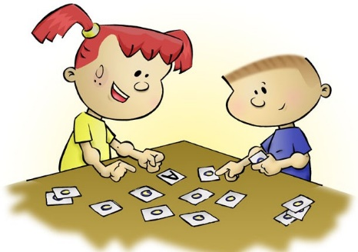

- Commercially-produced games - Scrabble (Mattel); to build confidence you may want to have a rule that words will not be longer than 4 letters, or the Junior version, where the letters are printed on the board, Boggle (Hasbro) or Match and Spell (Orchard Toys).

Spelling and Handwriting
It is best for your child to learn to use a fully cursive script: fully joining throughout a word encourages a muscle memory for whole words. Learning to touch-type encourages a muscle memory using a keyboard. Students should be encouraged to name letters as they write / type them within a word.

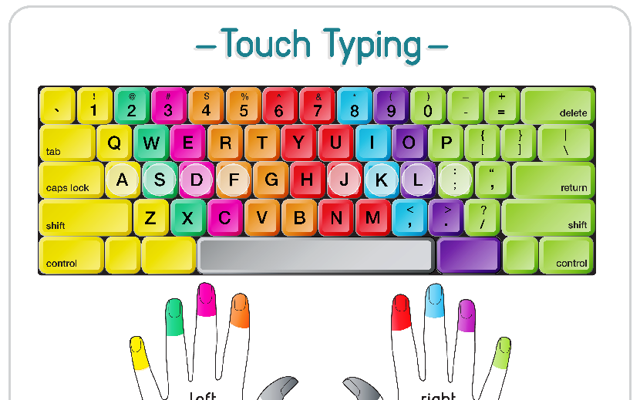

Spelling Resources to use at Home

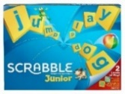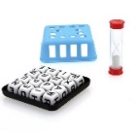  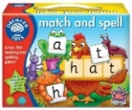 | Games  Match and Spell (Orchard Toys)  Scrabble/Scrabble Junior (Mattel)  Boggle (Hasbro)
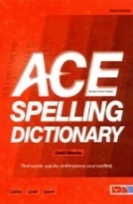 | Ace Dictionary  Your child may have learnt how to use an ACE spelling dictionary at school.  The word is found using the index at the front. All your child has to do is identify the vowel sound and the number of syllables in the word.
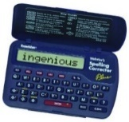 | Electronic spellchecker  e.g. Franklin Collins
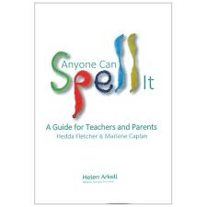 | Anyone Can Spell It (Helen Arkell)  https://www.helenarkell.org.uk/  Lots of ideas for different ways to learn spellings

Websites/Apps

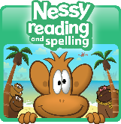 | Nessy Reading and Spelling  https://www.nessy.com/uk/  A Free Trial is available.
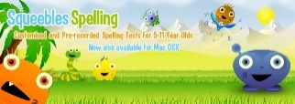 | Squeebles App  £4.99  https://keystagefun.co.uk/literacy-apps/squeebles-spelling-test/  This spelling app lets you set up completely customised spelling tests for your children with the words they need to learn. Tests can be shared between devices.
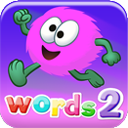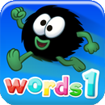 | Nessy Hairy Words Apps 1 & 2  £2.99 each (for children aged 5-7)  https://www.nessy.com/uk/apps/  Learn the first 200 high frequency Sight Words and help the Hairies jump to safety.
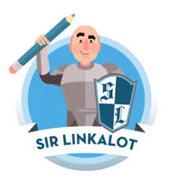 | Sir Linkalot Spelling App  https://www.sirlinkalot.org/  7-day free trial available  The app contains lists of words, including homophones, which are taught in a visual way, linking the spelling with a memorable animation

