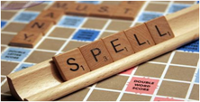

Supporting your child with Spelling: Part 1

Spelling can be an area of persistent difficulty for children and adults with dyslexia. Part 1 of our newsletters on spelling looks at why your child may find spelling difficult and suggests an approach for learning ‘tricky’ words, which are often words which we write most often.

Dyslexia and Spelling
Some words have regular letter-sound correspondences, e.g. a word like ship can be segmented (split up) into its separate sounds (sh i p) when spelling.
However, your dyslexic child might find it difficult to match sounds with the correct letter representation, which could result in the word ship, being spelt as sip, chip or shib.
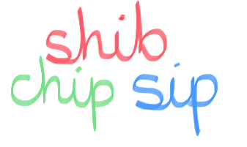
A word like sail also has regular letter-sound correspondences (s ai l). However, a difficulty for your child might be remembering how to spell the ai sound in the middle of the word, as there are different ways to represent this sound, e.g. ai, ay, or a (in a word of more than one syllable). Another confusion might be with the word sale, which sounds the same but has a different meaning and spelling.

Other words have irregular letter-sound correspondences and cannot be spelt the way they sound. These are often referred to as ‘tricky’ words for that reason.

Examples include words like, said, does, one. These ‘tricky’ words are often ones children use frequently in their writing. Difficulty with visual sequencing may make it harder to learn these tricky spellings. Your dyslexic child/young person will need explicit teaching of spelling, using a multi-sensory, cumulative (building on previous learning) approach.

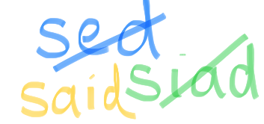

Tricky words: using a multi-sensory approach
Look at your child’s writing to find the common ‘tricky’ words they find difficult to spell and try this multi-sensory approach.

- Look at the word (visual)

- Say the word and name each letter (visual/auditory)

- Write the word/trace it with a finger/make it from plastic letters/write it in sand (tactile) while saying each letter name (auditory/visual/tactile)

- With ‘tricky’ words, use letter names rather than sounds, as sounds may be misleading

Handwriting and spelling

It’s best for your child to learn to use a fully cursive script: fully joining throughout a word encourages a muscle memory for whole words.
Pausing frequently when writing, to recall a spelling, could be a reason for poor letter formation and handwriting, so becoming automatic with spelling common words can help.
Spelling Part 2 (Issue 6) will give you more tips for helping your child with spelling and suggest some useful resources!

