Dyslexia and Personal Organisation: Information for Parents/Carers

Self-organisation is the ability to organise our thoughts and possessions and to carry out tasks in a step-by-step fashion. Dyslexic students can have great difficulty in independently managing this process. This can impact in many areas of their life.

Four Key Organisational Skills

Chunking - this is the process of breaking longer, more complex tasks into smaller, more manageable steps. This applies to both school projects and household jobs and will show your child that tasks have a beginning, middle and end, so they do not feel overwhelmed.

Goal setting - once your child knows all the steps involved with a particular task, support him/her to set their own short and long term targets to achieve their end goal. This will improve both their own organisational ability and general effectiveness.
Making plans - this follows on naturally from goal setting and is the process of how the goals will be fulfilled, for example, “I’ll learn one word per night using my preferred spelling strategy.”
Managing time, environment, papers/equipment/possessions - encourage your child write down important tasks in a ‘to-do’ list either in digital form on a phone or tablet, or on a paper visual planner or calendar. Help him/her to estimate how much time each task will take. After completing the task, ask whether the time estimate was accurate or not. If needed, suggest adjustments for next time. It may also help for your child to write the due date directly on schoolwork/projects.
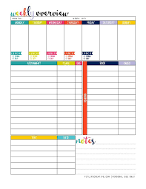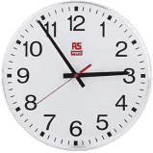

Organisational strategies for home - adapted from https://www.surreycc.gov.uk/schools-and-learning/schools/at-school/extra-support-for-your-child/helping-your-child-at-school/organising-skills
Newsletter Issue 3 was about supporting your child’s memory processes. Some of the strategies below for personal organisation will help to support memory.
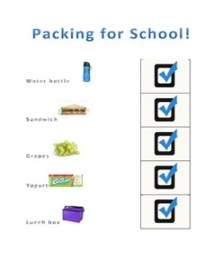
- Develop 'reminder cards' (using words, symbols, pictures or photographs) to provide visual reminders of routines, equipment needed, how to lay out a piece of work, etc. These can be pocket size and/or larger for putting on the wall. For example, when your child returns to school, having a checklist on the front door with the days of the week and all the equipment they need to take for each day and a similar checklist (on a pocket card) to ensure they have everything required for going home; having 'jobs' card for everyone in the household. 'Reminder cards' work best if the child makes their own, with your help if necessary.
- Use stapler and clips to keep paper/notes together. Colour-code files for each subject and extend colour-coding to equipment and text-books (e.g. using stickers) for each subject. The same colours can be used on a checklist or timetable, so your child can look for items by their colour code.
- Develop routines: having set times for doing tasks, e.g. always feeding the pets straight after a favourite television programme; always emptying the school bag as soon as they get home; always putting the school bag in the same place; keeping their key in the same pocket of their bag.
- Use 'organiser' boxes - one box for each day of the week, where workbooks and homework are placed when finished with, ready for the next lesson; or to keep different things together (e.g. all books in one box, all Lego in another, and so on).

- Use 'post-it' notes, small cork board or dry wipe board, diary/ personal organiser, 'do-it-now' note pad, or electronic notes for reminders. Siri can be used on an iPhone or iPad for voice typing in the notes app.
- Develop a homework plan/timetable for each day of the week, which includes when they will do the homework (including time of day), how long they will spend on the homework and when it needs to be returned. It is better to do the homework as soon as possible, as it is easier to remember what has to be done. Talk homework through with a parent, brother, sister or friend, to check that they really understand what to do before they start. Set aside a space at home where your child can work without interruption. It might work best if this is somewhere near you for times when they need your help. Keep school supplies and technology, such as laptops, nearby.

Children and young people with dyslexia often lack temporal awareness (a sense of themselves in space and time). Although many may master the skill of telling the time using a digital watch, they may not have the same ability to ‘feel and manage time’.

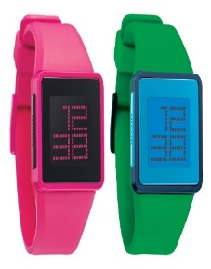

Help your child gain a sense of time by:
- giving them a feel for blocks of time, e.g.by linking 10 minutes to an activity that they enjoy which takes that amount of time;
- using a popular or invigorating piece of music that lasts about 2 minutes. Play this at the beginning, or end of a lesson whilst they get out or clear away equipment within the time deadline;
- using a timer to show them the amount of time passing when setting timed tasks. A sand timer is a great way to see time passing;
- using timers to encourage them to spend longer periods of time on one task and not get distracted or jump from one job to another.

