Supporting Memory Systems at Home: Information for parents/carers

Memory systems are important, not only in relation to academic learning but also for lots of life skills – remembering a shopping list, preparing a roast dinner and remembering passwords for a computer at work or online shopping!

Different types of memory system
We use our short-term memories to hold information for a few seconds – for example, to remember a phone-number or email address whilst writing it down or typing it into a phone. Where we then use or apply this short-term information – such as adding up a list of numbers or working out where we are in a set of instructions to determine which is the next step – we are using our working memory systems.
Working memory is important as not only does it support our responses to information/instructions, but it also enables us to focus and concentrate our attention as well as organising how we arrange information and transfer it to the longer-term memory systems.
About 10% of people have difficulties with working memory; this figure is much higher for people with specific learning differences such as Dyslexia, Dyspraxia or ADHD.
Typically, a person with Dyslexia is likely to find it harder to retain and respond to verbal input such as speech. Visual input is often easier for them to retain and can work well to support verbal input. In other words, it’s helpful to support learners with something to look at to remind them of what they’ve heard.

Working memory systems are sometimes described as the ‘post-it’ notes used by the brain – only a little information can be recorded and it’s only for a few seconds. The amount of information varies from person to person and also within the individual at different times/in different circumstances.
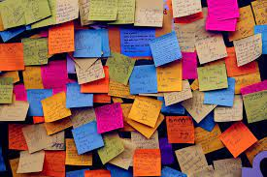

Ideas for supporting memory systems
- Remember – post-it notes are small, so only give small chunks of information/instructions at a time.
- Post-it notes can easily get lost, so be prepared to give a reminder of information/instructions – your child doesn’t choose to forget.
- Keep instructions short and simple so that your child has less content to retain and process.
- Ask your child to repeat these short, simple instructions back to you – this builds in an additional reminder and enables you to check what your child thinks that you’ve just said…
- Making connections to other learning and experiences helps with storing new learning tidily in the brain where it can be found and used again. So, if you’re looking at a literacy task with your child, remind them what they worked on last.
- Make it memorable! Humour is great for boosting the memory so make a funny story including the items on a shopping list or the order of tasks for getting ready for bed. Sets of instructions can have a rhythm added for emphasis – you could add a melody if you’re feeling creative!
- Make it personal! Linking to other memories/experiences is a great way to cement learning, so encourage your child to make connections to people/places/events that have meaning for them. For example, when working on the ‘ea’ in words like ‘beach’ refer back to a trip to the beach.
- If your child is working on reading/spelling specific words, encourage them to use different colours to pick out and reinforce different sections – perhaps the tricky bit, or a ‘silent letter’ that keeps being forgotten (thumb), or one colour for verbs (doing words) and another for nouns (objects, people and places).

More ideas for supporting memory systems
- Applying a new piece of information/learning helps us to store and find that new learning again another time, so try to put new learning to work – spotting a word/letter pattern in a book, an advert on TV, a WhatsApp message from Grandma and so on.
- It’s helpful to ‘check in’ with your child if they are trying to remember or work on a set of instructions – so ask them, “What do you need to do now?” – this is useful for errands around the house as well as work-based tasks.
- Add something kinaesthetic (to do with movement or touch) to reinforce sets of instructions – so for a 3-part set of instructions, encourage your child to touch a finger (or fold a finger down) for each instruction so that there is a physical connection to each part of the input.
- Be aware that everyone finds it more difficult to use their memory systems efficiently when they are feeling stressed and/or tired, so break things down even more and build in extra reminders.
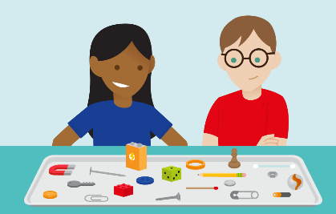
- You can play games to encourage good use of the memory – Kim’s Game (child looks at objects on a tray, adult secretly takes one away for child to work out) or shopping list type games – “I went to the shops and I bought……” to build up retaining and repeating sequences of information. The shopping list game can be ‘modernised’ or adapted to suit the individual – perhaps, “I went to [name of favourite clothes shop] and I bought….” or even shopping for football teams or players!
- Enjoy giving your own memory a work-out! Do you use strategies to support your memory systems? Compare notes with your child – this encourages thinking about how to focus on memory skills and establishing what are effective strategies.

