**SUFFOLK COUNTY COUNCIL**

**CHILDREN AND YOUNG PEOPLES SERVICE**

GROWTH POLICY

**Summary of Growth Policy**

This document sets out the criteria that will be used and applied to allocate funding to schools under Suffolk County Council, Children and Young Peoples Services Growth Policy.

The “Schools revenue funding operational guide” published by the Education Funding Agency states that “the growth fund can be used only for the purposes of supporting growth in pre-16 pupil numbers to meet basic need, to support additional classes needed to meet infant class size regulations and to meet the costs of new schools”.

In particular funding will be allocated on the following methods.

1. **New Class Funding –** this relates to the Local Authorities requirement for schools to take on additional half form and full form entries into the school above what they currently provide to deal with increased need in those schools and surrounding catchment areas.

2. **Low Level Basic Need Funding** - this relates specifically to pupil growth in the whole school where the Local Authority are aware of local pressures on the school and will pay out to those schools which apply and meet the necessary criteria.

3. **New Schools and Significantly Growing Schools Funding** – this relates to allocating funds to brand new schools and those schools that are opening 10 new classrooms in one year. This provides a pre-opening budget to pay for those costs incurred before the school has any pupils to ensure that the school can be operational on day one of opening.

**New Class Funding**

Schools which are requested by the Local Authority to take on additional half form or full form entries into Reception and above will be eligible for New Class Funding.

A school would take in a half or full form entry at the start of each Autumn Term and as school budgets are based on the previous Autumn Term census the school in effect sees a funding shortfall for these additional pupils for the period September to March. These new pupils will then feature in the following year’s census and the school will receive the appropriate funding for them.

The funding being made under this policy to the school is to recognise the shortfall that exists and to enable a school to appoint the necessary staff and set up and furnish a new class room. The funding recognises the cost of a classroom rather than the number of pupils who may then occupy it.

The funding that is being made available for is based on the following full year figures:

1.0 FTE Teacher at UPS Level 1 = £45,182

0.5 FTE Teaching Assistant – Mid Point Grade 3 (Point 16) = £11,617

Class Setting Up Allowance = £ 5,000

Total = £61,799

As the period in question is September to March, 7/12ths of this level of funding will be paid to the relevant schools.

Teacher = £26,356

Teaching Assistant = £ 6,776

Class Setting Up Allowance = £ 5,000

Total = £38,132

Please note that under the current Education Funding Agency funding arrangements eligible Academies will receive the full payment of £61,799. £36,049 will be paid for the period September to March and then £25,750 will be paid in the following financial year for the period April to August. Academies do not receive the funding from the new pupils until the start of the academic year. The Local Authority claims the funding back through academy recoupment on the Schools APT submission in January.

**Schools with Local Authority Request for Full Form Entry**

For those schools which are taking on a full form of entry (i.e. going from a one class of 30 to two classes of 30) the final structure of the school will mean that the number of classes increases from 7 (those schools with Yr R to Yr 6) to 14. This means that at the start of each financial year the school would be eligible and receive a lump sum payment of £38,132.

This payment would be made to the school as long as the school was fulfilling the requirement requested by the Local Authority. The Local Authority reserves the right to adjust the funding accordingly if the class situations change however any agreements/requests that have been made by the LA will be honoured in that financial year. The LA recognises that it is possible for potential pupil growth to not affect the school as expected but the school will still have actioned a plan at the LA’s request and will have made arrangements to appoint and furnish a new class.

**Schools with Local Authority Request for Half Form Entry**

For those schools which are taking on a half form of entry (i.e. going from 30 pupils to 45 pupils) the final structure of the school will mean that the number of classes required increases from 7 (those schools with Yr R to Yr 6) to 11. This will mean that these schools will have to manage mixed classes however the Local Authority recognises the need for funding in order to support this change and would pay the lump sum of £38,132 in the first four years so that schools were able to plan for this changes rather than the LA spread the funding over the full 7 years of change.

This payment would be made to the school as long as the school was fulfilling the requirement requested by the Local Authority. The Local Authority reserves the right to adjust the funding accordingly if the class situations change however any agreements/requests that have been made by the LA will be honoured in that financial year. The LA recognises that it is possible for potential pupil growth to not affect the school as expected but the school will still have actioned a plan at the LA’s request and will have made arrangements to appoint and furnish a new class

Annex A is for illustrative purposes only but shows an example of the changes resulting from increased pupils, differing forms of entry and the when the funding will be made available.

Payment of both the full form entry and half form entry will be paid normally at the start of the financial year once approval has been given by the CYP Schools Infrastructure Team that the relevant entry is taking place in school.

**Low Level Basic Need Funding**

The Local Authority recognises that there are areas of Suffolk which are undergoing significant changes and increasing pupil numbers. The increase of these pupils into a school may not require or generate a new class but will have an impact on the organisation of the school.

Therefore any school which feels it is subject to this change will be able to apply to the Local Authority for Low Level Basic Need funding in order that they are able to continue to provide efficient education to meet the needs of the local population. This will ensure that funding is not issued for general pupil growth in all schools, only those schools where the Local Authority recognises the need to support the school.

To clarify, schools which have general pupil growth, also known as popular growth, outside of this Low Level Basic Need funding will not be entitled to receive this funding and the funding for those pupils will only appear in the following year’s school budget when the pupils are then showing in the relevant school census.

Low Level Basic Need funding will be calculated by comparing one years October census, the census which the current funding is based on with the in year October census which funds the following years budget. For the purpose of the calculation only Reception Year pupils to Year 11 pupils will count.

Any increase between those two figures of more than 10% will be eligible to receive funding.

As part of the calculation 10% of the previous October census will be deducted from the eligible children and it is the remaining numbers will be used to calculate the additional funding for the period September to March.

Schools would then receive the eligible number of pupils multiplied by 7/12ths of the relevant AWPU value, as used for the Basic Entitlement.

In exceptional cases agreed by the Local Authority where the increase in pupils is known to have existed in year but outside of the normal September intake then the eligible number of pupils will be multiplied by the appropriate number of months divided by 12 and multipliedby the appropriate AWPU value, as used for the Basic Entitlement.

A worked example and further information is shown in Annex B.

Any school which is due to receive funding through Low Level Basic Need but has also received funding for New Classes will see the New Class funding deducted from the proposed Low Level Basic Need allocation otherwise the Local Authority is in effect double funding the same pupils, albeit through differing mechanisms.

Funding for Low Level Basic Need will be paid to schools by the end of each Autumn Term following the collation of the October census data.

The “Schools revenue funding operational guide” states that :

*The growth fund may not be the most appropriate source of funding for growing schools and local authorities should consider requesting a variation to pupil numbers where there is a more permanent and significant change to numbers and where it is appropriate for the change to be reflected in the funding formula.*

**New school and significantly growing schools funding**

Where a new primary or secondary schools is opened in Suffolk or schools are significantly growing (significant growth is defined as the establishment of 10 new classrooms in one year), revenue funds will be set aside to pay for the opening costs of that school. The funding will be spilt into two parts. New schools will be eligible for both elements of the funding. Significantly growing schools will be eligible for part two funding only.

Part one is for the pre–opening costs this is a block allowance of £191,000 for a primary school and £259,500 for a secondary school.

The calculation for each phase is based on the costs of employing a Headteacher, a Deputy, Business/Finance Manager and Site Manager before the school opens. There is also an allowance set aside for advertising, travel and training. The Governing body however are able to spend the funding as they see fit for their school.

|  |  |  |  |  |
| --- | --- | --- | --- | --- |
| Heading | **Secondary School** | | **Primary School** | |
| Resource Lead Time | Total Start Up Funding | Resource Lead Time | Total Start Up Funding |
| Headteacher | 1 F.T.E. for 8 months | £78,000 | 1 F.T.E. for 8 months | £52,000 |
| Business Manager | 1 F.T.E. for 4 months | £18,000 | 1 F.T.E. for 4 months | £13,000 |
| Deputy Headteacher | 1 F.T.E. for 4 months | £32,000 | 1 F.T.E. for 4 months | £24,000 |
| Site Manager | 1 F.T.E. for 2 month | £8,000 | 1 F.T.E. for 1 month | £8,000 |
| Admin Officer | 1 F.T.E for 6 months | £18,000 | 1 F.T.E for 6 months | £18,000 |
| Recruitment Costs |  | £15,000 |  | £10,000 |
| Start up costs |  | £57,500 |  | £45,000 |
| Non Pay Costs |  | £30,000 |  | £20,000 |
| Miscellaneous Costs |  | £3,000 |  | £1,000 |
| **Total Start Up Funding** |  | **£259,500** |  | **£191,000** |

Part two is a setting up allocation which is made for each classroom that the school will have. This is to pay for the desks, chairs and equipment in each classroom in the school. The calculation is based on average costs. However part two payments may be made in kind where equipment from closing schools can be re-deployed. The basic cost is £5,000 per class with 50% increase to £7,500 for specialised classrooms (i.e. Food Technology, Design and Technology, Science, Art and ICT). Please see Annex C for a breakdown of the costs. In addition to the funding per class we will also supply a block payment of £25,000 for primary and £50,000 to secondary to cover the cost of establishing office and communal space etc.

**Diseconomies of scale funding for new primary schools**

In addition to the lead in costs i.e. preopening costs and the setting up allowance, the ESFA guidance for the funding of new schools created to meet basic need states the growth policy should provide for diseconomy of scale costs.

The local authority is required to estimate pupil numbers for a new school, by working with the school and using the latest admissions and demographic data, to produce the individual school budget for the new school.

However, as new schools are unlikely to be at full capacity, it is recognised that the new school will incur diseconomies of scale costs e.g. some fixed management and premises costs, until the new school builds up their pupil numbers.

Diseconomies of scale funding will be provided only for year groups R,Y1 and Y2 for the first three years as they progress through the primary school. New year groups joining the school will be funded on estimated pupil numbers; no diseconomy of scale funding will apply

Estimated pupil numbers are those used to calculate the school budget.

Diseconomies of scale funding is the difference between the estimated pupil numbers and 75% PAN for R, Y1 and Y2 as they progress through the school for the first 3 years i.e.

diseconomies of scale funding = (75% PAN for R,Y1,Y2 – estimate for R,Y1,Y2) * AWPU

**Academies and Free Schools**

Academies and Free Schools are eligible for funding through this policy as the funding for growth is held by the Local Authority. However DfE guidance is clear that any funding paid to any school whether Local Authority Maintained, Academy or Free School must be done so as part of basic need. In simple terms, the Local Authority has requested the establishment to take on additional pupils and year groups.

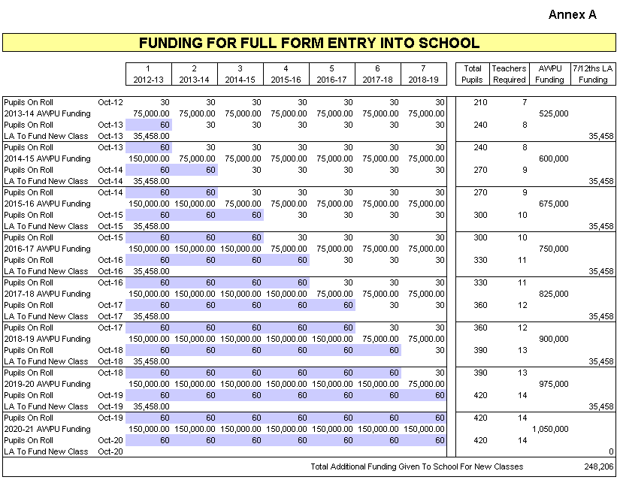

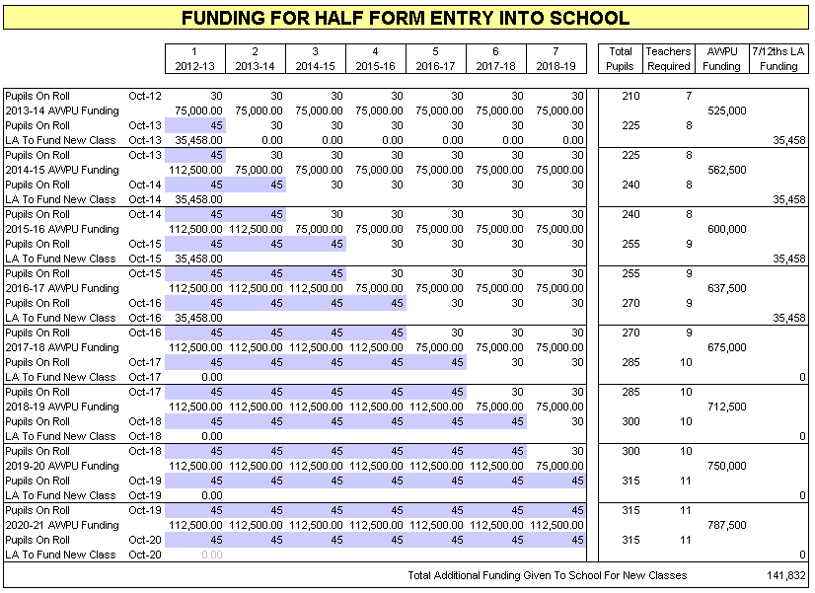

**Annex B**

**Low Level Basic Need - Eligibility**

**Either,**

a)  School has an increase of pupils from October 2017 to October 2018 which requires the school to reorganise their class structure to meet the basic need and is approved to be eligible by CYP Schools Infrastructure Team.

b)  School has been requested by the Local Authority to take on additional pupils but it does not fall under the New Class Funding part of the Growth Policy.

For both a) and b) schools must also have a 10% increase in pupils between October 2017 and October 2018 census to attract funding.

**How to Apply**

Any school that believes it meets the eligibility criteria for Low Level Basic Need Funding will need to contact the CYP Schools Infrastructure Team and demonstrate the schools need to re-organise. In particular show the schools Class Organisation as it currently stands and where it will be once the additional pupils are in school.  Any supporting commentary should also be included but does not need to be exhaustive.  Schools which are proved to be eligible will then go through the calculation and any funding that the school is entitled to will be paid to them by the end of the Autumn Term.

**Schools are advised to check that they would receive funding before they apply to ensure it is beneficial to do so. It is possible to be eligible and not receive funding depending on the pupil numbers involved.**

**Funding**

Schools which demonstrate the need to reorganise and meet the 10% increase will receive funding based on the following calculation.  The pupil numbers to use are Year R to Year 11 only.

Oct 18 census – Oct 17 census = **x** eligible pupils

**x** pupils – 10% of Oct 17 census = **y** pupils to fund

**y** pupils x £1,602 (7/12ths of £2,747) = **£ allocation**

**Worked Example**

**14.3% Increase**

**120** pupils **– 105** pupils **= 15** eligible pupils

**15** pupils **– 10.5** pupils **= 4.5** pupils to fund

**4.5** pupils x £1,602 = **£7,209**

**Additional Information**

Schools should be aware that this funding in itself will not support the cost of a new class and nor is it meant to.  The funding is set aside to assist schools in making these particular changes and full year funding for increasing pupils will then form part of the following year’s delegated budget.  The Department for Education have made it clear that any growth funding that is paid to schools must meet the Basic Need requirement and school pupil growth (sometimes referred to as popular growth) outside of this will be funded accordingly in the following years budget.

**Low Level Basic Need Calculation – Other Examples**

**School A**

October 2017 Census: 40

October 2018 Census 48

Increase of 20.0% which is above the criteria of 10.0%

48 – 40 = 8 eligible pupil

8 pupils – 4 (10% of October 2017 census) = 4 pupils

4 pupils x £1,602 (7/12ths of £2,747) = £6,408

**School B**

October 2017 Census: 215

October 2018 Census 238

Increase of 10.7% which is above the criteria of 10.0%

238 – 215 = 23 eligible pupil

23 pupils – 21.5 pupils (10% of October 2017 census) = 1.5 pupils

1.5 pupils x £1,602 (7/12ths of £2,747) = £2,403

**School C**

October 2017 Census: 215

October 2018 Census 235

Increase of 9.3% which is below the criteria of 10.0%

Therefore no funding to be allocated to school.

**Annex C – Class Room set up** 